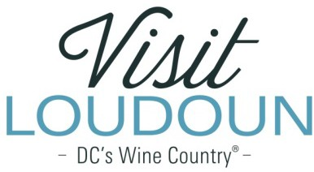

2019 Visit Loudoun Tourism Awards Entry Form

Tourism Branding, Marketing, or Promotional Campaign of the Year
Criteria: Innovative tourism campaign evaluated on the overall design and execution, as well as results generated against objectives.

Nominee

Tourism Marketing Promotion/Campaign:

Organization:

Design/Creative Firm:

- Campaign objectives and target audience:

- Campaign design and execution (samples required):

  - No Attachments
  - Attachments Saved as Part of Nomination

- Campaign results:

- What made this campaign successful?

Each nominee will be a guest of Visit Loudoun at the Annual Meeting & Tourism Awards program to be held during National Tourism Week in May 2020 from 11:30am-2pm (One guest per nomination.)

Please provide the following information for the nominee representative so that we may contact them regarding the nomination, arrange to receive an appropriate image to represent the event during the awards presentation, send them an invitation to the Visit Loudoun Annual Meeting and Tourism Awards Program, and request their RSVP:

Nominee/Nominee Representative Contact Information

- This address is the nominee’s business address
- This address is the nominee’s home address.

Name:

Title:

Organization:

Mailing Address:

City:
State:
Zip:

Phone: Email:

Nominator/Submitter

Nominator Name:

Relationship to nominee

Title

Organization

Address

City
State
Zip

Phone: Email:

Signature:

All nominations must be received by 4pm on Friday, February 28, 2020.

Please save your nomination form using the format below “award name”_”nominee name”
Go to https://www.visitloudoun.org/tourism-industry/industry-events/annual-meeting-tourism-awards/tourism-award-categories-nomination-forms/and scroll to the bottom of the page for submission information

