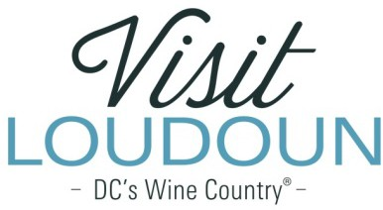

2021 Visit Loudoun Tourism Awards Entry Form

Tourism Branding, Marketing, or Public Relations Promotional Campaign of the Year
Criteria: Entries in this category may include marketing campaigns, public relations promotions or earned media coverage. This category recognizes creativity in campaigns or pitches, innovation, clearly stated objectives and how those are measured and the demonstrated results.

Nominee:

Tourism Marketing Promotion/Campaign:

Organization:

Design/Creative Firm:

- Campaign objectives, target audience and key performance indicators:

- Campaign design, innovation of the program and message(samples required):

  - No Attachments
  - Attachments Saved as Part of Nomination

- What was the implementation process for the marketing campaign / public relations campaign?

- Provide results from the program, which can include final campaign analytics (impressions, engagement, reach, likes, shares, etc.), ad value equivalency or circulation numbers.

- What made this campaign successful?

Each nominee will be a guest of Visit Loudoun at the Annual Meeting & Tourism Awards program, which takes place during National Travel and Tourism Week on May 5, 2022, from 11:30 a.m.- 2 p.m. (One guest per nomination.)

Please provide the following contact information for the nominee representative so that we may contact them regarding the nomination and request their RSVP at the awards luncheon. Please provide a high-resolution portrait image or logo to represent the nomination for inclusion in the awards program presentation:

Nominee/Nominee Representative Contact Information

- This address is the nominee’s business address
- This address is the nominee’s home address.

Name:

Title:

Organization:

Mailing Address:

City:
State:
Zip:
Phone: Email:

Nominator/Submitter

Nominator Name:

Relationship to nominee:

Title:

Organization:

Address:

City:
State:
Zip:

Phone: Email:

Signature:

All nominations must be received by 4 p.m. on Friday, March 11, 2022.
Please save your nomination form using the format below “award name”_”nominee name”
Go to https://www.visitloudoun.org/tourism-industry/industry-events/annual-meeting-tourism-awards/tourism-award-categories-nomination-forms/and scroll to the bottom of the page for submission information

