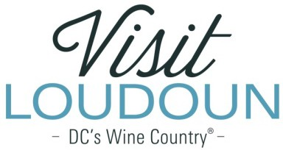

2019 Visit Loudoun Tourism Awards Entry Form Tourism Volunteer of the Year
Criteria: The individual that made a significant contribution to the tourism industry through volunteer service to one or more tourism-related organizations.

Nominee

Name:

Title:

Organization:

Supervisor:

- How has the volunteer made a significant contribution to the tourism industry?

- What makes this volunteer exceptional?

- How long has the volunteer been serving the tourism industry?

- How has this volunteer’s service made a difference to your organization?

- What other organizations has this volunteer also served?

Each nominee will be a guest of Visit Loudoun at the Annual Meeting & Tourism Awards program to be held during National Tourism Week in May 2020 from 11:30am-2pm (One guest per nomination.)

Please provide the following information for the nominee representative so that we may contact them regarding the nomination, arrange to receive an appropriate image to represent the event during the awards presentation, send them an invitation to the Visit Loudoun Annual Meeting and Tourism Awards Program, and request their RSVP:

Nominee/Nominee Representative Contact Information

- This address is the nominee’s business address
- This address is the nominee’s home address.

Name:

Title:

Organization:

Mailing Address:

City:
State:
Zip:

Phone: Email:

Nominator/Submitter

Nominator Name:

Relationship to nominee:

Title:

Organization:

Address:

City:

State:

Zip:

Phone: Email:

Signature:

All nominations must be received by 4pm on Friday, March 13, 2020.

Please save your nomination form using the format below “award name”_”nominee name”
Go to https://www.visitloudoun.org/tourism-industry/industry-events/annual-meeting-tourism-awards/tourism-award-categories-nomination-forms/
and scroll to the bottom of the page for submission information

