Partnership Information Request Form
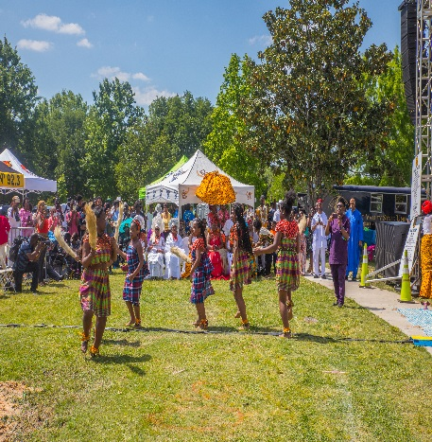
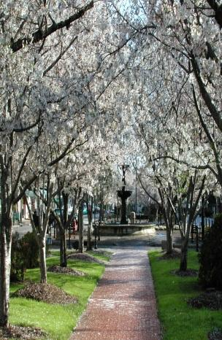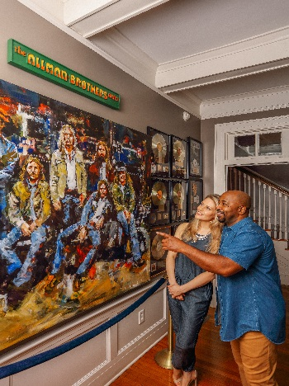
Visit Macon is a dynamic destination marketing organization that shares Macon’s story with visitors, meeting and convention planners, sports event planners and attendees, motor coach groups, leisure visitors, new residents, and other partners in order to bring people and revenue into the community and area businesses.

Required Information:
Business Name: __________________________________________________________
Primary Contact & Title: ____________________________________________________
Mailing Address: __________________________________________________________
City: ________________________ State: _________________ Zip: _________________
Telephone: (______) _________________ Web Address: _________________________
E-mail: _________________________________________________________________

Please check all categories below, which would apply to your business:
Arts/Entertainment/Nightlife Salon/Spa
Catering/Restaurant Shopping
College/University Sports & Recreation
Accommodations/Meeting Space Tours & Sightseeing
Annual Partnership Cost: $100
Annual Individual Partnership Cost (per person): $50
Kindly complete this form and return to:
Visit Macon
Attn: Aaron Buzza
450 Martin Luther King, Jr. Blvd. Macon, GA 31201
You may also scan this application and send to abuzza@visitmacon.org

Benefits and Values

In 2018, tourism in Macon…
- Supported 3,801 jobs
- Generated $395.77 million in direct tourist spending
- Generated $17.64 million in state tax revenues
- Generated $10.74 million in local tax revenues
- Generated $97.02 million in payroll
- Each Bibb County household would need to be taxed an additional $489 per year to replace taxes generated by tourism economic activity.

The Macon-Bibb County CVB works closely with community partners to promote their businesses to the traveling public. Our staff strives to develop and implement effective marketing strategies to increase the number of overnight visitors to Macon, GA and to foster economic development. As a CVB partner, you will receive the following benefits:

- Enhanced listing on VisitMacon.org and in the Visit Macon annual Travel Guide.
- Brochures and information distributed in the Visitor Centers. Destination Specialists at both Visitor Centers provide information to more than 60,000 visitors annually.
- Invitations to participate in or be marketed by Visit Macon through special events. Events include familiarization tours; showcase events like Macon on My Mind; regional and national trade shows; host travel writers and meeting planners.
- Potential to appear in marketing videos – e.g. That Guy You Met Today, Atlanta Eats.
- Promotions and special events listed in CVB social media accounts.
- Member spotlight in newsletters.
- Access to CVB Partner Portal – online access to convention and meeting information & ability to post coupons and/or specials.
- Complimentary use of CVB meeting space.
- Complimentary scheduling of I Am Macon training sessions for staff members.
- Invitation to Visit Macon Annual Meeting, holiday party and other member-only events.

