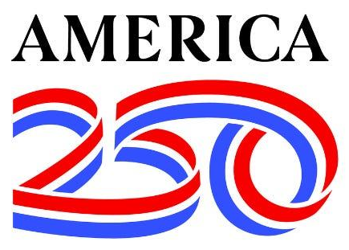
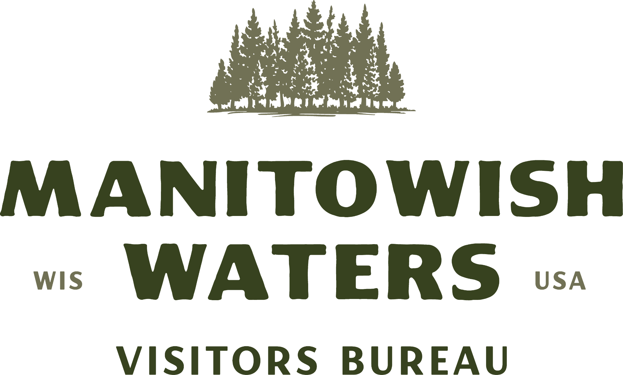
2026 4TH OF JULY PARADE ENTRY FORM
DOWNTOWN MANITOWISH WATERS
SATURDAY, JULY 4TH 1PM
Presented by the Manitowish Waters Visitors Bureau

REGISTRATION

Name of Business/Organization/Group: ______________________________________________________________
Contact Person: ___________________________________ Contact Cell Number: ____________________________
Mailing Address: _____________________________________________________________________________________
City: ____________________________________________________ State: _______________ Zip: ___________________
Business Phone: ____________________________ Email: _________________________________________________

ENTRY
Check all that apply. Please provide as many details as possible.

Tow Vehicle:
Car: ______ Pick-Up: ______ Larger Truck: ______ Horses: ______ Other: __________________________________
Vehicle will be pulling:
Trailer: ______ Boat: ______ Other: _____________________________________________________________________

My parade entry IS a:
Car: ______ Jeep: ______ Truck: ______ Golf Cart: ______ Motorcycle: ______ Bicycle: ______
Group of people walking: ______ Marching Band: ______

Brief description of entry: (used to help announcer talk about your entry)
______________________________________________________________________________________________________
______________________________________________________________________________________________________
______________________________________________________________________________________________________
______________________________________________________________________________________________________

The undersigned individual and his/her agents agree to hold harmless and waive all claims against the Manitowish Waters Visitors Bureau, The Town of Manitowish Waters and all other sponsoring institutions/agencies arising from their participation in the 4th of July Parade held on July 4. It is also agreed that candy, gifts, etc. will be distributed in a safe appropriate manner from the vehicle/float/ transportation that this application represents (for children’s safety, it may be handed to patrons). I have read the rules and information and understand that if I violate these rules I will be asked to leave.

Participant Signature: ____________________________________________________ Date: ______/_______/ 2026

This application must be submitted, with signature to:
Manitowish Waters Visitors Bureau, PO Box 251, Manitowish Waters, WI 54545

2026 4TH OF JULY PARADE ENTRY FORM
DOWNTOWN MANITOWISH WATERS
SATURDAY, JULY 4TH 1PM
Presented by the Manitowish Waters Visitors Bureau

INFORMATION
The official parade route is from North Lakeland Discovery Center along County HWY W to the gravel pit (just before County HWY W & HWY 51 intersection). Approximate length: 1.2 miles

Staging will take place at North Lakeland Discovery Center beginning at 12:00pm, Friday, July 4th. Entries should pull all the way into the Discovery Center for line up instructions from event staff. Parade units should use the gravel pit as a “fall out” area. Please come prepared with all entry materials (building supplies, candy, etc) to avoid traffic jams during parade staging. Multiple trips in and out of the narrow driveway at the Discovery Center causes major traffic flow problems and creates a safety hazard for emergency vehicles already in the line-up that may need to get out!

The official end of the parade is the gravel pit on HWY W just before HWY 51. Except for emergency vehicles, all parade units are asked to pull into the gravel pit and circulate around its perimeter holding there until the parade is over and volunteers usher units out of the pit. COUNTY AND STATE LAW ENFORCEMENT REMINDS US THAT ALL PARADE UNITS LEAVING HWY W TO TRAVEL ON HWY 51 AFTER THE PARADE MUST COMPLY WITH ALL WISCONSIN TRAFFIC LAWS. Only “street legal” parade units are allowed to travel on HWY 51. The Vilas County Sheriff’s Department will be handling traffic control before, during and after the parade.

The parade will halt at the judging stand across from Trig’s Village Market for a presentation of colors and a performance of the National Anthem. ALL SIRENS, HORNS, AND OTHERWISE LOUD ENTRIES MUST BE TURNED OFF AND REMAIN SILENT DURING THESE TIMES.

Each entry will be given a number during staging, which should be displayed in a highly visible area on both the front and rear of your entry so the judges and emcee can see it.

RULES
- All entries must be decorated in a 4th of July theme. This year’s theme will be “America 250”.
- No large, heavy or potentially harmful products may be thrown into the crowd from the parade entrants.
- Alcoholic beverages are prohibited in the parade.
- Drones are not allowed at the parade due to safety issues.
- All sirens, horns, music, etc. must be turned off during the presentation of colors, singing of the national anthem and a moment of silence.
- Absolutely NO confetti cannons, poppers, etc. Let’s respect the clean-up crews and keep MW debris free.
- Horse/animal units must have a “pooper scooper” following your entry to clean up messes.

2026 4TH OF JULY PARADE ENTRY FORM
DOWNTOWN MANITOWISH WATERS
SATURDAY, JULY 4TH 1PM
Presented by the Manitowish Waters Visitors Bureau

DAY-OF EVENT
Entries may begin lining up at noon. In order to keep the parade on schedule it is crucial that you arrive on time and are in the line-up no later than 12:45pm.

The parade starts at 1pm SHARP. Positions of entries in the lineup will be determined by the Manitowish Waters Visitors Bureau.

WEATHER POLICY
Due to unforeseen circumstances and unfavorable weather conditions, the Manitowish Waters Visitors Bureau reserves the right to be able to cancel this event at any time. We will do our best to notify participants as early as possible.

JUDGING & AWARDS
Parade entries will be judged by three volunteer judges. An award will be given to the float with the “Best Overall Theme” for the parade.

Any questions? Please call the MW Visitors Bureau office at 715-543-8488.

