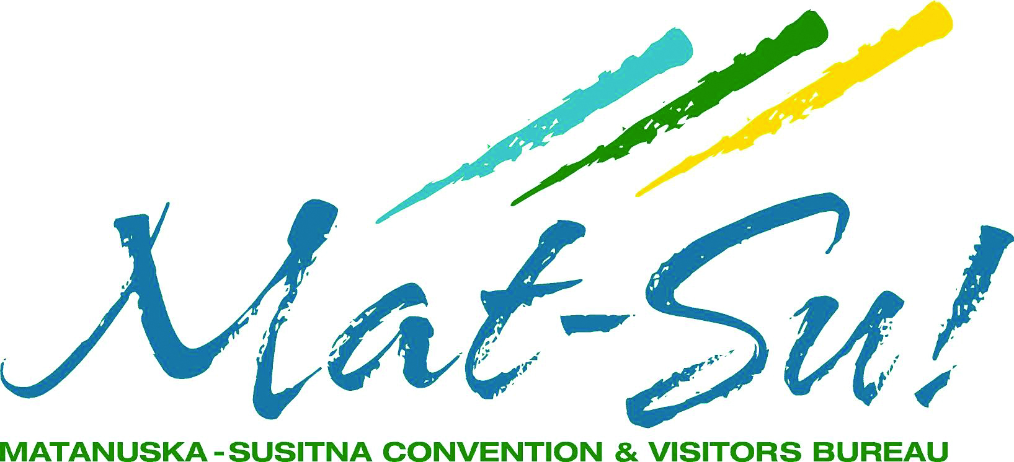
Strategic Plan 2020-2021
Mission
Create a vibrant visitor industry through authentic experiences that positively impact the communities where we live.
Vision
The Mat-Su Valley is the choice Alaskan destination to visit, experience and live.
PRIORITIES & OBJECTIVES
Sustainable Funding
- Proactively advocate for a 3-year grant funding agreement with the borough.
- Identify supportive assembly candidates and coordinate annual candidate forum.
- Refresh annual Community Awareness campaign.
- Explore new and non-traditional revenue opportunities.
- Reinforce the economic impact and “shared community value” of the visitor industry through multiple channels.
Support Tourism Infrastructure Development
- Advocate for Gateway Visitor Center.
- Advocate for South Denali Development.
- Inventory and prioritize new visitor infrastructure projects.
- Support Foundation fundraising efforts.
- Transition to broader Destination Management role.
- Seek and cultivate community partnerships.
Market and Brand the Destination
- Develop an effective marketing plan for all target markets.
- Deliver consistent messages and outstanding experiences.
- Incorporate “Stay another day” initiative.
- Create and implement a branding strategy.
Grow and Engage Membership
- Expand member educational programing and events.
- Maximize member value with tools and cooperative marketing opportunities.
- Target and form partnerships and alliances that best leverage resources and promote initiatives.

