Small Business Help with the COVID-19 Pandemic

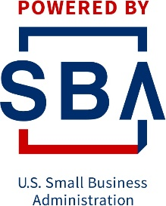
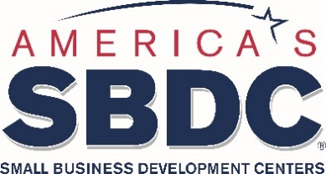

What SBDC Does | What SBA Does
Webinars on resources and strategies for:  - Emergency Loan and Grant Programs  - Business Survival  - Starting a New Business  Confidential, no-fee, one-on-one assistance in:  - APPLYING for financing  - Survival Strategies  - Financial Management  - Marketing  - Unwinding a Business  - Starting a New Business  Connections to other resources to help your business and employees  Find answers to the questions of today | Offers emergency loan and forgivable loan programs, including Paycheck Protection Program Loan guarantees, Economic Injury Disaster Loans and, Express Bridge Loans  Offers financing programs: 7(a), 504, Express, Community Advantage, Microloan, Export Express, Export Working Capital, International Trade Loan  Manages the 8(a) Business Development Program and HUBZone Program to help socially and economically disadvantaged people or entities obtain government contracts  Webinars on accessing capital and government contracting
What SBDC Does Not Do | What SBA Does Not Do
Does not provide funding of any kind – no loans, no grants, no equity investments but is able to help you identify opportunities  Does not evaluate your funding request or decide on the amount of funding you will receive | Does not provide individual assistance in applying for financing  Does not provide individual business and management advice

SBDCs are one of the resource partners with the Small Business Administration. We are working together with the Women’s Business Centers, SCORE and Veteran’s Business Outreach Centers to help provide guidance and training to America’s business community during this crisis and beyond.

