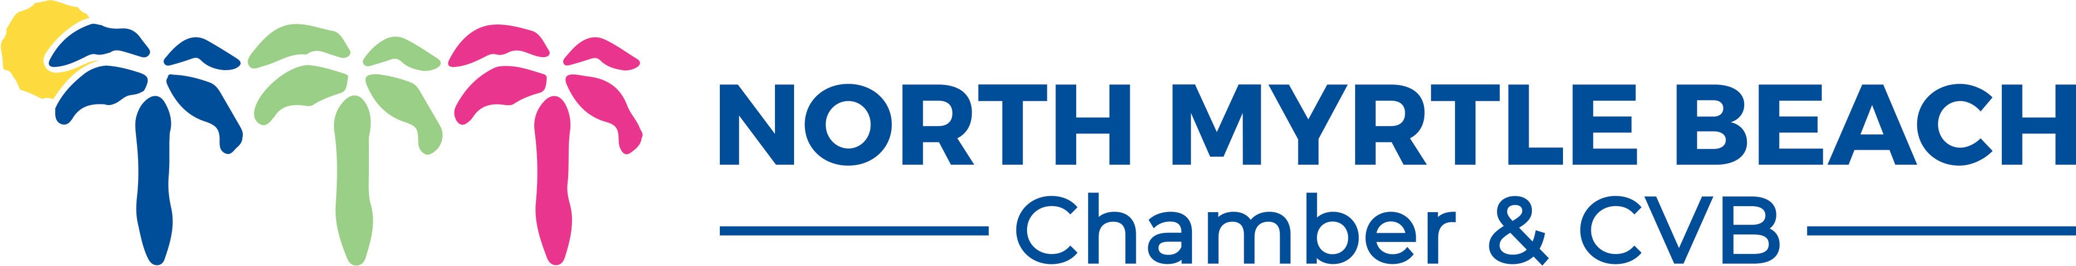
2019 Annual Report
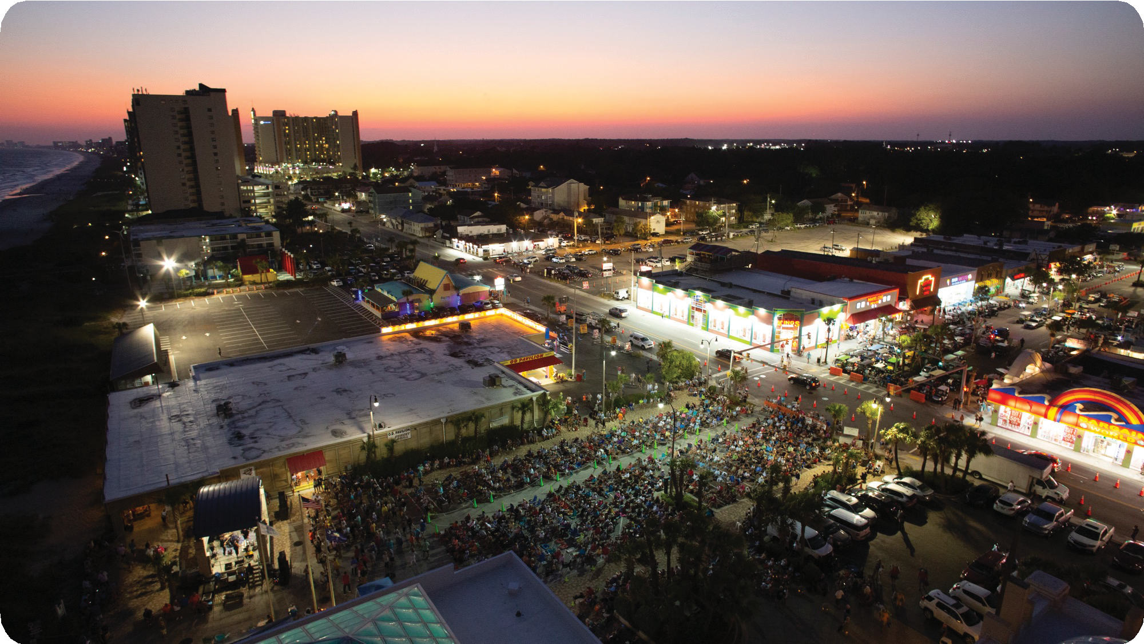

Looking back on fiscal year 2019 it was a year of transition and growth. We concentrated on our relationships in the community, region, and on our value proposition for our investor partners. We implemented changes, restructured some of our programs and deployed our team for the refined objectives. We completed these actions to be poised for the future.
The guiding principles for our organization were to:
- Grow the North Myrle Beach visitor and destination market
- Communicate our story
- Serve as the voice of business
- Focus on our customers
We utilized the tool DestinationNext and completed a community assessment that led our board’s strategic planning process. There were 135 participants in the completed survey through DestinationNext that afforded us the opportunity to explore our destination strength as well as community support and engagement. The findings from the assessment indicate that North Myrtle Beach is a trailblazer, we are headed in a positive direction with significant opportunities ahead. This information was then used for strategic align the feedback into the next steps.

We continued to conduct research in conjunction with Shannon Gray and Gray Research Solutions. We learned a great deal about the prospective visitors that used our ExploreNorthMyrtleBeach.com website and their demographic information as well as travel preferences. The analysis and partnership with the team at Crawford Strategy and Southern Tide Media ensured that our marketing initiatives were nimble and engaging the intended audience.

We were well served by our dynamic board members, committee participants, ambassadors, and professional staff. The countless hours of pro bono work contributed to the implementation, oversight,and program success was appreciated.

The highlights for the year are included within this annual report. As I sign off, I’d like to thank you for your engagement with us. The success of our organization is tied directly to your support through your time, dues investments, feedback, and participation.
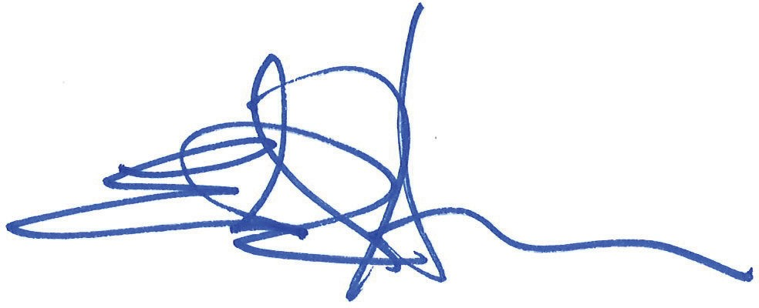
Sincerely,
2018-2019 Board of Directors

Ed Horton Board Chair
EXECUTIVE COMMITTEE:
Board Chair Ed Horton
Anderson Brothers Bank Immediate Past Chair Scott Ellis
RE/MAX Southern Shores
Treasurer Cyndee Colborn Seaside Vacations
Brandon Cox
Elliott Beach Rentals John Breeden South Atlantic Bank Jonathan Fussell Duplin Winery Mendel Bell
Touch MedSpa Stewart Brown CondoLux Vacation
Alex Husner Condo-World Andy Thomas Century 21 Thomas Callie Wise
State Farm Insurance
Ed W. Prince, III Cherry Grove Pier Marcia Hanscome Vacation Rentals
Monica Vehige McLeod Loris Seacoast Monroe Baldwin Myrtle Beach Tours Neil James
Santee Cooper
Phil Pate
Grand Strand Vacation
Ricky Martin
Martin Heat & Air

Secretary and President & CEO
Rentals & Golf Packages of North Myrtle Beach

Mission Statement
“To advance the prosperity of North Myrtle Beach.”
Cheryl Y. Kilday, CDME
North Myrtle Beach Chamber & CVB
BOARD MEMBERS:
Brent Groome
HTC
Matt Klugman
Vacation Myrtle Beach

Destination Marketing

Website Users and Sessions Website Users
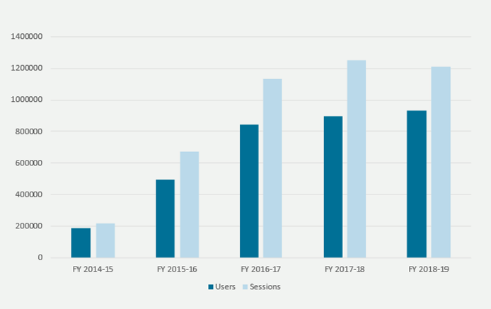
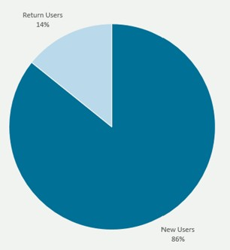
ExploreNorthMyrtleBeach.com attracted nearly 1 million unique visitors. More than 86% of users are new to the site.
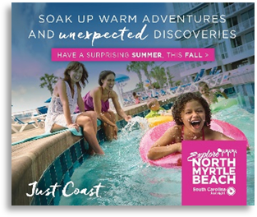
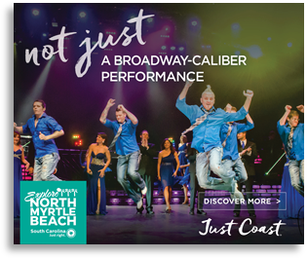
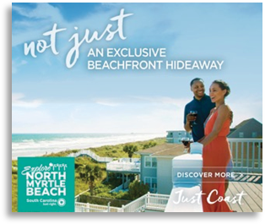
Advertising placements have been viewed by more than 45 million people this year and positions North Myrtle Beach as a collection of distinctive seaside communities.
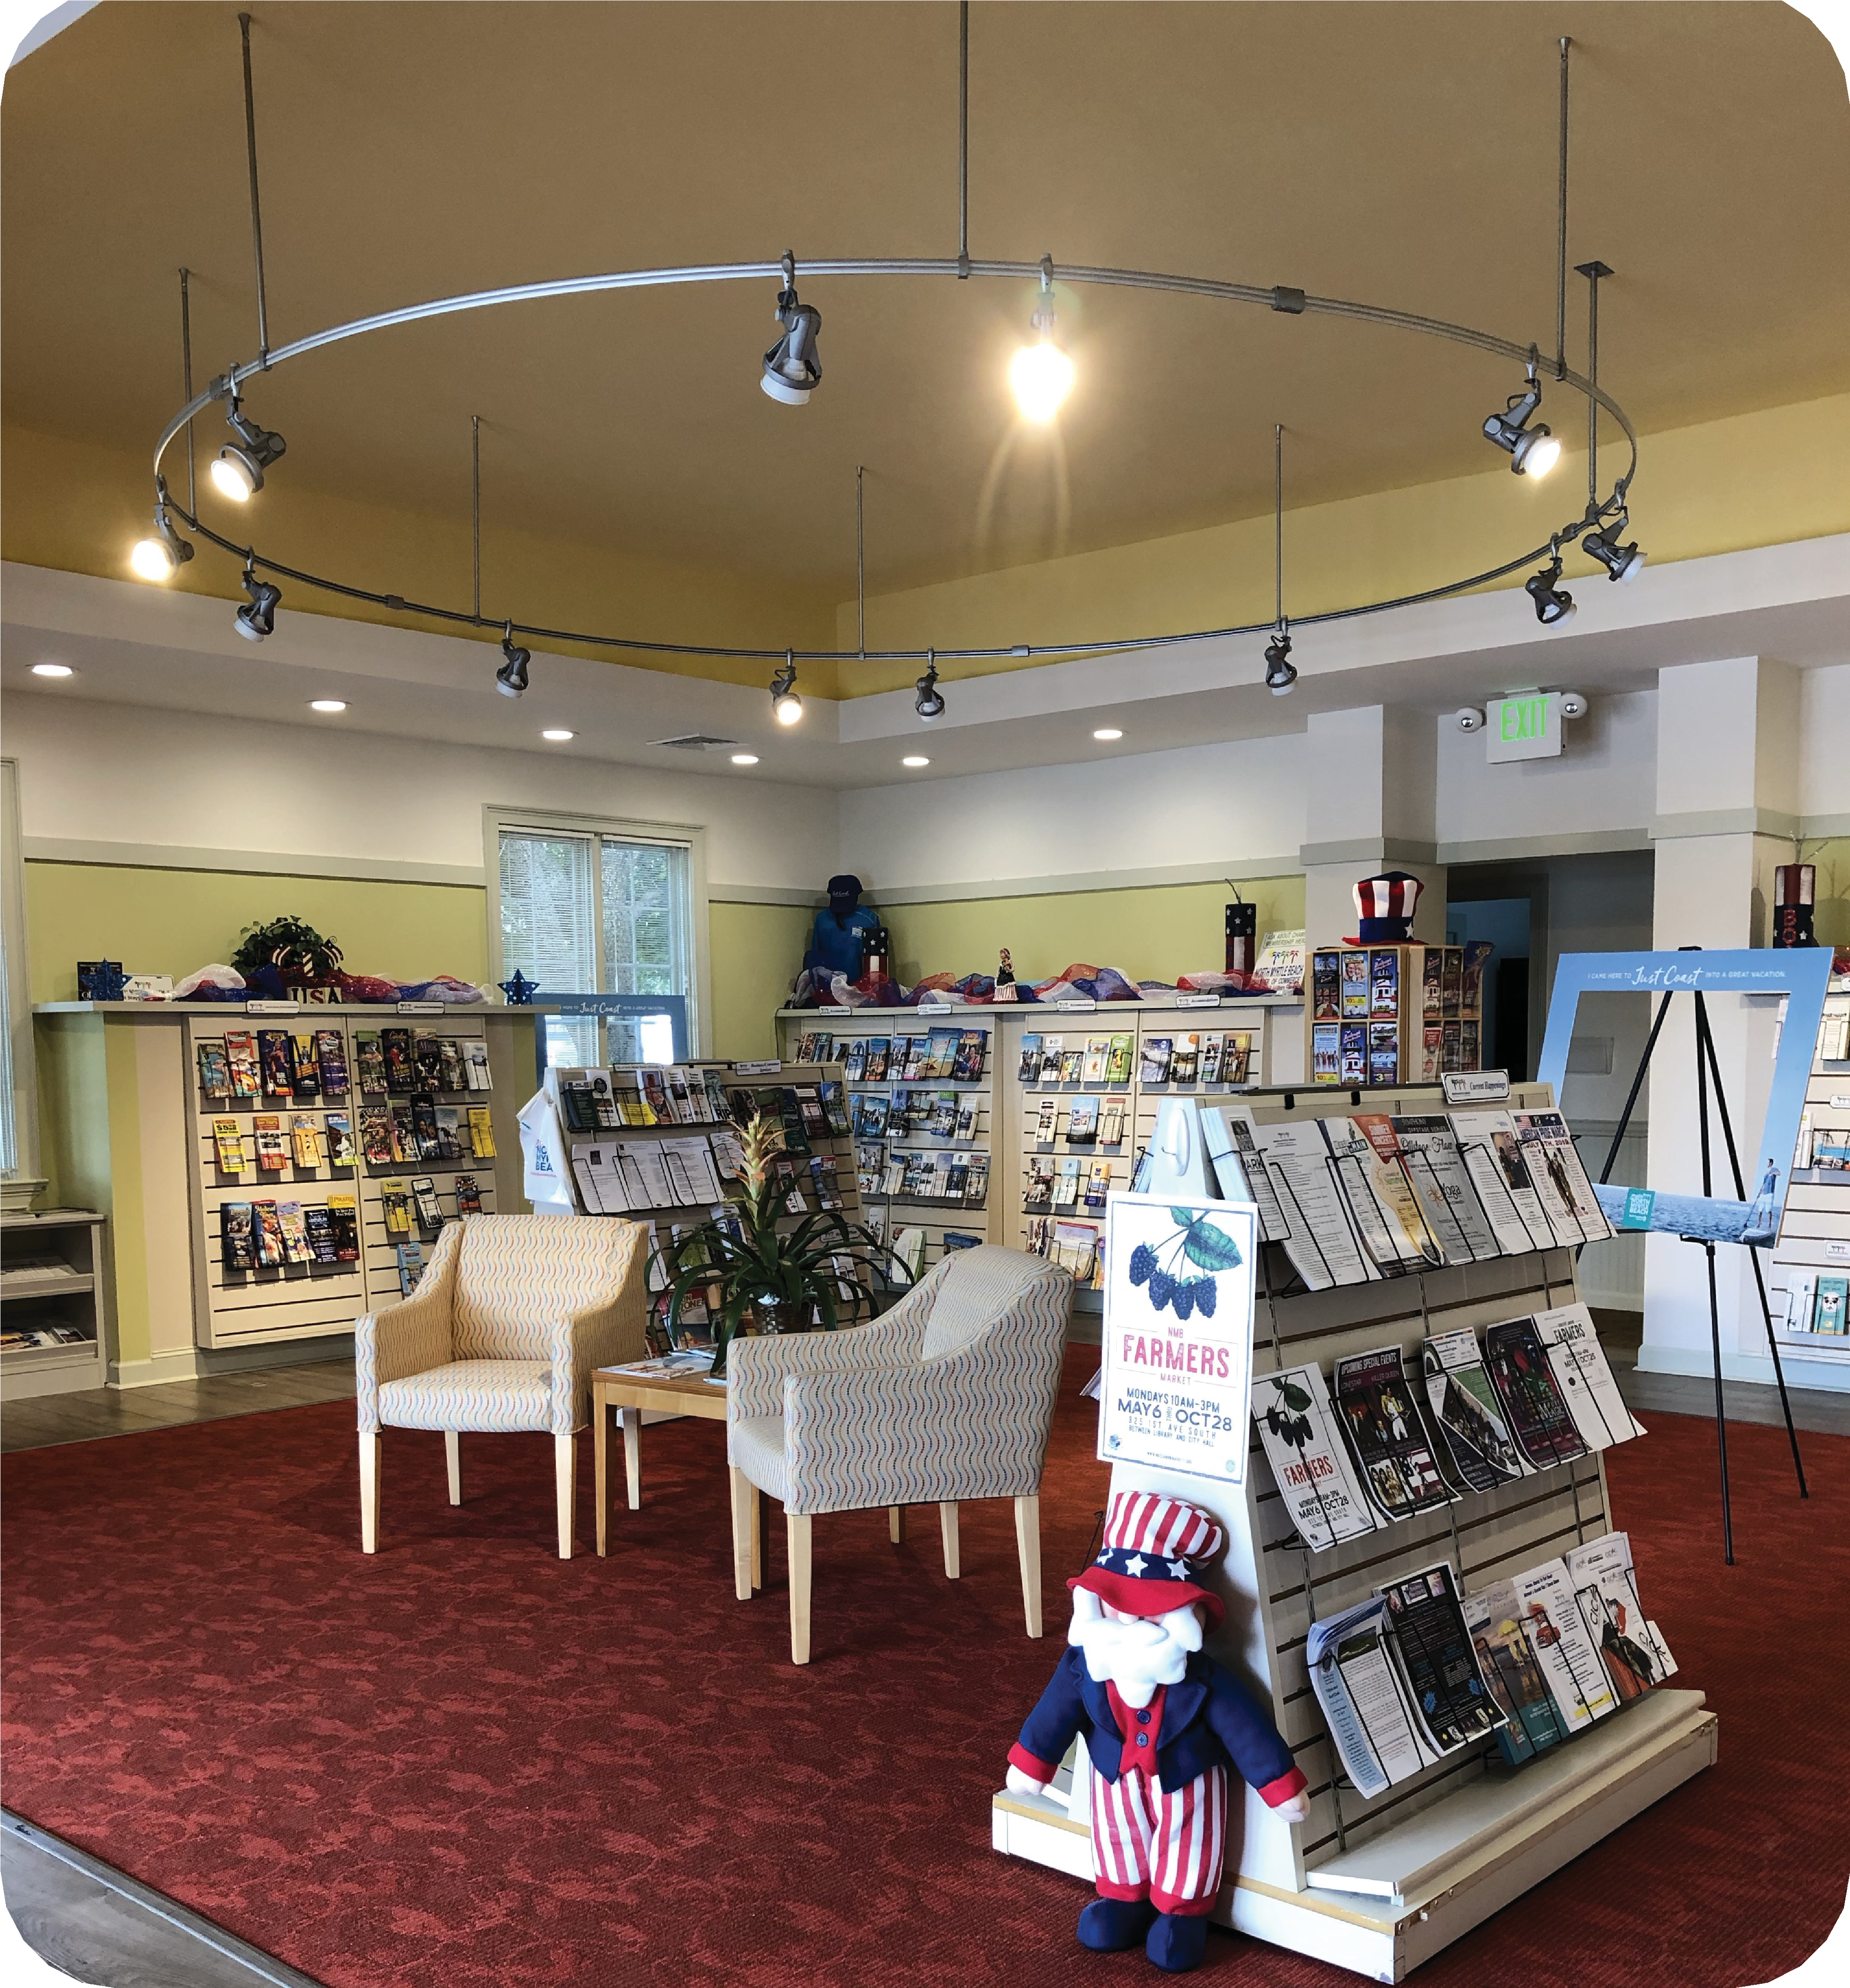
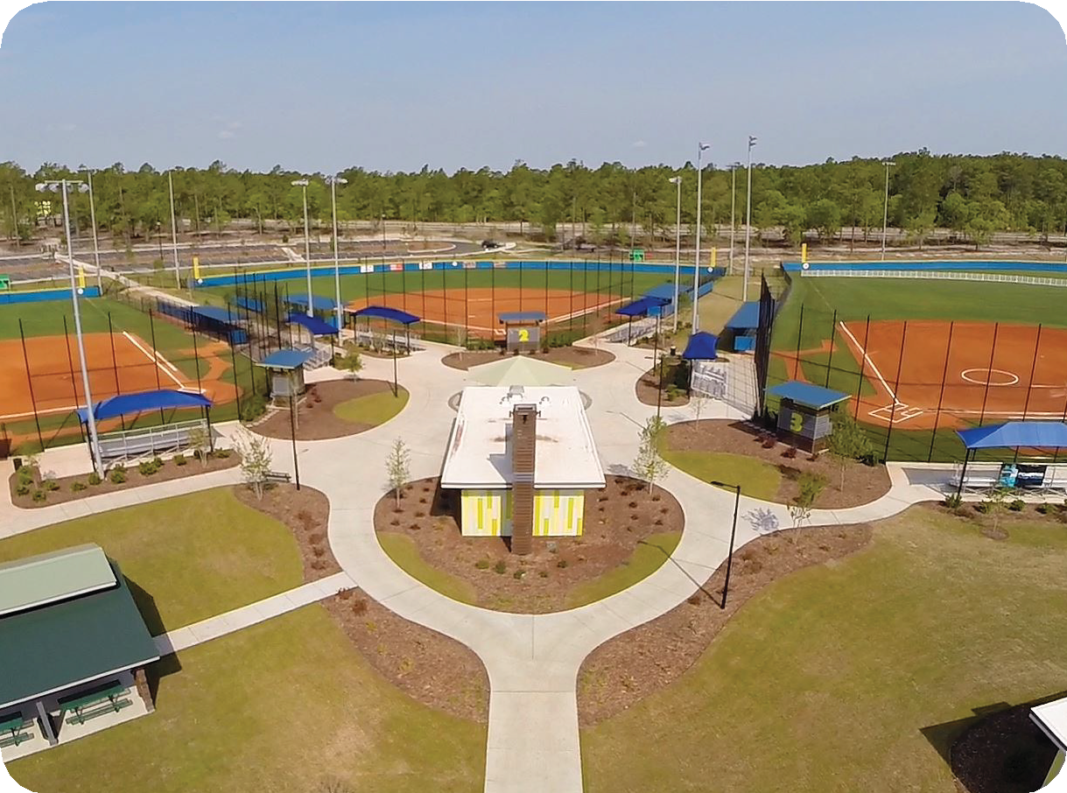

The Visitor Information Center Travel Counselors greeted 10, 938 visitors and made 74,957 business referrals.
Sports Tourism and Group Sales efforts generated 16 sports related leads for 17,880 overnight rooms and 19 group leads for weddings and reunions representing 1,666 room nights for a combined total of 35 leads and 19,546 room nights.

Government Affairs

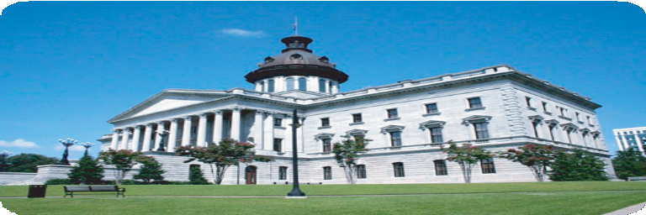

- We convened regular legislative calls while the South Carolina State Legislature was in session and had more than 500 call-ins to the conference calls.
- We had near perfect attendance at North Myrtle Beach City Council Meetings.
- Attended Horry County Council meetings at least once a month
- We worked in conjunction with city leaders for policy discussions, participated in parking policy, the ban on single use plastics, and other relevant business issues.

Member/Partner Programming
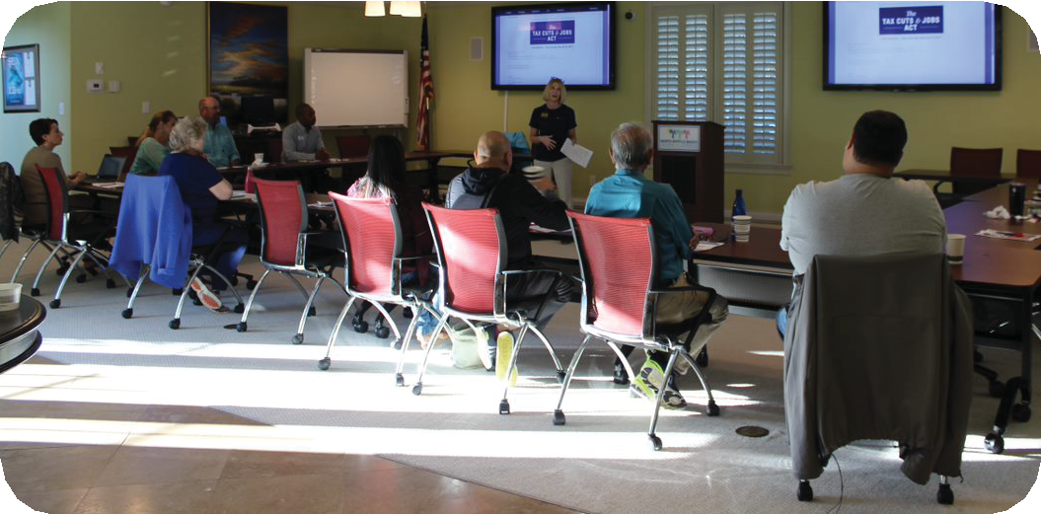
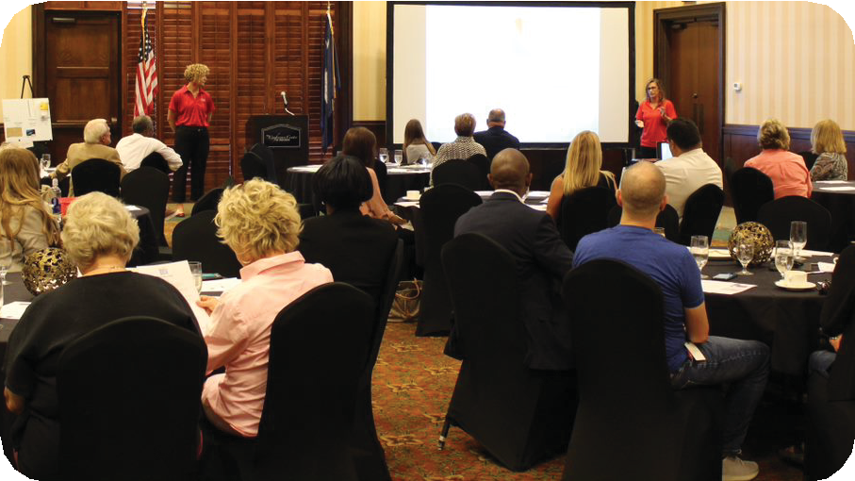
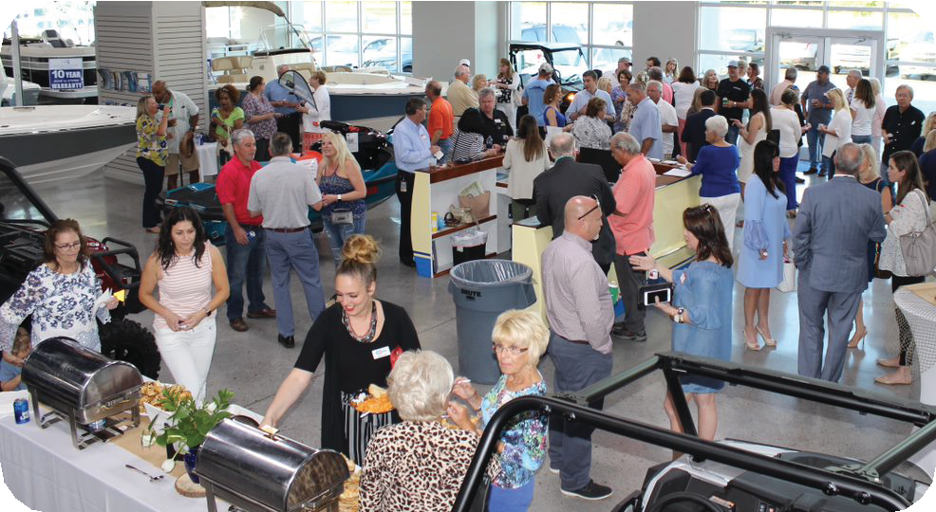

  - Membership numbers grew with 88 new members added this year
  - Our programs and business recognition have been covered through local media 43 times.
  - Our Chamber website, NorthMyrtleBeachChamber.com attracted more than 30,000 unique visitors where they find information about our community, Chamber members’ businesses, and resources they need.
- Membership retention hovered at 90%
- We’ve assisted our partners with media recognition and have received positive coverage 46 times on our members behalf.
- We provided programming 50+ times during the year

Monthly Business Recognition
Businesses were selected to be honored as Member of the Month – NMB Times, Duplin Winery, Barefoot
Landing, City of NMB, Carolina Dance Partners, Liberty Tax, Myrtle Beach Watersports, Sea Server, Z’s Amazing Kitchen
Legacy Business of the Month
Legacy Businesses were selected for recognition of being in business more than 25 years – Ocean Drive Barber Shop, Boulineau’s, Painter’s Ice Cream, Hoskins, Helen’s Style Center,
Cherry Grove Pier, RW Wood, Elliott, Waterway Furniture, Beachwood Golf

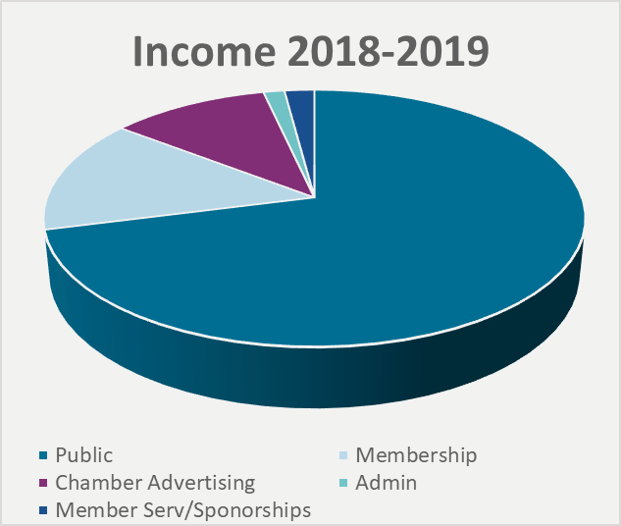
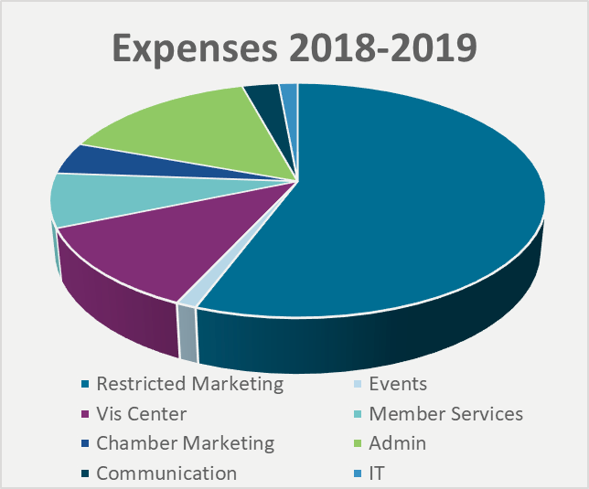
Finances

Visitor Profile & Economic Impact Research Snapshot of Findings
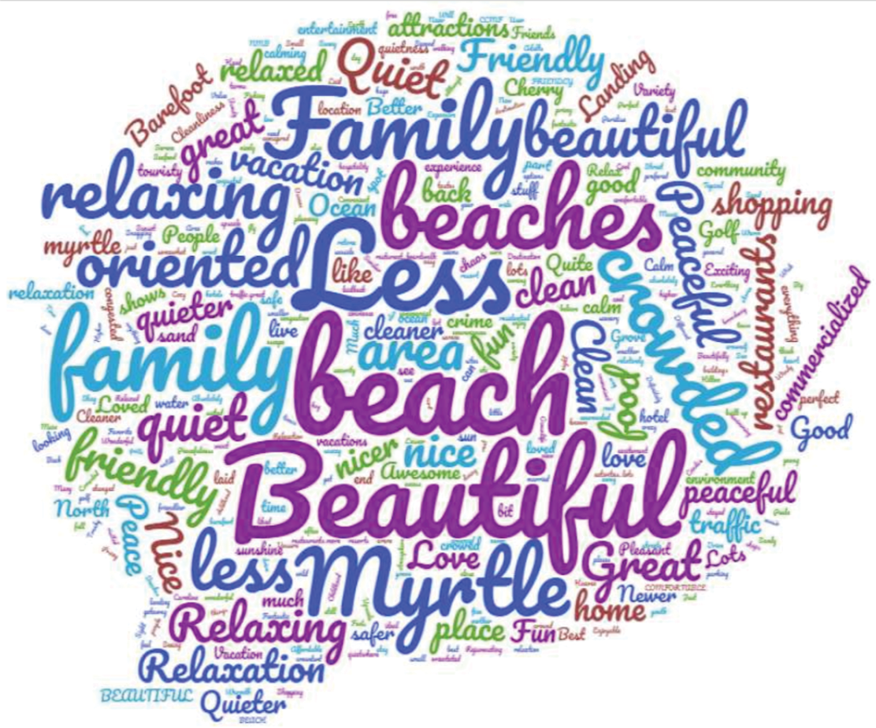
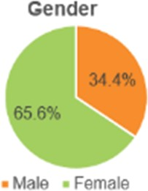
Word cloud of impressions of North Myrtle Beach.
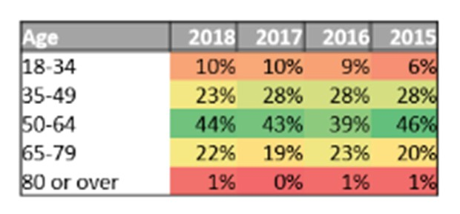
When visitors think about North Myrtle Beach, what comes to mind?

About 4 in 10 travel planning visitors are 50-64 years while 1 in 10 are 18-34.
Trip planning visitors tend to be female.
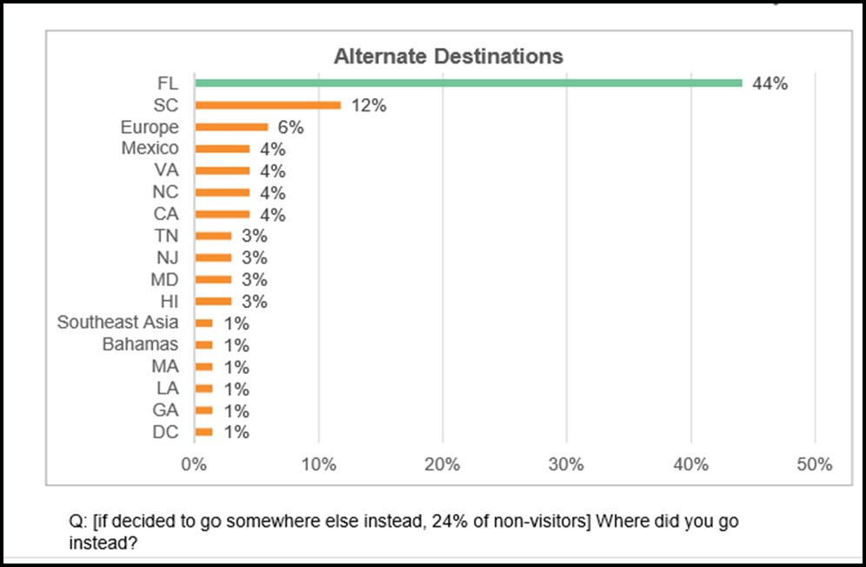

The biggest competitors to North Myrtle Beach are Florida, other destinations in South Carolina, Europe, and Mexico.

