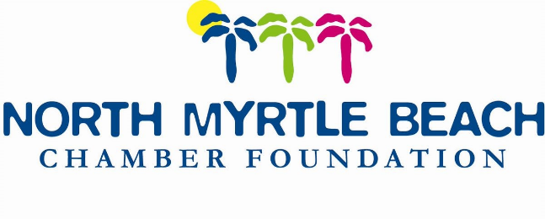
Community Grant Application

Complete the application form and submit with the proposal as outlined on the following page by January 10, 2022.

Grant Project/Program Title:

Grant Request: $

Purpose of the grant:

Organization Legal Name:

Contact Person Name/Title:

Address:

Email:

Direct Phone:

Has the organization previously received a grant from the NMB Chamber Foundation? If yes, please provide dates and project title?

Is this grant funding for general support or project support?

Total organization budget:

Total project/program budget:

Project/Program start and end dates:

PROPOSAL SUMMARY: one-half page, maximum.

Please summarize the purpose of your organization. Briefly explain why your organization is requesting this grant, what outcomes you hope to achieve, and how you will spend the funds if a grant is awarded.

NARRATIVE: two pages maximum.

Background - describe the work of your organization addressing each of the following:

A brief description of its history and mission.

The need or problem that your organization works to address, and the population your organization serves.

Current programs and accomplishments.

Funding Request - describe the program for which you seek funding.

If applying for general operating support, briefly describe how this grant would be used.

If your request is for a specific project, please explain the project including:

A statement of its primary purpose and the need or problem that you are seeking to address.

Anticipated length of the project.

How the project contributes to your organization’s overall mission.

Please send completed applications and a copy of your IRS 501(c)(3) status letter by January 10, 2022.

Cheryl Y. Kilday, CDME
North Myrtle Beach Chamber Foundation
1521 Highway 17 S
North Myrtle Beach, SC 29582
ckilday@DestinationNMB.com

