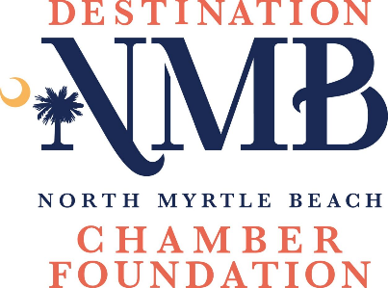

**Community Grant Application**

**Complete the application form and submit with the proposal as outlined on the following page.**

Grant Project/Program Title:

Grant Request: $

Purpose of the grant:

Organization Legal Name:

Contact Person Name/Title:

Address:

Email:

Direct Phone:

Has the organization previously received a grant from the NMB Chamber Foundation? If yes, please provide dates and project title?

Is this grant funding for general support or project support?

Total organization budget:

Total project/program budget:

Project/Program start and end dates:

# **PROPOSAL SUMMARY:** one-half page, maximum.

## Please summarize the purpose of your organization. Briefly explain why your organization is requesting this grant, what outcomes you hope to achieve, and how you will spend the funds if a grant is awarded.

# **NARRATIVE:** two pages maximum.

## **Background** - describe the work of your organization addressing each of the following:

### A brief description of its history and mission.

### The need or problem that your organization works to address, and the population your organization serves.

### Current programs and accomplishments.

## **Funding Request** - describe the program for which you seek funding.

### If applying for general operating support, briefly describe how this grant would be used.

### If your request is for a specific project, please explain the project including:

# A statement of its primary purpose and the need or problem that you are seeking to address.

# Anticipated length of the project.

# How the project contributes to your organization’s overall mission.

**Please send completed applications and a copy of your IRS 501(c)(3) status letter to:**

Cheryl Y. Kilday, CDME

North Myrtle Beach Chamber Foundation

1521 Highway 17 S

North Myrtle Beach, SC 29582

ckilday@DestinationNMB.com