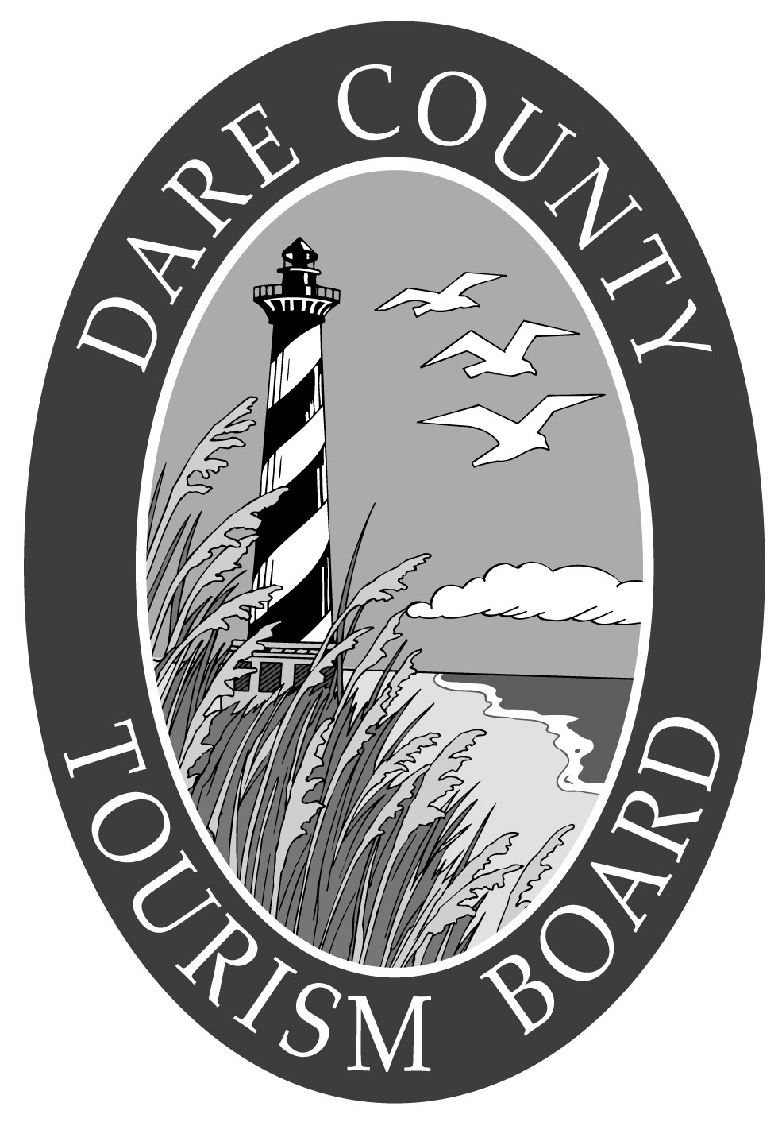
DARE COUNTY TOURISM BOARD
FIREWORKS PROJECT APPLICATION

Name and title of person making application: _________________________________________

Local Government name: _________________________________________________________

Non Profit entity name: ___________________________________________________________

If non-profit entity, you must enclose a copy of the written confirmation issued by the U.S. Internal Revenue Service conferring non-profit status under Section 501 of the U.S. Internal Revenue Code.

Principal place of business: ________________________________________________________

Address: ______________________________________________________________________

Phone number: _________________________________________________________________

1. Location of Proposed Firework Display:
______________________________________________________________________________

2. Project timetable (starting date and duration): ______________________________________________________________________________

3. Financial information (project total, and other sources of funding for this project). Engineering, surveying and other professional services, permits, overtime salaries, inkind services (ex. Administrative salaries of public employees) and any local, state or federal tax are not applicable.

________________________________________________________________________

________________________________________________________________________

________________________________________________________________________

________________________________________________________________________

4. Other information that may be helpful in considering the project (attach additional material as appropriate).______________________________________________

____________________________ ___________________________________
DATE SIGNATURE

