
The SoundSide
Site Rental Information

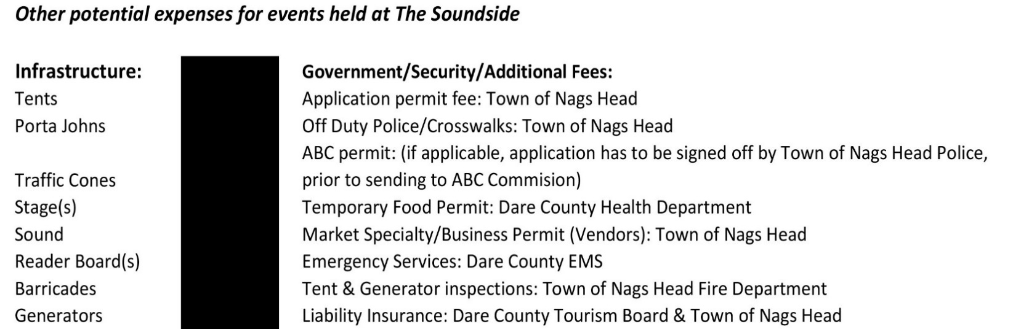

Event Name: Event Name Event Date(s): Event Date(s)
Type of Renter | Dare County Non-Profit | Dare County For-Profit | Outside of Dare County
Event Site Rental Rate (Per Day) | $750.00 | $1,800.00 | $2,600.00
Set up and Breakdown Days for the Event (per day) | $375.00 | $900.00 | $1300.00
Electrical Rates: all 220v & 50-amp poles on the site (per day) | $230.00 | $230.00 | $230.00
Electrical Rates: 100-amp box (per day) | $300.00 | $300.00 | $300.00
Wi-Fi at the Event Site: covers the entire length of the event (not per day) | $450.00 | $450.00 | $450.00
* Non-Profit Organizations (Dare County based) must submit proof of 501(c) status to receive above rate. *

** Any Site rental longer than 7 days will be negotiated with Outer Banks Visitors Bureau
Site Damage Deposits (Refundable after post-event walk through & landscaping test):
Under 500 = $500 per event |  | Over 500 = $1000 per event
The Outer Banks Visitors Bureau reserves the right to apply additional fees to the site security deposit for high-impact events.
Dairy Queen building & 23 parking spaces in front are for event organizer use only: not for event goers. Must be reserved in advance.
Pamlico Jack's and South Beach Grill parking lots are also available for off-site event parking, must be reserved in advance and indicated on your application.

CHECKLIST: Please read all guidelines, policies and rates. All forms are submitted to the Outer Banks Visitors Bureau.
Event Name: Event Name Event Date(s): Event Date(s)
No more than 1 year prior to your event, submit: | - Reservation application form with the $200 reservation fee. Make check payable to Outer Banks Visitors Bureau | Choose an item.
For tier 3 events with expected attendance of 750 or more, 90 Days prior to the Event, submit:  For tier 2 events with expected attendance between 250 and 749, 60 Days Prior to the Event, submit:  For tier 1 events with expected attendance less than 250, 30 Days Prior to the Event, submit: | - Final event permit form  - Crowd Gathering Activity Application fee to the Town of Nags Head (tier 3 is $300, tier 2 is $200, and tier 1 is $100)  - Final Site plan  - Final Parking plan  - Signed copy of the release and indemnity agreement for facility use  - Signed copy of the site guidelines, policies and rates  - NC ABC permit (will require ABC lease letter from Outer Banks Visitors Bureau)  Please note that Nags Head Town Code dictates application deadlines and late applications could result in denial of your permit from the Town. All items must be submitted to Outer Banks Visitors Bureau prior to the Town of Nags Head reviewing the permit application. Minor changes may be submitted for review up to 30 days prior. | Click here to enter a deadline. | Select Status
30 days Prior to the Event, submit: | - Remainder of the Site rental fee  - Site damage deposit  - Town of Nags Head Security Contract, signed and payment due (if applicable)  - Temporary Food Establishment Permit submitted to Dare County Health Department | Click here to enter a deadline. | Select Status
15 days Prior to the Event, submit: | - On-site Electricity request  - Final list of vendors and/or concessions and vendor number  - Proof of Certificate of Insurance for Public Liability  - Contact the businesses around the event site to let them know about your upcoming event | Click here to enter a deadline. | Select Status
3 Business Days Prior to the Event: | - Walk through Site with Outer Banks Visitors Bureau and Event Organizer representatives  - If applicable, pay any remaining permit fees due to the Town of Nags Head | Click here to enter a deadline. | Select Status
Day of Event | - Have all permits, licenses, etc. on hand at site. | Click here to enter a deadline. | Select Status
Post Event | - Walk through Site with Outer Banks Visitors Bureau and Event Organizer representatives  - Submit letter for refund of Site deposit | Click here to enter a deadline. | Select Status
The Outer Banks Visitors Bureau reserves the right to cancel the site reservation
if deadlines are missed by the Event Organizer

The SoundSide Event Site
Application Status
(OBVB & NH official use only)
Date
Status
6800 S. Croatan Hwy Nags Head, NC 27959
Event Application

- Event Info
  - Event Name: Event Name
  - Event Date(s): Event Date(s)
  - Event Time(s): Event Time(s)
  - Site Reservation Start & End Dates (Include move in and out dates): Site Reservation Dates
  - Estimated Total Attendance: Estimated TOTAL number of people to attend entire event
  - Estimated Peak Attendance: Estimated PEAK number of people at one time
  - Explain the Type of Event: Describe Event

- Event Contact
  - NonProfit Organization Name (if applicable, Non-Profit status letter required with application)
NonProfit Name
    - NonProfit EIN# EIN #
    - NonProfit Address: NonProfit Address
    - NonProfit Email: NonProfit Email
    - NonProfit Telephone: NonProfit Telephone
  - Event Organizer/Planner Name/Point of Contact (IF different from above named NonProfit):
Event Organizer Name
    - Event Organizer Address: Event Organizer Address
    - Event Organizer Email: Event Organizer Address
    - Event Organizer Telephone: Event Organizer Telephone
  - Name(s), email addresses, and cell/telephone number(s) of designated Crowd Control Manager, Point of Contact and any other representative(s) and responsibilities or titles, who will be responsible for maintaining contact with Town personnel throughout the event.

Name | Title or Role | Mobile number | Email
Name | Title or Role | Mobile number | Email
Name | Title or Role | Mobile number | Email
Name | Title or Role | Mobile number | Email

- Event Schedule
- Provide a full description/schedule for each day of your site reservation (can be tentative schedule).
Date | Times | Activity  i.e. Vendor set-up, Gates Open, Clean-Up etc. | Does activity require OBVB provided: |  | Is site open to General Public?
Date | Times | Activity  i.e. Vendor set-up, Gates Open, Clean-Up etc. | Electricity? | Wi-Fi? | Is site open to General Public?
Date | Times | Activity | ☐ 220V & 50amp  ☐ 100amp | WiFi | Public
Date | Times | Activity | ☐ 220V & 50amp  ☐ 100amp | WiFi | Public
Date | Times | Activity | ☐ 220V & 50amp  ☐ 100amp | WiFi | Public
Date | Times | Activity | ☐ 220V & 50amp  ☐ 100amp | WiFi | Public
Date | Times | Activity | ☐ 220V & 50amp  ☐ 100amp | WiFi | Public
Date | Times | Activity | ☐ 220V & 50amp  ☐ 100amp | WiFi | Public

- Event Details
  - List and describe all temporary structures. Town building Inspections will be required for generators and other temporary structures.
Describe temporary structures
  - Describe the use of electricity at the site.
Describe electricity needs & usage
  - List and describe any special hazards at this event. (i.e.: cooking-related fires, environmental emergencies). Include how you are managing these hazards with a list of relevant safety equipment that will be present at the event.
Describe special hazards & relevant safety measures
  - List the number and type of sanitation facilities that will be provided on site. The restrooms at the Harvey Estuarine Site are NOT available for use during any event held at the Soundside Event Site.
Describe sanitation facilities
  - Describe your process for collecting recyclables and solid waste. Event organizers/planners are responsible for securing a vendor for trash/recycle collection; the Town of Nags Head does not provide trash collection for events at the Soundside Event Site.
Describe solid waste & recycling plans
  - List all temporary signs to be displayed during the event. All signs shall be located within the boundaries of the event area and be directed internally. Signage shall be promptly removed once event is concluded. List temporary signage
  - Are you planning to have alcohol consumption during event: Yes or No
    - IF yes, please select alcohol type(s) to be served: ☐ ☐ ☐
    - IF yes, describe how alcohol beverages will be served at event. Describe how alcohol to be served
    - IF yes, a copy of the approved ABC permit:
☐ OR ☐
- Event Parking & Site Plan
  - Provide Information on designated parking areas and a traffic flow description on and off the event site. The Site can accommodate up to 1250 total guests with use of all OBVB lots and depending on layout of the event. Capacity is based on the peak attendance at one time during the event. Higher capacity is possible but will require a plan for off-site parking in addition to parking at the Site. If parking off-site, attach a letter from that property owner verifying how many excess parking spaces will be available for the event. Parking attendants are required for Miller’s Waterfront Restaurant and First Flight Adventure Park parking lots. (Event Organizers CANNOT use the Harvey Estuarine Site as part of their plans for parking or infrastructure)
Describe parking plan

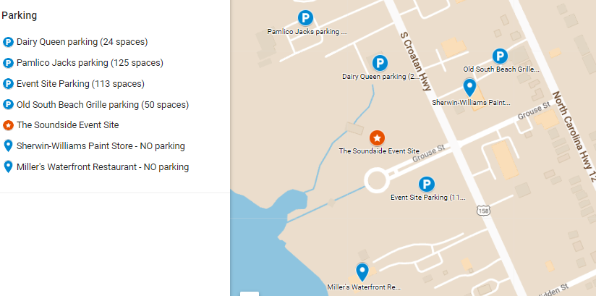
  - Check the box(es) below of the OBVB parking lots your event requires:
☐ Pamlico Jacks: (125 spaces) no parking allowed on the grassy areas due to the septic system; parking attendant needed; right turn only out of the parking lot.
☐ Dairy Queen: (24 spaces) located on the west side of the building, only available for event organizer or staff parking; all other spaces are reserved for First Flight Adventure Park.
☐ South Beach Grille lot: (50 spaces) only available for staff, volunteer or vendor parking. No public or event parking.

Name of Event organizer agrees to hold harmless the Outer Banks Visitors Bureau for any damage to vehicles or liability related to the vehicles being on the property. The Outer Banks Visitors Bureau accepts no responsibility for liability, loss, damage, or theft of equipment or property on the lots.

Name of Event organizer shall be responsible for any damage done to the lots or building due to their negligence while using the lot(s).

Name of Event organizer agrees that the vehicles are parking at their own risk.
  - Include the following elements on the event map (Tip: Choose “INSERT” tab, then “Shapes” to select lines, boxes, symbols, etc. to create your event layout on the below map.)
    - Boundaries of main event area within entire Site
    - Participant activity areas and access points (crowd flow)
    - Number and location of concessions, stages, or other event activity areas
    - Parking locations, estimated capacity and traffic circulation
    - Location of medical services if needed
    - Location and number of trash and recycling receptacles
    - Location and number of sanitary facilities
    - Size and location of tents or canopies
    - Location and number of generators or electric poles to be rented
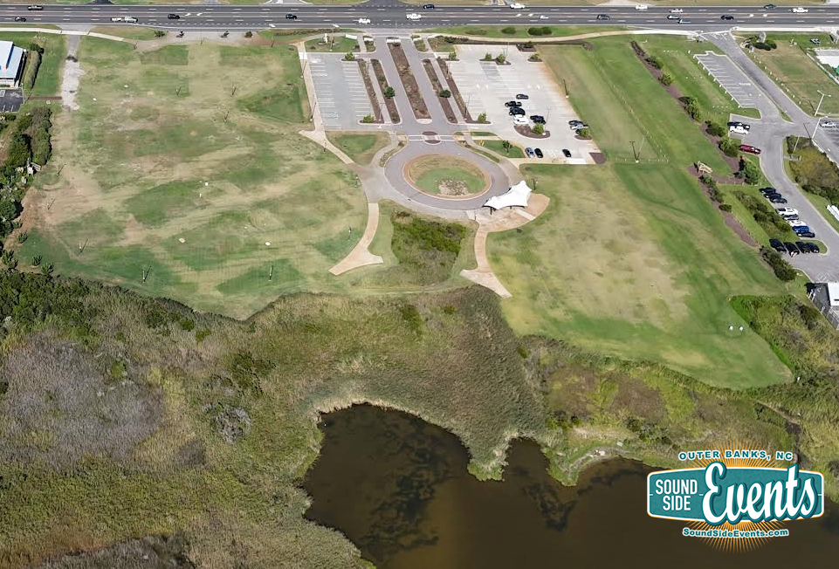
    - Please show your emergency exits on your event map

  - Comments

- Event Vendors
  - List all vendors and concessions. Applicants must purchase a vendor license (also called Specialty Market Permit) prior to operating concessions or provide proof that participating vendors already have a vendor license with Nags Head.
List vendors & concessions
- Event Safety & Communications
  - What are your plans for emergency medical services and first aid?
Describe Emergency Services & First Aid plan
  - How will you broadcast emergency information to your vendors and event attendees, both before and during your event?
Describe Emergency Communications
  - How are you planning to monitor weather conditions and what will be your protocol for a weather-related event cancellation?
Describe Weather Monitoring & Protocol
  - Describe use of parking and event staff or other personnel regarding crowd and traffic control. Please indicate if private security will be on site and if off-duty police officers are needed.
Describe Crowd & Traffic Control
  - How do you plan to ensure emergency vehicle access at the event?
Describe Emergency Vehicle Access Plan
  - If an evacuation of the site is not possible due to an emergency situation (i.e.: weather), what is your plan to shelter in place?
Describe Shelter in Place Plan

___
I have read the Soundside Event Site guidelines and completed this application and ensure that our group will comply with regulations, policies and fee schedule governing the use of the event site.

X Signature, Authorized Event Organizer Application Date
Signature, Authorized Event Organizer Application Date

Town of Nags Head – Dare County Tourism Board

(dba Outer Banks Visitors Bureau)

Release and Indemnity Agreement for Facility Use

WHEREAS, the undersigned has requested the use of The Soundside event Site owned or operated by the Town of Nags Head and the Dare County Tourism Board (the “Owners”), located at 6800 S. Croatan Hwy. Nags Head, NC and do engage in activities for the exclusive benefit of the undersigned.

NOW, THEREFORE, In consideration of the mutual promises or other good and valuable consideration, the undersigned does hereby for himself/herself, his/her heirs, executor, employers, successors, of himself/herself or of his/her employees, administrators, and personal representatives, I/We/The Event Organizer), Name of Event organizer understand and agree to the following:

The Owners shall not be liable for any damage to property or person by reason of the Event Organizers use or occupancy of the Premises and the Event Organizer agrees to save the Owners harmless from and against all claims, suits, demands, actions, and the cost and expense thereof, including attorney’s fees, arising out of any property damage or personal injury occurring as a result of applicant’s use of the Premises. *The Event Organizer further specifically agrees that it will procure and keep in full force at its expenses, Commercial Liability Insurance in an amount not less than $1,000,000.00 per occurrence, which policy or policies of insurance shall show the Owners as additional insured. Event Organizer will cause a certificate of insurance to be furnished to the Owners evidencing such coverage and said policy shall provide that said insurance may not be cancelled without written notice to the Owners at least thirty (30) days prior to any cancellation.

I/We/The (Event Organizer, Name of Event organizer hereby declare that the terms of this Release and Indemnity Agreement have been fully read and understood by me, and freely and voluntarily entered into and accepted by me, and I hereby acknowledge that I have read and understand this agreement. This agreement shall be in full force and effect any time after the execution thereof.

X Name of Event organizer X Signature, Authorized Event Organizer
Name, Authorized Event Organizer Signature, Authorized Event Organizer

*If Event Organizer is renting as an individual, the commercial liability insurance is not required. It is understood that the individual’s homeowner’s policy may apply. Please consult with your insurance agent or carrier. This statement does not act as a waiver of any of the other conditions of paragraph 3 cited above. If the individual renter has an organization, commercial entity or other recognized entity providing any assistance or services then that entity or organization is required to carry commercial general liability insurance with the specified limits and is required to provide the Town of Nags Head and Dare County Tourism Board with a certificate of insurance as noted above.
THIS PAGE MUST BE SUBMITTED WITH THE FULL APPLICATION

FOR TOWN USE ONLY
Comments or restrictions imposed by Police, Fire, Zoning, Health Department or Other: Click here to enter all comments or restrictions here.

APPROVED BY:
Outer Banks Visitors Bureau, Executive Director:
Click here to enter electronic signature.

DATE: Click here to enter a date.

COMMENTS: Click here to enter comments.
APPROVED BY:
Planning & Development Director: Click here to enter electronic signature.
Date: Click here to enter a date.

Comments: Click here to enter comments.

Fire Chief: Click here to enter electronic signature.
Date: Click here to enter a date.

Comments: Click here to enter comments.

Police Chief: Click here to enter electronic signature.
Date: Click here to enter a date.

Comments: Click here to enter comments.

Public Works Director: Click here to enter electronic signature.
Date: Click here to enter a date.

Comments: Click here to enter comments.

Chief Building Inspector: Click here to enter electronic signature.
Date: Click here to enter a date.

Comments: Click here to enter comments.

Town Manager: Click here to enter electronic signature.
Date: Click here to enter a date.

Comments: Click here to enter comments.

The office of the Town Manager, PO Box 99, 5401 S. Croatan Hwy, Nags Head, NC 27959; 252.441.5508

