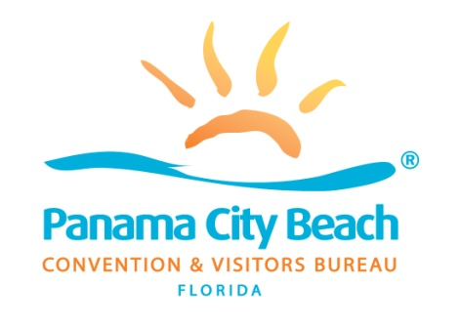

1. **CALL MEETING TO ORDER**
2. **ROLL CALL**
3. Invocation
4. Pledge of Allegiance
5. **REQUESTS TO ADDRESS THE BOARD ON AGENDA ITEMS (3 Minutes)**
6. **ACTION ITEM**
   1. Discuss and consider for approval entering into an agreement with Sports Facilities Companies to serve a Lessee Representative for the Panama City Beach Sports & Events Center, Mr. Dan Rowe
7. **AUDIENCE PARTICIPATION**
8. **ADJOURNMENT**

**NOTE: The meeting location is in the CVB OFFICES LOCATED AT 17001 PANAMA CITY BEACH PARKWAY and not the usual location of Beach City Hall.**

AGENDA

SPECIAL CALLED BOARD MEETING

Panama City Beach Convention & Visitors Bureau, Inc.

Panama City Beach

Friday, March 18, 2022 08:45 a.m. Panama City Beach Visitor’s Center Conf Rm