PALM BEACH INTERNATIONAL AIRPORT

2020 FIRST QUARTER UPCOMING PROJECTS WORKSHOP

*****January 22, 2020*****

**Start 2020 out right!**

**Receive project information directly from PBI Staff!**

**Learn how to bid on airport projects!**

**Meet current Prime Contractors and Consultants!**

**2:00 PM - 5:00 PM**

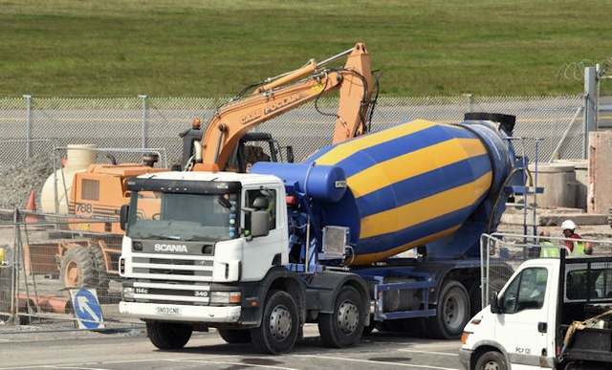



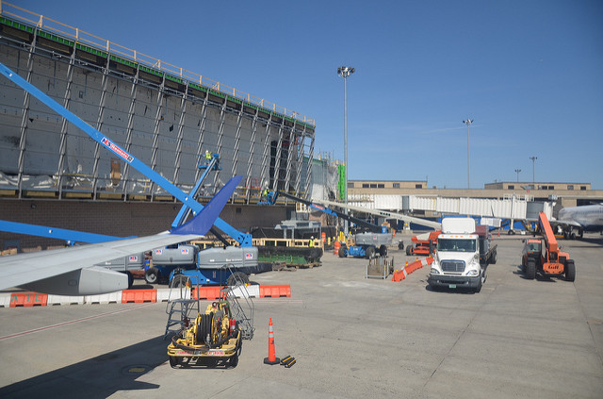

**Location:** DOA Conference Room

846 Palm Beach International Airport

West Palm Beach, FL 33406

Sponsored by  and 

Please RSVP to Lorraine Gassett at [lorrainegassett29@gmail.com](mailto:lorrainegassett29@gmail.com) or (954) 854-1894