PALM BEACH INTERNATIONAL AIRPORT

DBE/ACDBE application

assistance worKSHOP

FEBRUARY 26, 2020
1:00 PM - 5:00 PM

Get Assistance with your DBE/ACDBE Application!

Get the FACTS about the importance of being certified!

Bring your supporting documents to be reviewed!

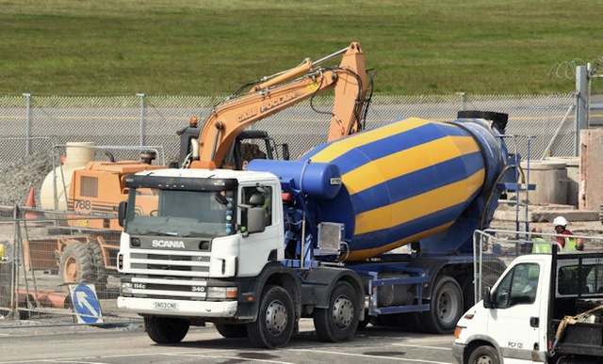

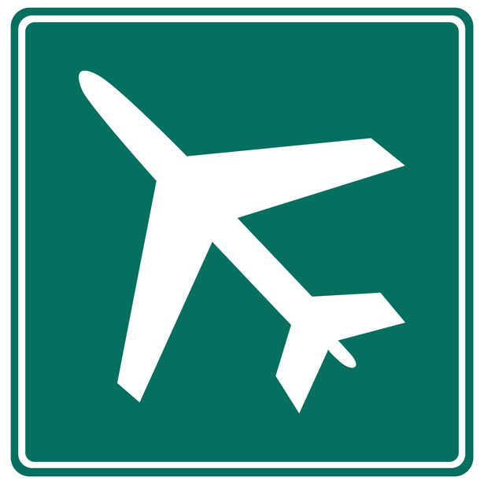

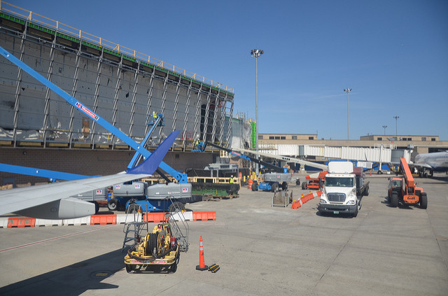

Location: DOA Conference Room
846 Palm Beach International Airport
West Palm Beach, FL 33406

Sponsored by and

Please RSVP to Lorraine Gassett at lorrainegassett29@gmail.com or (954) 854-1894

