PBIA 4th quarter UPCOMING PROJECTS WORKSHOP

October 9, 2019 3:00 Pm – 5:00 PM

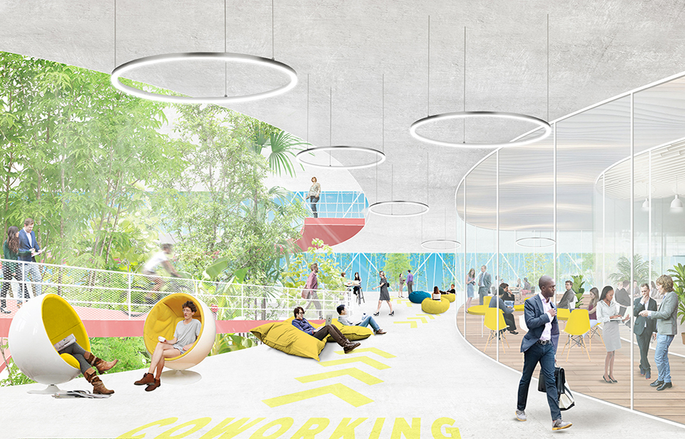

Get ready for 2020!

Be the first to know about upcoming projects at the Department of Airports!

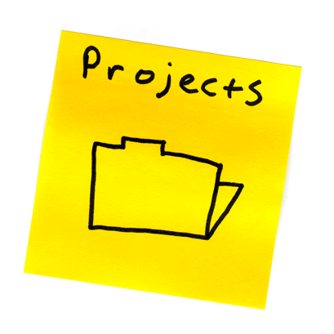
Location
DOA Conference Room
846 Palm Beach International Airport
West Palm Beach, FL 33406

Directions

Take I-95 to Belvedere Road Exit
Travel West on Belvedere to 8th Street
Take left (south) on 8th Street
Bldg 846 entrance is on the left-hand side (3rd left)
adjacent to the commuter apron.
Note: There is no vehicular access from the terminal roadway into the facility; all vehicular traffic must enter from 8th street.
Sponsored by and

Please RSVP to Lorraine Gassett at lorrainegassett29@gmail.com or (954) 854-1894

