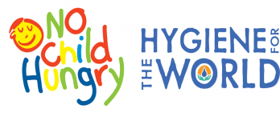

WHO WE ARE
No Child Hungry seeks to overcome childhood hunger through events held with corporate and community groups who collect, pack, and provide nutritional meals to hungry children, families, and those who care for them. Similarly, Hygiene for the World aims to prevent the spread of disease through events with corporate and community groups who pack and provide hygiene products to those in need. Through these two programs we organize a variety of events to promote our missions.

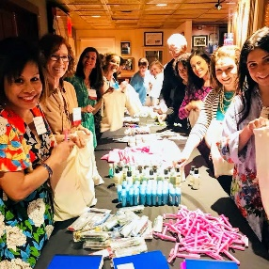
We love to work with groups of all sizes and ages who are looking to give-back to their communities. We seek to create memorable, team building events by making everything turn-key and having staff at each event.

(SOME OF) WHAT WE DO
1. Hygiene Kits- 3 different sizes - The kits most often go to veterans. They include all new items with our partner Hand in Hand Soap (available in Whole Foods, Kroger, Target, Bloomingdales, Wegmans).
*Sometimes, this activity will include the decorating of the cloth pouch the hygiene items go in. This expands the activity beyond just packing.

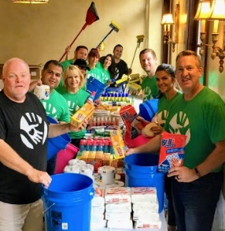
2. Comfort Kit - these are kits with 22 items used in a variety of settings, i.e. your staff stands around the room with the items, clients or potential clients have to go around the room to get the items and have to meet your staff in the process. This helps connect the people you want to connect. Usually light food items or deserts and drinks are also available.

*Comfort kits are designed to be given to facilities that house women rescued from trafficking, but can be customized for other causes.

3. Rescue Buckets - used after a disaster. School backpacks. Sometimes these are for school supplies, but many times we decorate the backpacks and fill them with items for children at a children's hospital. The contents are usually from a list provided by the hospital.

4. Stop Hunger Bags - this is like a hygiene kit build only with food items. These are usually distributed to shelters etc.
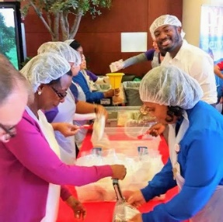
5. No Child Hungry Meal-Packing - Our most popular event! These are high energy events and provide dynamics we can't create in any other activity. Meal-packing includes teams of 12 working side by side to pack nutritious meals that are then distributed to the place of your groups choice. Usually 50% stay local and 50% go international. Competition develops between the lines as cheers are yelled out by every line after completion of each box of meals.

*In all of these activities, we provide everything you need except people and tables.

For more information on our events contact us at:
cayla@myneighborschildren.org or 678-674-7488

