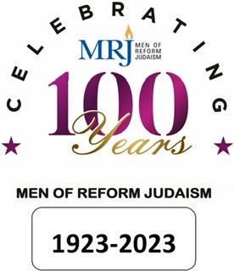
HONORING OUR PAST – LIVING IN THE PRESENT – FORGING OUR FUTURE

CENTENNIAL AWARDS

J. Jacques Stone Award - presented in recognition of outstanding service to the Temple Community. An activity performed or organized by your Brotherhood to help support your temple.

Milton E. Harris Award - presented in honor of outstanding service to the local community. Perhaps a fun event for more than just the Temple or helping those in need.

J. Robert Arkbush Award - presented in recognition of outstanding social action/interfaith programming. Organized by your Brotherhood, to bring about better understanding of other faiths within your Temple; or to educate other faiths and better relationships within the Jewish Community.

Jerome Siegel Award - in recognition of outstanding Men's Only Programming. A program organized by your Brotherhood for Men Only. This program should be about better communication and bonding of men, not just a program that excludes women.

Morton Kemper Intergenerational Award - in recognition of outstanding intergenerational Achim corps programming. A program that promotes interaction, communication, bonding and learning between various generations and ages of participants.

Dr. Alan Gardner Award - in recognition of outstanding youth, teen or college programming.
A program to help, support and educate the younger members of the Temple Community, or the Community in general.

Irving Richman Award - in recognition of outstanding Adult Jewish Educational Programming. A program organized to support Adult Jewish Education.

Stuart Aaronson Award - in recognition of Outstanding General Programming.
Any program organized by your Brotherhood that would not fit into any of the above
categories.

AWARDS ARE PRESENTED TO
Congregations under 500 Members - Congregations over 500 Members
Our goal to award as many as possible, therefore you may apply in more than one category.
SUBMISSIONS MUST BE RECEIVED BY 5/1/23 – VIA EMAIL TO: andych8@aol.com

