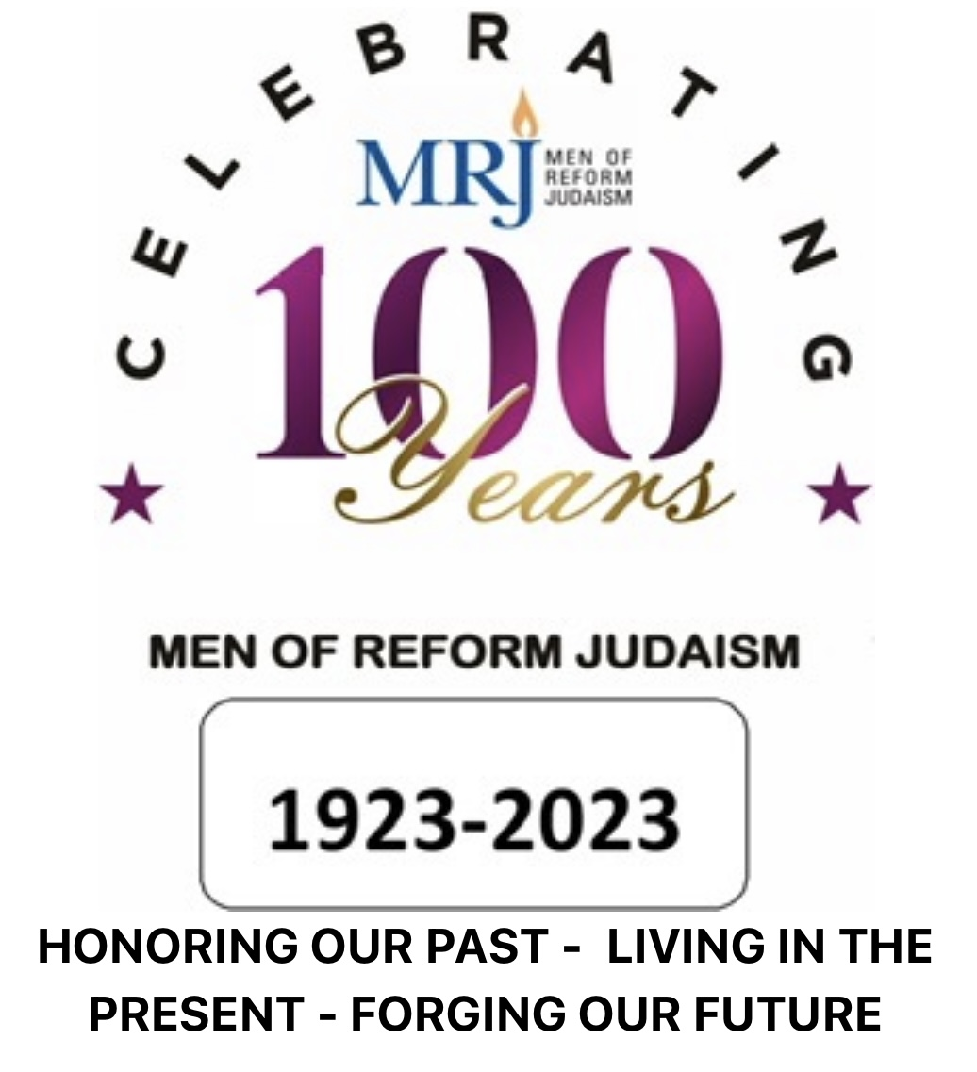
AWARD APPLICATION

Name of Brotherhood _________________________

Name of Temple ________________________

Size of Temple <500 members ____ >500 members ____

Address ________________________

Person Submitting Application _______________________

Email _______________________

Phone # _______________________

President _______________________ Vice-President ____________________

All URJ-affiliated Reform Temple Brotherhoods are welcome to submit an application for awards for their outstanding programs over the two-year period prior to the Centennial. Awards are judged by a panel of MRJ members and are presented at the Centennial. Multiple awards or no awards may be given in a category based on the judge's discretion and the number of qualifying entries.

We are looking for any activity or program you are particularly proud of, new and unique ideas, innovative ways of doing an established activity or even just how you are doing it bigger and better. Successful programs are not only about raising money or large attendance but more about innovation and execution. Brag and share with your fellow clubs.

Please submit a separate page for each award being applied for and write the name of the award and the Temple name at the top of each page.

For each program you are submitting, please provide the following as appropriate.

Number of Attendees

Gross Cost to Run

Profit (Loss) if intended as a fundraiser

General description of the event

Additional Background

Any feedback from attendees

Would you run this program again – why or why not

Any photos you may have (photos may be used for promotional purposes)

ALL SUBMISSIONS ARE DUE BY MAY 1, 2023
VIA EMAIL TO: andych8@aol.com

