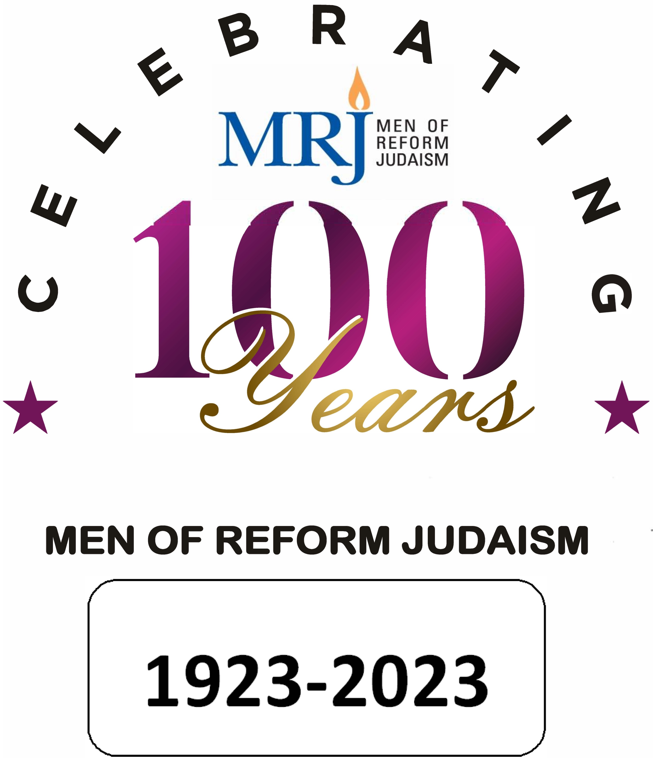
PROVIDENCE, RHODE ISLAND
June 23 -25, 2023

Thursday 6/23 at “The Graduate”
7 – 11PM meet and greet at hotel bar

Friday 6/24
Breakfast on your own
9:00am – Bus departs to Temple Beth-El
9:30am – President’s welcome
10:00am – Program: History: Indigenous Peoples. “Landback Movement” Guest Speaker Silvermoon LaRose, Assistant Director Tomaquaq Museum
11:00am – Program: "American Irony: Religious Freedom & Slavery in Colonial Newport." Guest Speaker Keith Stokes
12:00 noon lunch –
1:30pm Implicit Bias – (Newpoint Strategies)
Breaktime 2:30 – 2:45
2:45pm implicit bias second session
3:45pm Bus to hotel
5:15pm Bus return to TBE
5:45pm dinner at TBE
7:00pm Shabbat services, Keynote: Rabbi Rick Jacobs, President, Union for Reform Judaism
9:00pm vans return to hotel (or post-oneg)

Saturday
Breakfast on your own
9:00am Bus to TBE
9:30am Torah study
10:30am Shabbat morning services with congregation and Bar Mitzvah family
12:00 noon lunch – Greetings and Proclamations with Rhode Island Governor Daniel McKee, Providence Mayor Brett Smiley, Sam Zurier on behalf of the RI Senate and Steve Howitt on behalf of the Mass. House.
1:00pm Presentation and Question & Answer session with Congressman Cicilline (The Congressman recently announced he will retire from Congress in June 2023) https://cicilline.house.gov/press-release/cicilline-to-lead-rhode-island-foundation
2:00pm Awards presentation
3:00pm Past-President’s panel/history
4:30pm forum – What can we do for you? What do you need from us?
5:15pm Bus to hotel
7:00pm Saturday Evening dinner and Havdalah at the University Club
9:30pm return to hotel/home

Sunday
At “The Graduate” Hotel
8:00am Breakfast at hotel
9:00am business session finance/budget
Election of Officers
All are welcome - (only Executive Council members may vote)

*Speakers and programs are subject to change without notice

