Deliciously Decadent Delights – Prince William & Loudoun, VA
Day 1
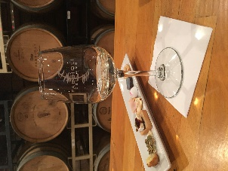
Tempt your taste buds with your first stop at Roots 657, a café and local market located at the corner of Route 657 and Route 15 just south of the village of Lucketts. Enjoy a Chef Tasting with small bites of Chef Rich Rosendale’s specialties. Peruse the market, filled with candles, pottery, soaps, condiments, foods, wine, and beer, a selection curated from Chef Rosendale’s local and world travels.
Fabbioli Cellars
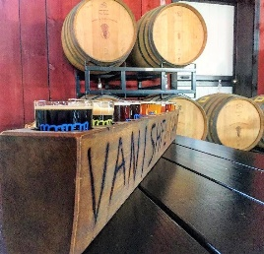
Next, take a short drive to Fabbioli Cellars for small bites with wine pairings as you enjoy the view from the tasting room, overlooking the 25 acres of vines. Be greeted by the aroma of fresh baked baguettes when you enter the tasting room and be delighted by the tree in the center of the building, with crystals dripping from its branches. After sampling some of Fabbioli’s fine wines, visit their wine shop on the main floor to browse their wide selection of fine wines. You’ll even find a few named after their beloved cat.
Vanish Brewery
Vanish Brewery isn’t just known for their beers. When you approach the 53-acre Black Hops Farm in Lucketts, VA, you’ll be welcomed by the mouthwatering scent of smoked barbeque and wood fired pizza. Sip some of their more than 20 beers on tap while you enjoy scenic views from their outdoor seating, or chat with the bartender in taproom.
Finish the evening with a meal you can experience at Chefscape Kitchen. With their state-of-the-art culinary kitchen and partnerships with producers throughout the county, you’ll experience a cooking lesson that turns into dinner. Learn to make fresh pasta or create a unique dish to enjoy.
Day Two
Loudoun has a rich history rooted in a tradition of agriculture. Visit the Loudoun Farm Heritage Museum to travel through Loudoun’s past and consider its future as D.C.’s Wine Country grows and evolves. Learn about Loudoun’s first inhabitants as you study Native American artifacts, interact with the Tic-Tack Horse Shack exhibit to learn about Loudoun’s vibrant equestrian history, and explore their many interactive exhibits that showcase how agriculture has grown in Loudoun as you learn where your food came from.
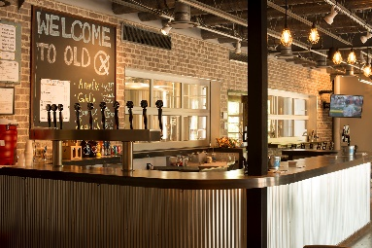
One of more than 30 breweries along the LoCo Ale Trail, Old Ox Brewery is the place to go and hang out with friends. Named for one of the oldest roads in Loudoun County that originally connected the agricultural producers of Loudoun to the markets in Fairfax County and beyond. Yet another way to bring the farm to table. Enjoy a tasting and tour at Old Ox Brewery.
Old Ox Brewery
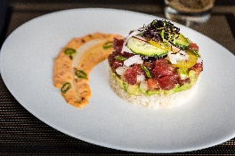
The Conche turns indulgence into an art form. Enjoy lunch at this trendy chocolate-themed restaurant, with a menu crafted by renowned Chef Santosh Tiptur. Take a peek into the Chocolate Lab where beautiful truffles, bonbons and decadent desserts are crafted daily. Finish the experience with a dessert activity.
The Conche
At Stone Tower Winery, guests can enjoy beautiful views of Hogback Mountain from the Harvest Barn or Tower View Tasting Room while they savor wines made from the 80 acres, and growing, of vineyards on property.
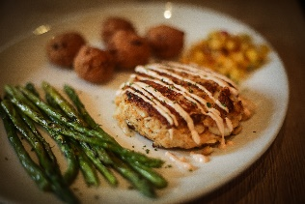
To top off the day, kick up your feet and relax for dinner. The experience will be brought right to your table with dinner at Out of the Blue Seafood. You will feel like the boat just pulled in with how fresh the seafood is arriving at your table. They hand select their crabs, including their enormous colossal blue crabs, by the former commercial fisherman and owner. They even have a custom designed steaming system so your fresh catch is cooked with tender care.
Out of the Blue

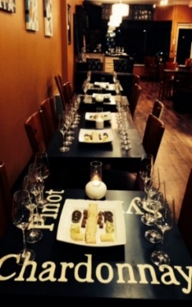
Day 3
The Bottle
Shop
Explore the historic town of Occoquan by enjoying delicious food and beverage! Begin your tour by receiving a warm welcome from the former mayor, Earnie Porta. Discover over 300 years of history in a guided driving tour of the quaint riverside town as he highlights the past and unique details of Occoquan. Uncover stories of the historic buildings and how the town got its name.
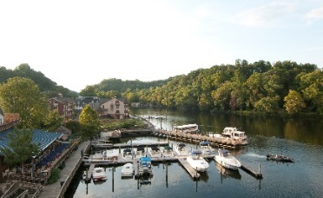
Take a seat with a glass of wine and an appetizer from The Bottle Shop. The menu is the perfect balance of casual and fancy with appetizers ranging from Parmesan-Asiago Dip to Bacon-Wrapped Dates. After your meal, take home a bottle from their vast selection of wines and craft beer from all around the world.
Madigan’s Waterfront
Next is lunch and a view at Madigan’s Waterfront. While gazing at the dazzling Occoquan River, savor a meal of mini crab cakes, chicken salad-filled pastry cup, & Tilapia Bruschetta; a dish served over seasoned flatbread topped with basil, fresh tomatoes, parmesan cheese, and a balsamic glaze.

During your main course, So Olive will give you a taste of, and educate you about, their wide variety of olive oils, such as their Persian Lime Olive Oil. After your entrée course, stroll through the individual shops around Occoquan and take a piece of the history home with you.
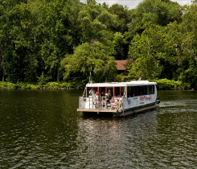
Miss Rivershore
All aboard Miss Rivershore for a water-route tour on the river. As your journey progresses, the captain will provide narration on the real estate, history, wildlife, and boats along the way. Your course will come to a sweet end with a slice of Mom’s Apple Pie. You can chose from one of their many flavors, including the Bourbon Walnut and Virginia Blackberry pie.
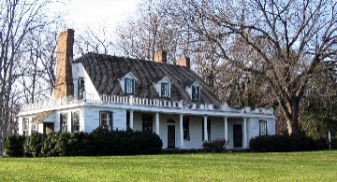
Rippon Lodge
After a busy day of tasting delightful food and enjoying the spectacular views of the Occoquan River, you will travel to Rippon Lodge for a historic tea. Built in 1747, Rippon Lodge is the oldest home in Prince William County. It doesn’t get more authentic then touring a home from Colonial Virginia while having tea as they would in the 18th - 19th century.

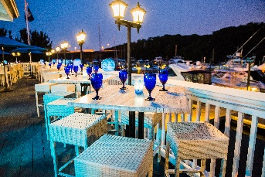
The history will continue with dinner at The Harbour Grille, settled along the Occoquan River. While enjoying the view of the marina, sample from menu items such as the Angus Ribeye Steak or Grilled Atlantic Salmon with Crispy Parmesan Polenta. Nothing like enjoying surf and turf along the water to top off a perfect day!
The Harbour Grille

Day 4
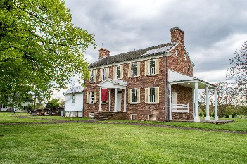
Ben Lomond
Manassas was an especially important spot during one of America’s most influential moments: the Civil War. You will begin your day at Ben Lomond Historic Site, a hospital used during the First Battle of Manassas. As you explore the home, a tour guide will provide narration on what it was like to be a patient in 1861. You will be fully immersed in the experience as you will hear, smell, feel, and even taste the history. One of the oldest ways to make food, an open-hearth cooking demonstration, will also be on-site.
Nathan’s Dairy Bar
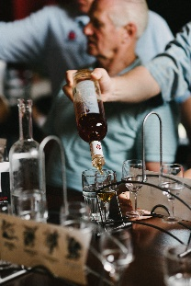
MurLarkey
Distilled Spirits
Finish out your culinary adventure with a knockout tour at MurLarkey Distilled Spirits. If there are two things the team at MurLarkey knows, it is spirits and quality customer experiences. Unaged and aged distilled spirits are made, stored, bottled, and shipped right on site. Walk around the plant for an in-depth tour on the production process of spirits and have a tasting too!

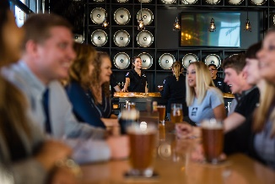
Your next food stop will take place at 2 Silos Brewing Company. The newest destination brewery in the region, this expansive property repurposed a historic barn with two silos attached (get it?!) which are the focal point of this impressive brewery and live music venue. Between the 10,000 square foot beer garden, bocce courts, multiple bars, and an impressive farm-to-table inspired menu, you may not want to leave!
2 Silos Brewing

Okra’s Cajun Creole
To book this itinerary, contact your personal travel partners, Mark Kowalewski (mkowalewski@pwcgov.org), Hannah Oliver (oliver@visitloudoun.org), and Mike Stoupa (mstoupa@pwcgov.org), for help with your suggested itinerary, dining suggestions and hotel selection.

