Farms, Fields, and Fermentation – An Agriculture Tour
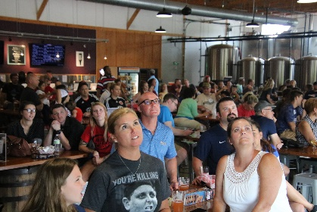
Day 1
Farm Brewery at Broad Run
Crack open a craft beverage over lunch at The Farm Brewery at Broad Run. This family run farm-turned-brewery stays true to its original farm roots, as they still grow their own hops and fruit on property. Enjoy a walk through the hop field where the owner can tell you about growing techniques and how the product is used in the production of their refreshing craft beer.
Next, step onto the tractor pulled wagon for a guided tour of Windy Knoll Farm. Owners Don and Helen Taylor will share their experience as local sheep and cattle farmers and the advanced farming techniques they use to make their land more environmentally stable. Tour the 1,000-acre farm, see local wildlife and relax in the cozy barn with warm hospitality before your next stop.
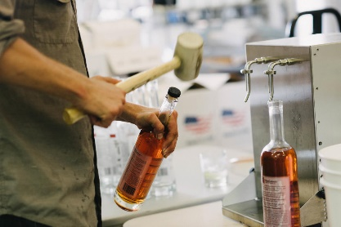
Travel & Leisure named your next destination one of the 25 best distilleries in the United States. Murlarkey Distilled Spirits is a second generation Irish-American family owned distillery and for a private tour and tasting. Learn about the distilling process from grain to glass and sample this family-owned distillery’s cocktail ready spirits. You could try their barrel aged dark whiskey called Brutality, all-natural gin titled Imagination, or the gluten-free vodka aptly named Divine Clarity. Distilled to perfection, packaged with pride and delivered with cheer, MurLarkey embodies the Irish heritage, culture and love for life it was founded on.
MurLarkey Distilled Spirits
After a full day, pull up a chair at Effingham Manor Winery for dinner. This 18th century manor home was settled by William Alexander, the namesake founder of the city of Alexandria, and has five original outbuildings which you can tour. What makes dinner tonight extra special is the type of entertainment you can select from: a comedy show, Civil War historian, or a murder mystery theater. Be sure to pick up a souvenir in their gift shop to commemorate your visit as the King or Queen “of Effing Everything”.

Day 2
Starting your day cuddling and bottle-feeding goats, as well as petting alpacas and llamas, at The Little Goat Farm at the Lake. These adorable animals are incredibly friendly and love to be held and pet. They make their own soap and goat cheese on-site so be sure to take some home to use later. Gaze out over the serene lake while these cute animals vie for your attention.
Travel back in time to the early 19th century to learn about historical farming techniques at Ben Lomond Historic Site. Imagine being the family whose house was overtaken during the Battle of First Manassas and having to pack your entire possessions and family into a small room where you’d have to life for months while soldiers were treated for numerous injuries. During your guided tour, view a hearth cooking demonstration and hear what would have been on the menu in the 1800’s.
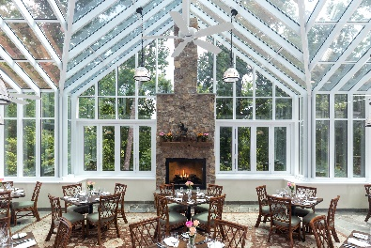
Stop for lunch at the Goodstone Inn and Restaurant. Drawing inspiration and purpose from its location on farmland in Middleburg, Virginia, The Restaurant at Goodstone seeks to provide its guests with an unparalleled dining experience, offering the finest in French Country cuisine. A Virginia farm-to-table restaurant using only the finest, fresh ingredients available — mostly sourced from Goodstone’s own organic herb and vegetable gardens and the finest purveyors in the country.
Goodstone Inn
Built between 1807 and 1809, Aldie Mill was an active hub of the community that consisted of a merchant mill, country mill, and granary, and has Virginia’s only known tandem water wheels. President James Monroe was even an early customer while living in nearby Oak Hill. Enjoy a tour of this historic mill and learn how the mill worked during a live demonstration with the miller.
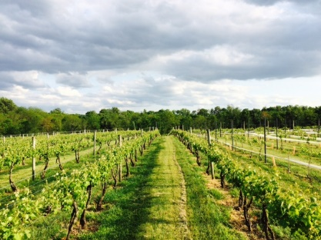
Enjoy a tasting at Zephaniah Farm Vineyards, located just outside Leesburg, on a 376-acre four-generation working farm. Named after the owner’s great-grandfather, Zephaniah Jefferson Hatch, who built and owned the Monticello Steamboat Company in the late 1800s. Century-old trees line the picturesque drive leading to the 1819 manor house that was constructed by the same builder of nearby Oak Hill, the home of former president James Monroe.
Zephaniah Farm Vineyards
Enjoy dinner at Tuscarora Mill. Known as "Tuskie’s" to locals, the restaurant has earned its reputation through its "authentically local" experience felt in the ambience and décor, conveyed by the passionate staff and evident in the quality locally sourced cuisine.
Day 3
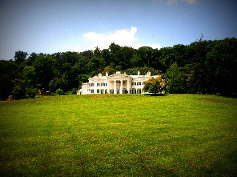
Take a tour of Morven Park. The guide will speak to the architecture and decorating style of the late 19th century which Marguerite Davis preferred. Home to former Virginia governor Westmoreland Davis and his wife Marguerite, the Davis furnishings, which include 16th century Belgian tapestries, hundreds of silver pieces, Hudson River Valley paintings, and Asian treasures play a major role in the home today.
Morven Park
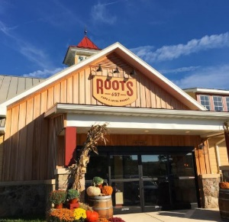
Following the tour continue to the opposite side of the 1,000-acre property to enjoy an equestrian program. Whether taking part in a polo lesson or learning about the different breeds of horses, this is a great place to see why Loudoun County is Virginia horse country.
Roots 657
Lunch today is at to Roots 657 Café & Marketplace. The cafe and locally-inspired market offer the chef’s regionally curated products, featuring local artisans alongside our own house-made soups, salads, sandwiches and fresh-baked goods.
Vanish Brewery isn’t just known for their beers. This sprawling 53 acres property is home to the Mid-Atlantics only hops-processing facility – bringing the farm to table name even more meaning. Sip some of their more than 20 beers on tap while you enjoy scenic views from their outdoor seating, or chat with the bartender in taproom.
To book this itinerary, contact your personal travel partners, Mark Kowalewski (mkowalewski@pwcgov.org), Hannah Oliver (oliver@visitloudoun.org), and Mike Stoupa (mstoupa@pwcgov.org), for help with your suggested itinerary, dining suggestions and hotel selection.

