History Meets Mystery

Mystery Tours are meant to surprise and excite. Engage your groups by visiting Prince William and Loudoun, VA. From water-route tours to chocolate demonstrations, and even a laser lightshow, your groups will never guess the adventure they are in for!

Day 1

Explore the historic town of Occoquan by enjoying delicious food and beverage! Begin your tour by receiving a warm welcome from the former mayor, Earnie Porta. Discover over 300 years of history in a guided driving tour of the quaint riverside town as he highlights the past and unique details of Occoquan. Uncover stories of the historic buildings and how the town got its name.

Take a seat with a glass of wine and an appetizer from The Bottle Shop. The menu is the perfect balance of casual and fancy with appetizers ranging from Parmesan-Asiago Dip to Bacon-Wrapped Dates. After your meal, take home a bottle from their vast selection of wines and craft beer from all around the world.
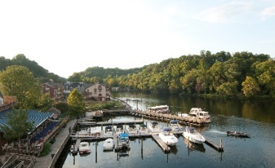
Madigan’s Waterfront
Next is lunch and a view at Madigan’s Waterfront. While gazing at the dazzling Occoquan River, savor a meal of mini crab cakes, chicken salad-filled pastry cup, & Tilapia Bruschetta; a dish served over seasoned flatbread topped with basil, fresh tomatoes, parmesan cheese, and a balsamic glaze.

During your main course, So Olive will give you a taste of, and educate you about, their wide variety of olive oils, such as their Persian Lime Olive Oil. After your entrée course, stroll through the individual shops around Occoquan and take a piece of the history home with you.
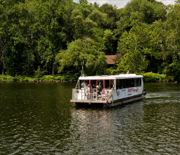
Miss Rivershore
All aboard Miss Rivershore for a water-route tour on the river. As your journey progresses, the captain will provide narration on the real estate, history, wildlife, and boats along the way. Your course will come to a sweet end with a slice of Mom’s Apple Pie. You can chose from one of their many flavors, including the Bourbon Walnut and Virginia Blackberry pie.
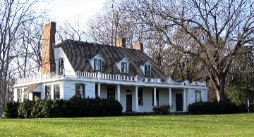
Rippon Lodge
After a busy day of tasting delightful food and enjoying the spectacular views of the Occoquan River, you will travel to Rippon Lodge for a historic tea. Built in 1747, Rippon Lodge is the oldest home in Prince William County. It doesn’t get more authentic then touring a home from Colonial Virginia while tasting tea as they would have served it 200 years ago.
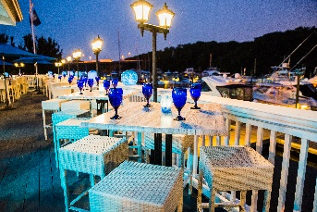
Harbour Grille
The fun will continue with dinner at The Harbour Grille. While enjoying the view of the marina, sample from menu items such as lump crab cakes with sweet potato fries, grilled salmon with crispy parmesan polenta, or a certified Angus ribeye. There is nothing like enjoying surf and turf along the water!

Before calling it a night, your group will want to experience an awe-inspiring laser light show at the Irene V. Hylton Planetarium. Listen to music from artists such as The Beatles, as colorful lasers create works of art above you.

Day 2

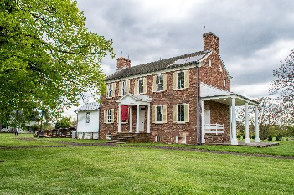
Manassas was an especially important spot during one of America’s most influential moments: The Civil War. You will begin your day at Ben Lomond Historic Site, a hospital used during the First Battle of Manassas. As you explore the home, a tour guide will provide narration on what it was like to be a patient in 1861. You will be fully immersed in the experience as you will hear, smell, feel, and even taste the history. One of the oldest ways to make food, an open-hearth cooking demonstration, will also be on-site.
Ben Lomond Historic Site
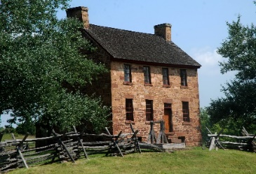
Manassas Battlefield
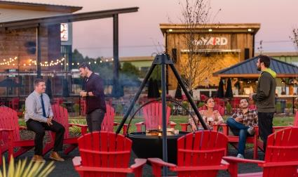
Visit Manassas National Battlefield and soak up all the history it has to offer. It is the site of the Civil War’s first major clash. The field overlooks Bull Run. There is a 45-minute film which covers the First and Second Battles of Manassas. You can then make your way to the Museum where artifacts and exhibits about the First Battle of Manassas are displayed.
2 Silos Brewing Company
Next, hop by 2 Silos Brewing Company to taste of some of the local beers and ales. This brewery is a destination brewery featuring live music and from-scratch food. The brewery got its name from the former grain barn with its two iconic silos.
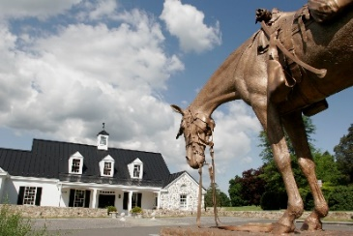
Make your way to Middleburg, the Horse and Hunt Capital of the Country and visit The National Sporting Library and Museum. This hidden gem located in Middleburg, Virginia has a deceiving name. Take a docent-led tour through the art museum where the pieces come alive from the stories and make sure to visit the rare book room with books as far back as the 1500’s and unique pieces from President Roosevelt. Be sure to ask a librarian what a fore-edge book is!
National Sporting
Library and Museum
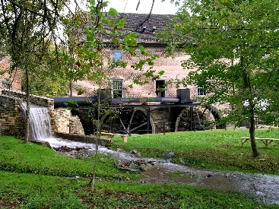
Middleburg is also home to a plethora of charming shops and restaurants. Spend some time exploring downtown before meeting the Grey Ghost. The legend of the Grey Ghost haunts Loudoun. Join Warpath Tours to explore the Mosby Heritage Area and follow the path of John Singleton Mosby, a Civil War vigilante. Travel historic roads and visit battlefields and historic sites throughout Loudoun.

Enjoy dinner this evening at Clyde’s Willow Creek Farm. This destination restaurant is a sprawling, rustic tavern comprised of several antique heavy timber buildings destined for demolition over 20 years ago. These barns, stables, homes, and taverns were reassembled to create the complex of dining rooms. Clyde’s features original artwork, historic artifacts, and a collection of museum quality 18th century horse-drawn carriages - many strung from the high ceilings. True to its name, Clyde’s is located on a working farm where their team of chefs draw inspiration for the classic tavern menu.

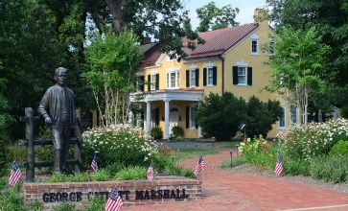
Day 3

The picturesque streets of Historic Downtown Leesburg offer a pleasant morning of exciting activities. Take a step back in time with a tour of the Marshall House, home of George Marshall, the creator of the Marshall Plan for post-World War II European Recovery.
Marshall House

Continue through downtown Leesburg while playing the “Gallery Game.” The “Gallery Game” is a scavenger hunt through the galleries with the goal of finding three paintings, sculptures of other pieces to establish an answer to the puzzle. Who can solve it the fastest?

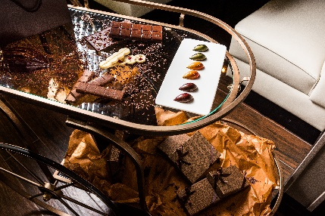
Step into the historic space that is Casa Nostra to enjoy lunch, from the checkered entryway to the brick walls, this restaurant brings exceptional Italian cuisine to life with bold expressions of color, texture and artistry in every dish with handmade pasta, from scratch sauces, and authentic Italian traditions.

End the tour with a sweet surprise at The Conche, a restaurant with a deceiving name. When you enter, you will be greeted by the rich aroma of fresh chocolate. Enjoy lunch and a chocolate sculpture demonstration from the chef.
The Conche

To book this itinerary, contact your personal travel partners, Mark Kowalewski (mkowalewski@pwcgov.org), Hannah Oliver (oliver@visitloudoun.org), and Mike Stoupa (mstoupa@pwcgov.org), for help with your suggested itinerary, dining suggestions and hotel selection.

