

**Remembering Our Heroes**

Pay homage and thank our military members for their service on this tour honoring U.S. Veterans. Visit historic sites, enticing museums, and various dining options.

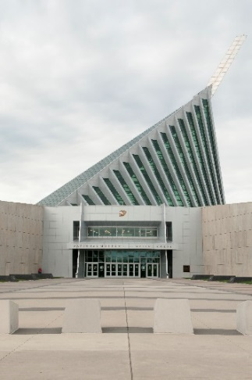Start off your day with an experience at the **National Museum of the Marine Corps.** Uncover the history of the Corps, test your skills as a Marine, and get insight into the lives of those who fight for our freedom. During your visit, see the incredible Gene Hackman narrated film, “We, The Marines” for a first-hand experience of what it takes to become a Marine.

**National Museum of the Marine Corps**

Visit Marine Corps Base Quantico for a **gourmet lunch at The Clubs at Quantico**. Marine Corps Base Quantico is the home of Marine Helicopter Squadron One, the unit tasked with transporting important personnel including the President and Vice President of the United States, and the FBI Training Academy.

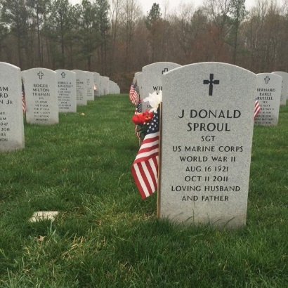

**Quantico National Cemetery**

While on base at **Marine Corps Base Quantico**,visit **The Marine Shop** in the Town of Quantico for a wide selection of gifts and apparel. All purchases support programs which recognize and award active duty Marines and Sailors.

Afterwards, pay homage at **Quantico National Cemetery** where our nation’s veterans are remembered with a private flag laying ceremony. Your group will have the honor of supporting the **Missing In America Project**, an organization whose mission is to find, identify and inter unclaimed remains of fallen veterans. Experience a once-in-a-lifetime opportunity by placing flags on the graves of these previously forgotten heroes.

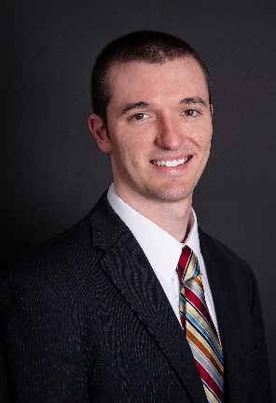

**Mike Stoupa**

Tourism Sales Specialist

14420 Bristow Road

Manassas, VA 20112

571-359-2628

Mstoupa@pwcgov.org

**P: 703-792-8420 www.VisitPWC.com F: 703-792-4278**

**When planning your next reunion, please reach out to our travel professional:**



**Totes and Boats**

Discover unique shops in our historic towns, find a bargain at Virginia’s largest outlet mall and indulge yourself in Prince William & Manassas!

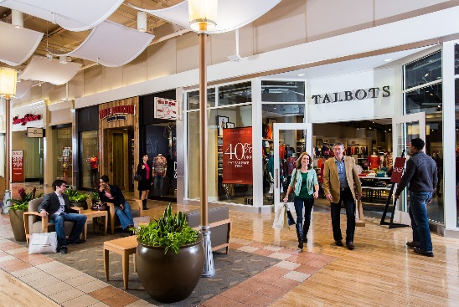If you are looking for a great deal, visit **Potomac Mills** - the largest outlet mall in Virginia. Here you have more than 220 shops and eateries to choose from. Coupon books for groups will provide additional savings for your shoppers!

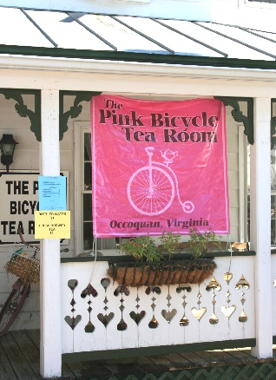Enjoy lunch at one of the many nationally recognized restaurants within walking distance of the stores including **Bahama Breeze**, **Matchbox** or **The Cheesecake Factory**.

Later, venture over to the quaint town of Historic Occoquan for a **wine cruise along the Occoquan River** aboard **Miss** **Rivershore**. Take in the beautiful scenery and serene sounds as you float down the water with a full glass of Virginia wine. You may even spot one of our bald eagles.

Or you can stroll the streets as you browse the boutique stores and sample tasty treats. Try a slice of cranberry apple or Virginia blackberry crumb pie from **Mom’s Apple Pie**. You can even have a light afternoon tea at the **Pink Bicycle Tea Room**.

Finish your afternoon shopping in the boutique stores before ending your day with **dinner overlooking the river**. Riverfront restaurants include Madigan’s Waterfront, Bottle Stop: Wine Shop, Bar and Eatery, Occoquan Inn, The Electric Palm and The Harbour Grille.

**When planning your next reunion, please reach out to our travel professional:**



**Mike Stoupa**

Tourism Sales Specialist

14420 Bristow Road

Manassas, VA 20112

571-359-2628

Mstoupa@pwcgov.org

**P: 703-792-8420 www.VisitPWC.com F: 703-792-4278**



**A Civil War Discovery Trail**

Picture yourself standing in the center of the same battlefield that marked the beginning of the Civil War. Virginia is home to 122 Civil War battle sites – the highest number of all states involved in the war. That’s why setting up camp in Prince William & Manassas is the perfect option for Civil War buffs and history enthusiasts alike.

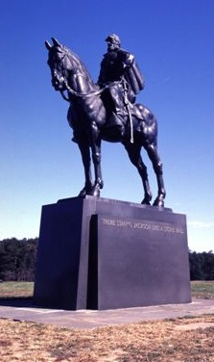Start your journey at **Manassas National Battlefield Park** and discover where Stonewall Jackson got his nickname. Stand on Henry Hill, where Union soldiers lead by General McDowellsurrendered to the Confederates. You’ll feel as though you are a part of the action as you are guided through the fields where the first battles of the war were fought. Make sure to get a picture with Stonewall Jackson before you leave!

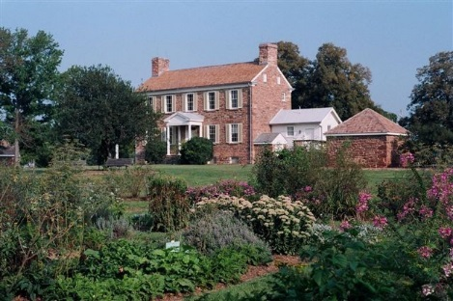Afterwards, drive over to **Ben Lomond Historic Site** to continue your Civil War filled trip. Soldiers were taken here after the Battle of First Manassas to care for their wounds and left their signatures on the walls to prove it.

For lunch, try a local favorite in **City Grille**! Just a stone’s throw from Manassas National Battlefield, sink your teeth into delectable American comfort food such as their prime rib or Philadelphia cheesesteak specials.

Follow the same path that Abraham Lincoln traveled to **Liberia Plantation** to confer with his General Irvin McDowell. Once the largest and most successful grain and vegetable plantation in the City of Manassas, the brick house was also used as a military hospital during the Civil war. See if you can decipher the signatures and drawings left behind by soldiers on the walls of the home.

Discover artifacts from the war and uncover more history of the area at the **Manassas Museum**. Take home unique souvenirs and collectibles from Echoes, the museum store, to forever remember your Civil War experience.

**When planning your next reunion, please reach out to our travel professional:**

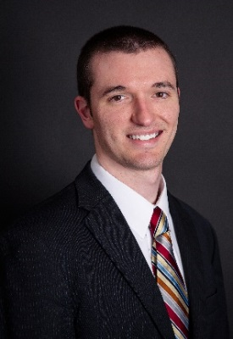

**Mike Stoupa**

Tourism Sales Specialist

14420 Bristow Road

Manassas, VA 20112

571-359-2628

Mstoupa@pwcgov.org

**P: 703-792-8420 www.VisitPWC.com F: 703-792-4278**



**Explore Hallowed Grounds**

Pay homage and thank our military members for their service on this tour honoring U.S. Veterans. Visit historic sites, enticing museums, and various dining options.

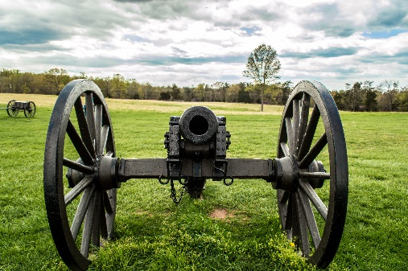Explore the **Freedom Museum** at Manassas Regional Airport where you can watch planes take off during your guided tour. Your veteran guide will focus on the U.S. military’s involvement in 20th-century wars through memorabilia, interactive displays and photographs.

Next, let your Civil War guide dressed in his military uniform lead you to **Manassas National Battlefield Park**. There, discover the artifacts uncovered from the battlefield and walk the hallowed ground where two major Civil War battles unfolded.

For lunch, eat heartily at the **Golden Corral Buffet & Grill or The Great American Buffet**, casual all-you-can-eat dining restaurants with a generous amount of options.

Afterwards, follow the same path that many wounded soldiers traveled to **Liberia Plantation**. Once the largest and most successful grain and vegetable plantations in the City of Manassas, the brick house here was used as a military hospital during the war. See if you can decipher the signatures and drawings left behind by soldiers on the walls of the home.

Round off your trip with another Civil War hospital at the **Ben Lomond Historic Site**. Soldiers were taken here after the Battle of First Manassas to care for their wounds and left their signatures on the walls to prove it. Learn about 19th century medicine used to care for the injured soldiers.

**When planning your next reunion, please reach out to our travel professional:**



**Mike Stoupa**

Tourism Sales Specialist

14420 Bristow Road

Manassas, VA 20112

571-359-2628

Mstoupa@pwcgov.org

**P: 703-792-8420 www.VisitPWC.com F: 703-792-4278**



**Wine, Dine, and Sunshine**

This itinerary is filled with group activities to recharge your body and restock your wardrobe for a truly memorable trip!

After a healthy breakfast, let your inner creativity shine with an **open air painting session at Brentsville Courthouse and Historic Centre**. Founded in 1820, this site acted as the main hub of county business for 70+ years. Choose from the 1822 courthouse and jail, 1880 church, or 1850 farmhouse as your creative backdrop!

Spend the morning discovering treasures in **Historic Downtown Manassas**. The shops and stores of this charming brick lined city are full of gifts to take home and enjoy. Shop for specialty olive oil at Manassas Olive Oil Company, the newest Vera Bradley purse at Allyssa Bryn Marketplace and home decor at The Things I Love. So many stores, so little time!

While shopping, sample Cajun cuisine at **Okra’s**, taste Portuguese and Italian fare at **Carmello’s** or savor authentic Greek food at **Katerina’s** for an al fresco lunch. Your palette will thank you anywhere you go!

A trip wouldn’t be complete with a stop at **Effingham Manor Winery**. Sample their wine at this historic 18th century manor home overlooking acres of beautiful countryside. The winery features year-round, seasonal events and host wine tastings seven days a week in the barrel room and manor house.

**When planning your next reunion, please reach out to our travel professional:**



**Mike Stoupa**

Tourism Sales Specialist

14420 Bristow Road

Manassas, VA 20112

571-359-2628

Mstoupa@pwcgov.org

**P: 703-792-8420 www.VisitPWC.com F: 703-792-4278**

**P: 800-432-1792** [**www.DiscoverPWM.com**](http://www.DiscoverPWM.com)[**GroupTravel@DiscoverPWM.com**](mailto:GroupTravel@DiscoverPWM.com) **F: 703-396-7160**