Small Group, Big Experience
A small group can be an exhilarating way to experience a destination. You’re spending your time getting to know everyone else in the group, as well as indulging in activities larger groups cannot take advantage of. This tour highlights the distinct luxuries in Prince William & Manassas, specially tailored for a group of 20 people or under. Call on your creative and adventurous side on this feature-rich tour!

Day 1:
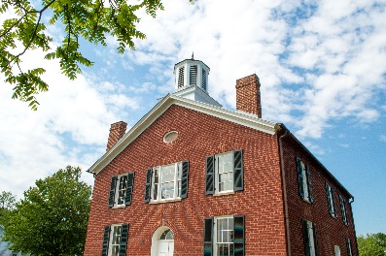
Dive into a piece of history over a catered lunch at the Brentsville Courthouse Historic Centre. Dine in the 1920’s schoolhouse before you tour a 1820’s courthouse and haunted jail. It was here in January 1860 that the Prince William Cavalry was formed in response to John Brown’s raid in nearby Harper’s Ferry. Today, the jail has been restored to it’s 19th century “charm” and the exposed wood beams provide a haunting atmosphere as you listen for the spirits of those who may not have left.
Brentsville Courthouse

Your next stop is Ben Lomond Historic Site for a VIP tour. Used as a hospital after the First Battle of Manassas during the Civil War, your tour will take in the sights, sounds, and smells of what it was like to be a wounded soldier in July 1861. You’ll visit parts of the house which are not open to the general public and may include a cooking demonstration, musket firing demonstration, or other interactive experience.

If you prefer your spirits distilled, jaunt over to Murlarkey Distilled Spirits for a private tour and tasting. Learn about the distilling process from grain to glass and sample this family-owned distillery’s cocktail ready spirits. You could try their barrel aged dark whiskey called Brutality, all-natural gin titled Imagination, or the gluten-free vodka aptly named Divine Clarity.

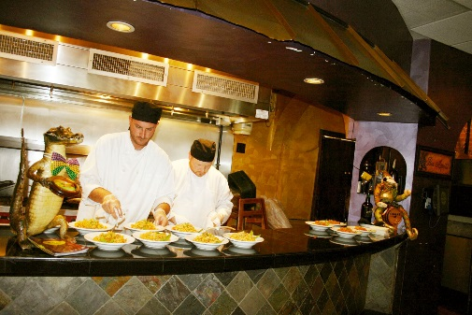
Since you will have worked up quite the hunger for adventure, you’ll appreciate the variety of the nearby dinner options. Take in a rustic barn dinner at Windy Knoll Farm, observe a chef’s cooking demonstration at Okra’s Cajun Creole, relax over a glass of wine with dinner at Effingham Manor, or relish fine cuisine at the church-turned-steakhouse at Malone’s. In addition to delectable food, your eyes will feast on the memorable atmosphere of your dining destination.
Okra’s Cajun Creole

After dinner, enjoy a dance class at The Center for the Arts. Your feet will learn new tricks in this beautiful venue with exposed brick and warm wood beams, leftover from its days as a candy factory!
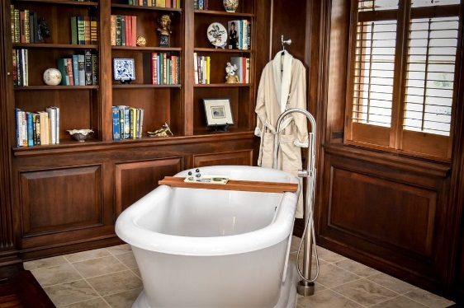
Inn at Evergreen
Tonight, your group will overnight at The Inn at Evergreen. Built in the 1800’s, Evergreen played an important role during the Civil War and the Underground Railroad movement. This 11-room upscale inn is listed on the National Register of Historic Places, as well as the National Underground Railroad Network to Freedom. Your rooms may also overlook the 18th hole of the adjacent private golf course!

Day 2:
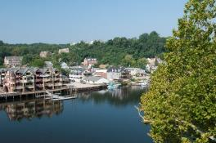
Receive a warm welcome to Occoquan by the former mayor, Earnie Porta. Enjoy a guided tour of the quant riverside town as he highlights the history and intriguing details of Occoquan. Discover stories of the historic buildings, including The Odd Fellows Hall, and why the historic markers may not be entirely accurate.
Occoquan

After your tour, refine your taste buds at So Olive, Occoquan’s olive oil and vinegar specialty store. So Olive will provide a tasting of and education about their distinct olive oils, such as the blood orange fused olive oil. As you spend some time exploring the unique shops around town, peruse their selection of over 20 different flavors of olive oil and balsamic vinegar for use at home.
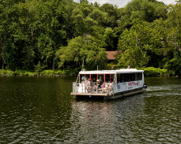
Miss Rivershore
Board Miss Rivershore for a tour along the river and take in the beautiful scenery as your captain highlights details about the real estate and boats along the journey. Enjoy a glass of wine or pint of beer as you travel along the Potomac River to lunch at Tim’s Rivershore. This staple restaurant for locals is a hidden gem for visitors as it sits on the banks of the Potomac, offering incredible views to pair with their fresh seafood options.
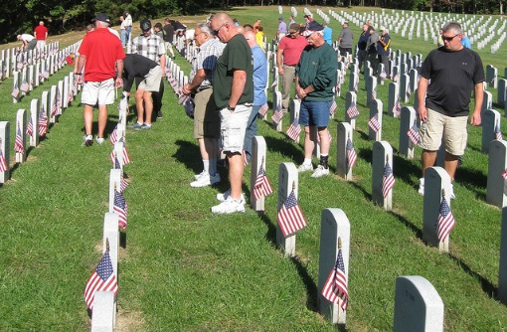
After lunch, pay your respects at Quantico National Cemetery with a private flag laying ceremony at the graves of veterans whose remains were previously forgotten. Hosted by the Missing in America Project, their mission is to find, identify and provide full military burial for these now remembered heroes.
Quantico National Cemetery

Continue your journey at the National Museum of the Marine Corps. Telling the story of America through the eyes of Marines, this world-class museum is expanding and your group will get a VIP experience in the new combat artist gallery. You could meet the artist and discuss their creative process, see art being made, or meet the gallery’s curator to talk about the significance of the pieces on display.

If your group is adventurous, you may opt to give them a guided kayak or paddleboard tour of the Occoquan River.

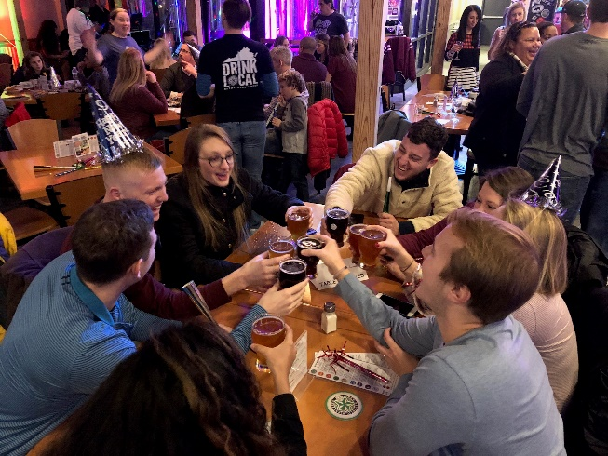
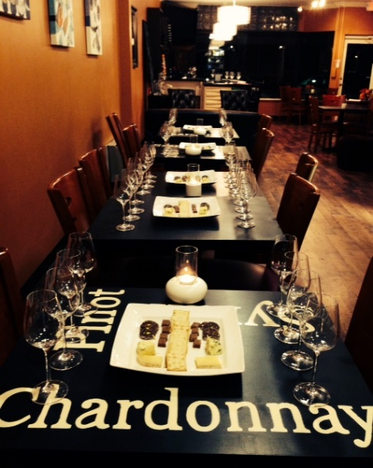
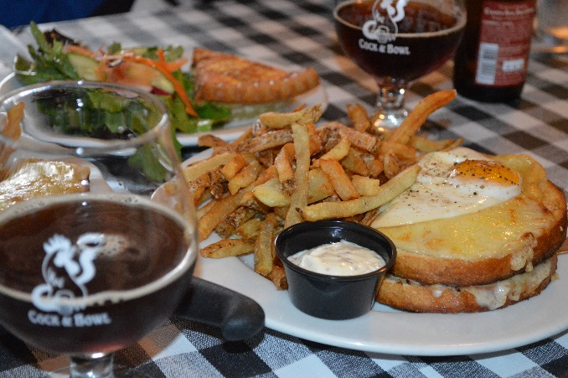
End your day by traveling to Brew Republic where you’ll discover the brewing process from start to finish. Get a behind the scenes look at their facility and taste their Great American Beer Festival award-winning beer. Alternatively, send your palate to Paris by way of Occoquan for French cuisine at Bistro L’Hermitage, sample Belgian fare and libations at Cock & Bowl, or unwind with a wine paired dinner at Occoquan’s only wine bar, Bottle Stop.
Brew Republic Bierwerks
Cock & Bowl
Bottle Stop

Day 3:
After a scrumptious breakfast, choose your own adventure this morning:
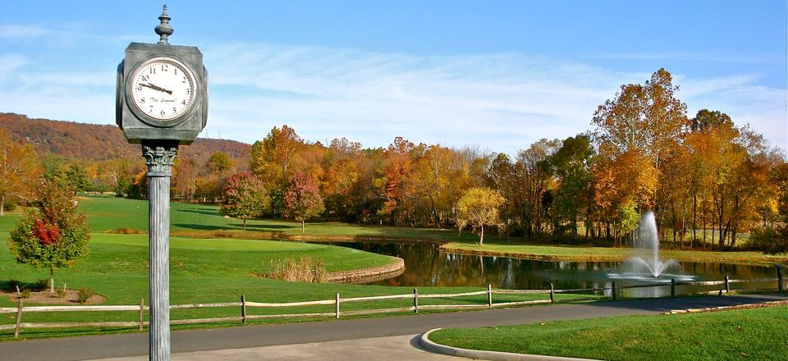
- Group One: Enjoy a leisurely morning of golf at Evergreen Country Club. Guests of the Inn at Evergreen are permitted to use this private, members-only, course. After 18 challenging holes, enjoy a refreshing lunch in the clubhouse.
Evergreen Country Club
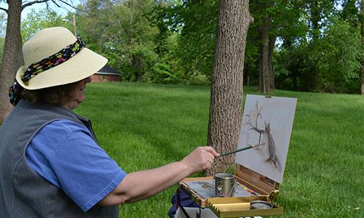
- Group Two: Use your creative side this morning! Go outside for plein air painting with Creative Brush, create your own earrings and necklace as you learn the art of paper quilling at Mix Colors Art Studio, or pick your inspiration as you paint over a glass of wine at Muse Paint Bar. After your class, enjoy some free time to shop and explore in Historic Downtown Manassas. Enjoy lunch at a restaurant of your choice with your included Downtown Manassas Gift Card.
Plein Air Painting with Creative Brush

Regroup back at the Inn at Evergreen before departing for home.

For help planning your next group tour, contact our sales department:
Mark Kowalewski – mkowalewski@pwcgov.org Mike Stoupa – mstoupa@pwcgov.org

