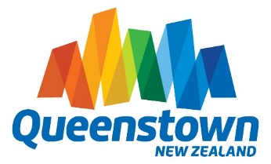
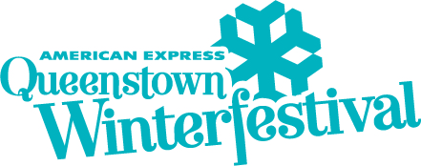
2017 Queenstown Winter Festival Dates Announced
Queenstown, New Zealand (27 July, 2016) – The dates for Queenstown’s new four-day Queenstown Winter Festival have been confirmed for 22 to 25 June 2017.
The official celebration to mark the beginning of Queenstown’s winter season is being reshaped into a shorter, action packed four-day event from next year, beginning on Thursday 22 June, running through to Sunday 25 June. The dates are deliberately timed to be around two weeks after the scheduled start to the ski season but prior to the Australian and New Zealand school holidays.
American Express Queenstown Winter Festival director Lisa Buckingham says the revamped Festival will retain community favourite events and inject some new and exciting events for 2017.
“We are looking forward to presenting this newly formatted festival to the community and visitors next year. We work very hard to ensure that the Queenstown Winter Festival is an event that locals and visitors alike can enjoy,” says Ms Buckingham.
Destination Queenstown chief executive Graham Budd says next year’s Festival will announce the start of the 2017 winter season with renewed vibrancy.
“We’re excited to bring the Southern Hemisphere’s biggest celebration of winter to the community again in 2017. The new format will allow both visitors and locals to participate in and enjoy the entire festival experience,” says Mr Budd.
Planning for the 2017 event is already in full swing, with the focus now on working with sponsors and stakeholders to design an exciting new Festival programme.
ENDS
For more information please contact:
Lisa Buckingham
Festival Director
Queenstown Winter Festival
Phone: +64 3 441 2466
Email: lisa@winterfestival.co.nz
WINTER STARTS HERE! From 22 June to 25 June, the 2017 Queenstown Winter Festival celebrates winter fun and festivities with four days of totally outrageous and uniquely Queenstown events. Join us on Facebook or Twitter, or keep an eye on www.winterfestival.co.nz to be first with the latest news and hot updates.
Started in 1975, the Festival was born when a group of clever locals thought the arrival of snow was a ‘great excuse for a party’. The group organised races on the mountain and in town, lollies for the kids, beers for the grown-ups, a concert or two and a local ball, all of which were a great success. News quickly spread and over the years it has grown in size and stature to become the Southern Hemisphere’s biggest winter celebration.
Now an iconic event cemented on Queenstown’s calendar it attracts 45,000 attendees and injects a whopping $57 million back into the local economy.
Despite phenomenal growth, the Festival has stayed true to its roots and is still a Festival by the community, for the community. It has evolved to forge a unique identity as New Zealand’s premier celebration of all things winter and holds a special place in the heart of Queenstowners.

