TRAVEL

Rhode trip! Some days, it’s all about northern Rhode Island’s simpler pleasures.
By Brian Amaral Globe Staff,Updated April 27, 2023, 10:00 a.m.
1
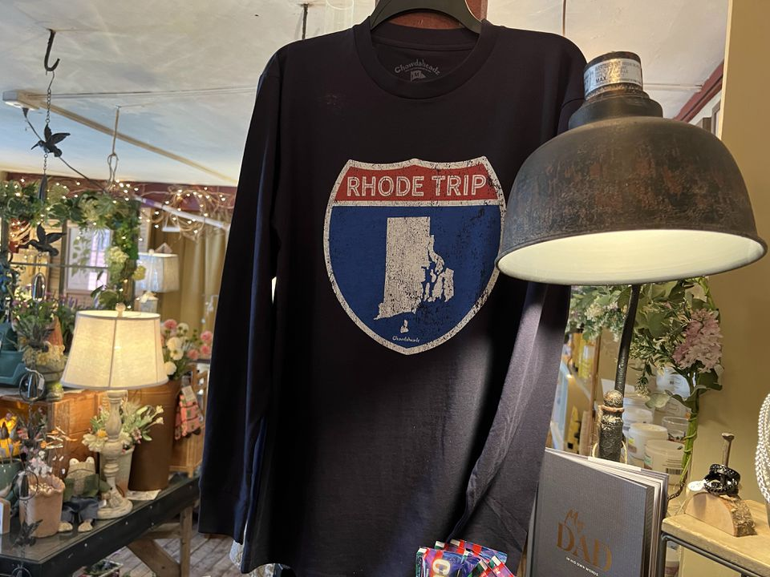The Brown & Hopkins Country Store is the perfect place to stop in if you're on a Rhode trip.BRIAN AMARAL/GLOBE STAFF
GLOCESTER, R.I. — My train pulls out of the station right on time, which is good, because I have a lot to do today. But my fellow passengers, I notice, don’t seem to be in a particular rush. They also seem to be primarily children, accompanied by their parents. And their lack of urgency is just as well, because the train’s departure point is the same as the destination: a quaint shop called Harmony Products, which sells locally made soaps, candles, honey, and other assorted crafts and gifts on Putnam Pike.
This half-mile loop trip on what’s called a grand scale train isn’t about where you’re going. It’s about where you are. And where you are, if you were me on a recent spring Saturday, is northern Rhode Island.
It’s a sometimes-overlooked part of this great state, much more rich and complex than just Salty Brine’s “No school, Fosta Glosta.” It’s a place to which I always try to escape for a day when I’m tired of the hustle and bustle of Rumford, the bright lights and the big city of East Providence. You can keep your Newport mansions, your South County beaches, your Providence performing centers of art: Some days, it’s all about northern Rhode Island’s simpler pleasures.
One such day was a recent Saturday, which started at the Harmony Railway. Yes, children love the 10-minute trip. It also brings out the inner child in the adults who come out there by themselves, and there are plenty of those, too.
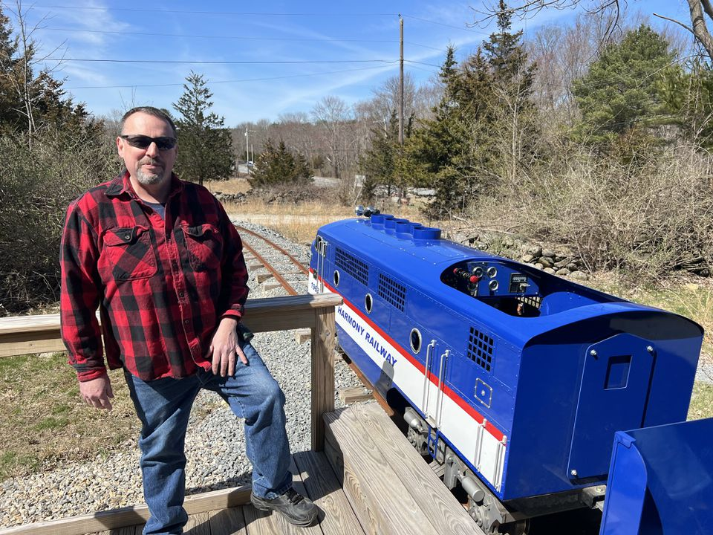
Russ Gross is the owner and conductor of the Harmony Railway.
BRIAN AMARAL/GLOBE STAFF
“It was a way to share this beautiful spot,” said owner (and conductor) Russ Gross, a retired Providence firefighter who opened the operation in 2020 on property that’s been in the family since after the Civil War. “There’s a little magic in the train.”
Indeed. Here and all around northern Rhode Island.
Once my train journey had concluded — after me and my fellow passengers pointed at some chipmunks and posed for some selfies and disembarked — my next stop was downtown Chepachet, where you’ll find some local shopping and, in July, the Ancients and Horribles parade — crazy outfits, outlandish floats, satirical commentary on anything and everything. I dipped into the Brown & Hopkins Country Store, which dates to 1809. Just to browse. Then I spotted a pair of baby “boogie socks,” which were shaped like pigs and rattled when you shook them.
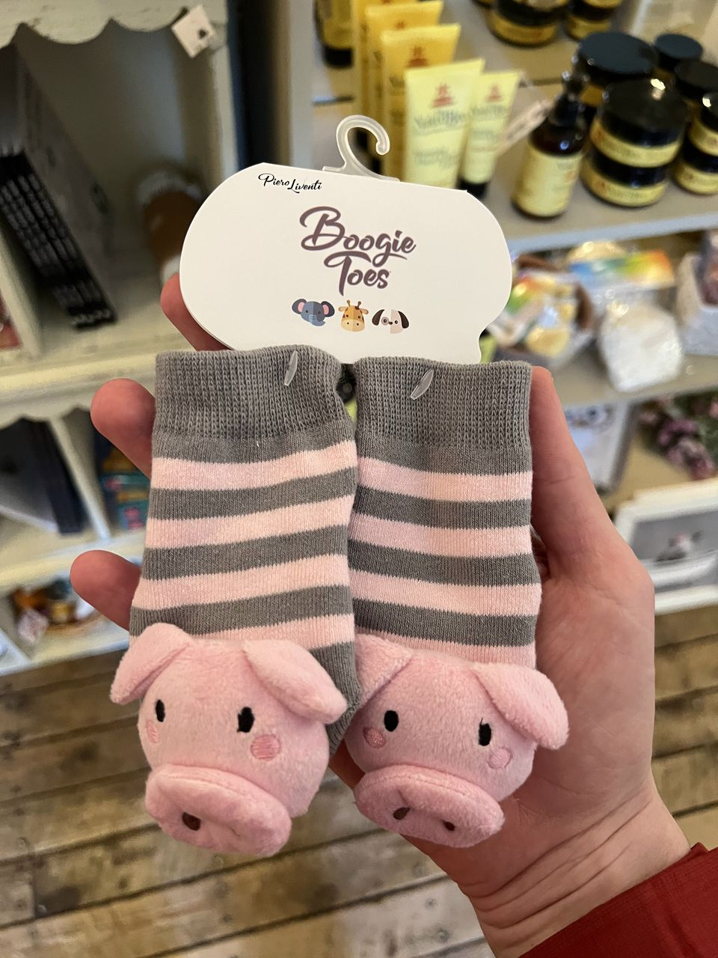
"Boogie Toes" socks at the Brown & Hopkins Country Store are too much for even the most disciplined shopper to resist. BRIAN AMARAL/GLOBE STAFF
Purchased pigs in hand, I went next to The Town Trader, where I again couldn’t help myself and bought a postcard of an old Chepachet grammar school, which is now the Glocester Town Hall. According to the shop’s friendly and cowboy-hatted proprietor, the Town Hall still has the old school desks in the attic. I was surprised those desks weren’t for sale at The Town Trader. They had seemingly everything else on offer, from a tin of Flamin’ Hot Cheetos to various chandelier options and everything in between.
Other commerce-, culture-, or history-focused options in northern Rhode Island: The Museum of Work & Culture in Woonsocket. The Stadium Theatre in Woonsocket. Rustic Tri-View Drive In in North Smithfield, set to open in late April.
As I solicited ideas for this article about a trek to the state’s northern reaches, I was advised to pack a lunch. After all, I’d have to cross multiple rivers to get there. I’m glad I didn’t, because if I had, I’d have missed out on the Taco Shop in Harrisville, where I had a great burrito and some nice guacamole. I then went to Bravo Brewing in Pascoag, where I picked up a fabulous root beer and checked out a farmer’s market.
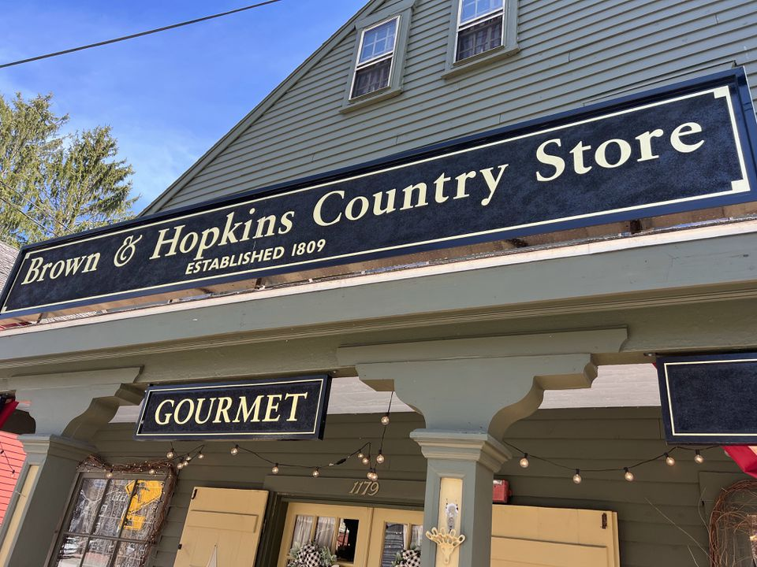
The Brown & Hopkins Country Store was established in 1809. BRIAN AMARAL/GLOBE STAFF
Pascoag is one of those charming old mill-centric Rhode Island villages. It has an old-time feel, but not solely old-time. Indeed, across from the brewery sits a new bar, established in the year 2023, called Elayna’s. The tagline posted in the window was: “A little classy. A little trashy. A little smart a$$y.” It was, sadly, too early for a martini.
Other lunch and beverage options: Blackie’s, Smithfield, try the nachos. J’s Deli, Smithfield and Woonsocket, try The Graduate. Nickle Creek Vineyards (opens in May) in Foster or Mulberry Vineyards in Glocester, try the wine. Gator’s Pub in Slatersville, try the volleyball.
After my train trip and my shopping and my eating, I really needed to stretch out for a ramble. Northern Rhode Island has no shortage of options for this (though you might need to wear orange at some times of the year, as it’s also a hotspot for hunting). I went to the trails at Black Hut Management Area in Burrillville. The day was warming up by now, the temperatures rising along with the spring song of a chickadee.
Other hiking options include Jerimoth Hill in Foster, the highest point in the state at 812 feet (eat your heart out, Johnston landfill!), the Glocester Land Trust, and the beginning of the North-South Trail, a 77-mile route running the length of Rhode Island to the Atlantic Ocean.
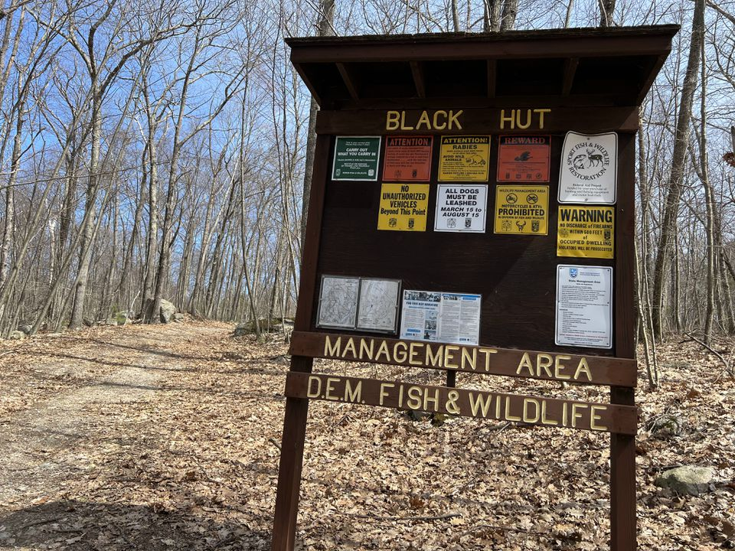
The Black Hut Management Area is one of the many places in northern Rhode Island to go for a walk or, in certain times of the year, hunt and fish.BRIAN AMARAL/GLOBE STAFF
But I wasn’t ready to head south just yet. First I needed some ice cream. So I headed to Wright’s Dairy Farm & Bakery in North Smithfield. Waiting in a long, Easter-weekend line, I saw an older woman in tears after someone paid for all her stuff. People are kind everywhere in Rhode Island, but given the scenery I was feeling like I’d walked into a Frank Capra movie.
Outside, we said hello to some of the cows and calves lolling in the shade. A Rhode Island red hen passed underfoot as I ate my ice cream sandwich at a picnic table. My belly was full of great food and drinks and ice cream. My lungs were full of fresh air. The pig socks were rattling in my pocket, the postcard ready to be filled with notes on my day. I was finally ready to head home to East Providence. And my only regret was that the Harmony Railway isn’t yet long enough to take me all the way there.

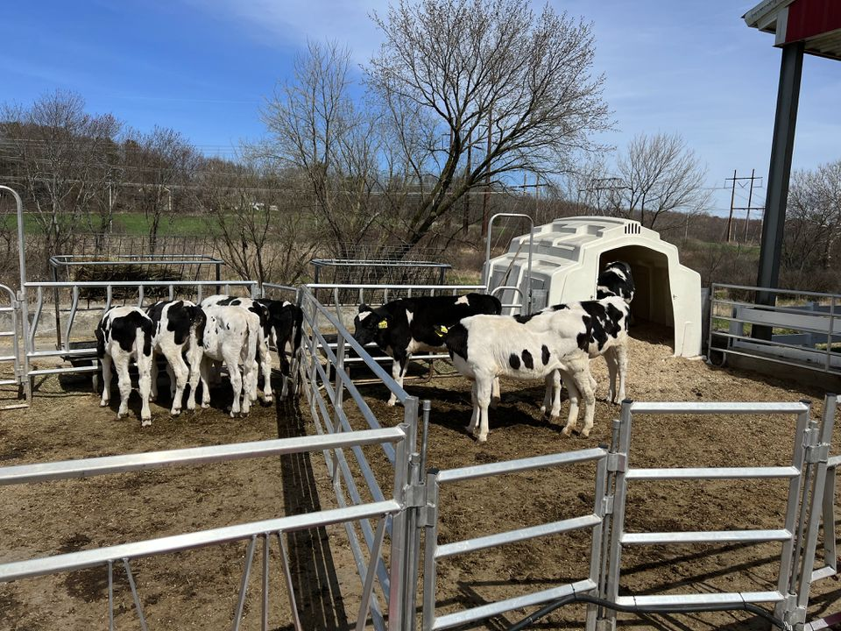
Wright's Dairy Farm & Bakery in North Smithfield gets you up close and personal with the animals that make the milk going into your ice cream. BRIAN AMARAL/GLOBE STAFF

Brian Amaral can be reached at brian.amaral@globe.com. Follow him on Twitter @bamaral44.

