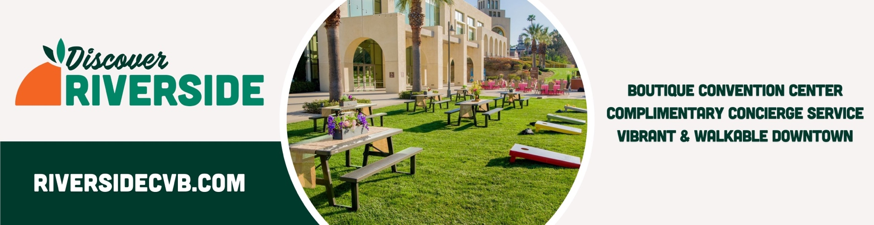

MARKETING ASSISTANCE FORM

We are pleased to offer assistance in the marketing of your upcoming event. We offer strategic opportunities to promote your event, supported by our strong local relationships with news media and the City of Riverside. We optimize marketing efforts through press releases, publishing your event on the city’s Community Calendar, and featuring a large digital ad on two, city-managed, electronic billboards lining the 91 and 215 freeways. We leverage additional outlets such as the Riverside Weekly e-News and Outlook Community Calendar. Rounding out our marketing initiatives to promote your event, we utilize our own social media accounts to disseminate your event details to a broader audience.

In order to best support your marketing needs, please provide the below information at least 30 days prior to your event:

EVENT INFORMATION:

Name of Event:
Type of Event (if sporting event, please provide type of sport):
Location of Event (please provide complete venue name and address):
Dates(s) of Event (MM/DD/YY):
Daily Start/End Times:
Anticipated Attendance:
Description of Event Programming/Activities:
Ticket Price Range (detail if varied by age; mark N/A if free):
Comments/Special Request:

CLIENT CONTACT INFORMATION:

Contact Name:
Affiliation with Requested Event:
Preferred Contact Method:
Phone #/Email Address:
Day of Event Contact (if different from above):
Day of Event Contact Preferred Contact Method:
Phone #/Email Address:
Organization/Event Website:
Organization Instagram Handle (please provide if you are comfortable with us reposting content/tagging your account in posts):

LOGOS/PHOTOS:

Please submit organization/event logo to us electronically in .jpeg format. If you have photos you would like us to utilize in social media posts, please send in .jpeg format as well.

PRESS RELEASE:

Please indicate if you would like us to write a press release using the information provided or if you would prefer to provide us with a ready-made press release. (Note: We will send to you for final approval prior to release).

If you provide us with a press release, could we offer additional detail expressing our excitement for the event? (Note: We will send to you for final approval prior to release).

DIGITAL BILLBOARDS:

Please provide an electronic copy of both a high-resolution logo and a pre-designed event flier/marketing graphic, if available.

Market St. Riverside Convention Center Parking Lot
- Image size Landscape, 432 pixels wide x 240 pixels tall (A 48 pixel character will be 1 foot tall)
- File Format - Still Images: JPG, GIF, PNG for still image content at 100% quality; Use RGB color, not CMYK
- No solid white or solid bright backgrounds

Marketplace (Near 215/60 Freeway Interchange)
- Image size 264 pixels wide x 136 pixels tall
- High resolution (no higher than 130)
- Full color, RGB only
- Photoshop jpeg only

HOW TO REACH US:

Contact: Mary Kate Little, Marketing & Communications Manager

Phone: (951) 500-2862

Email: Mary.kate@littlemarketinggroup.com

