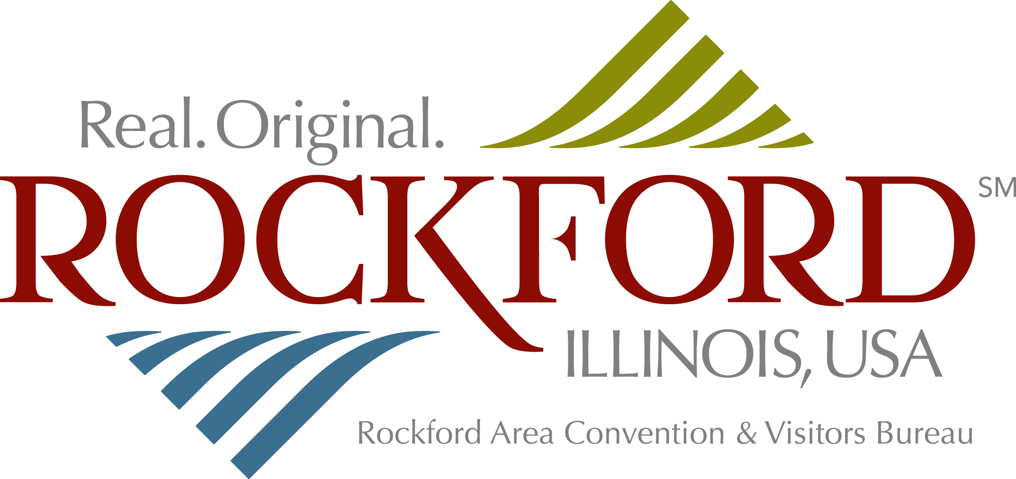 | 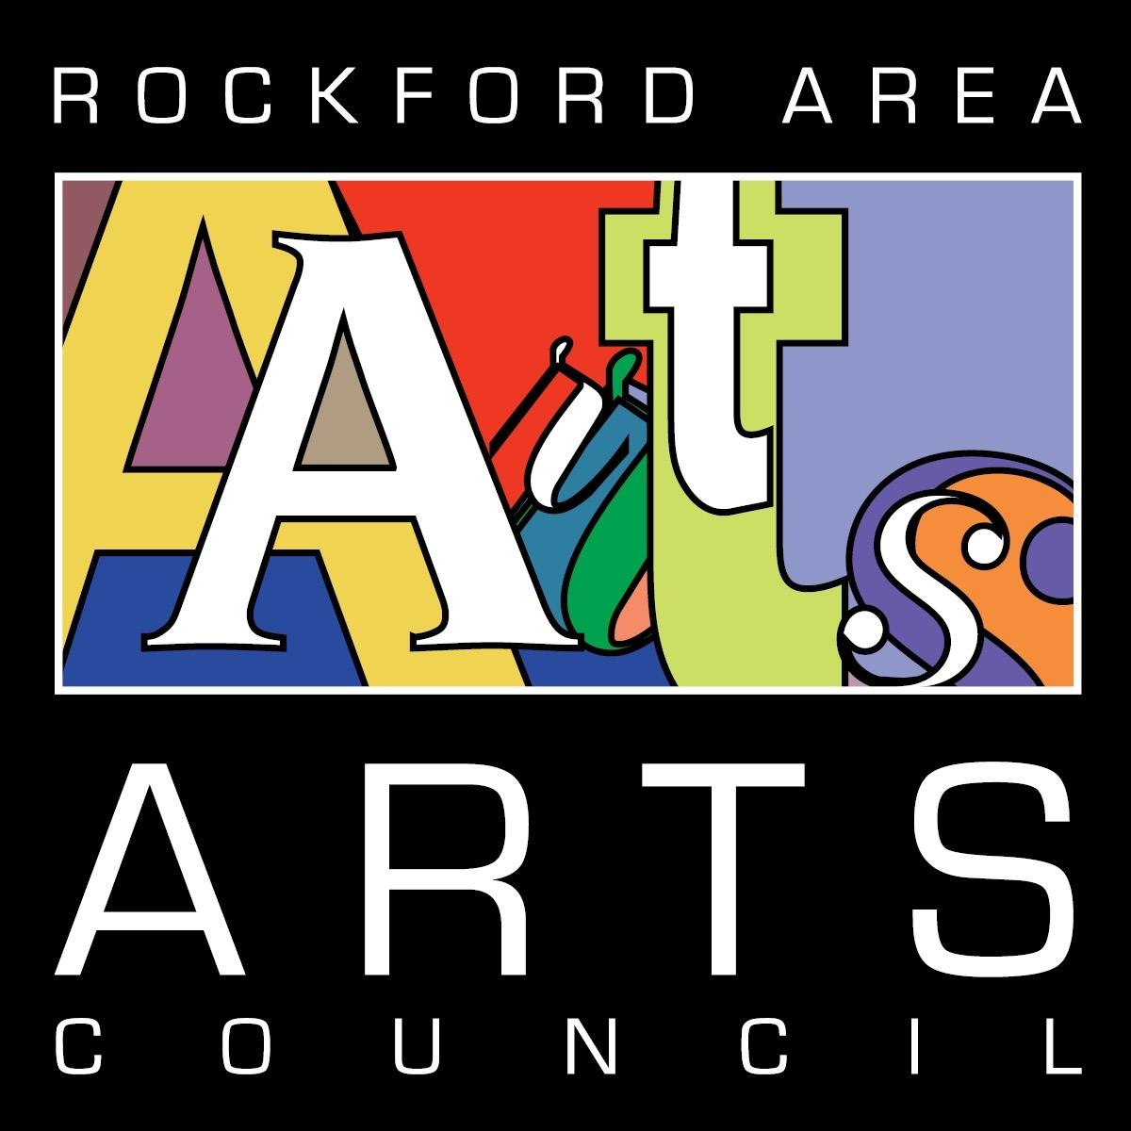 | 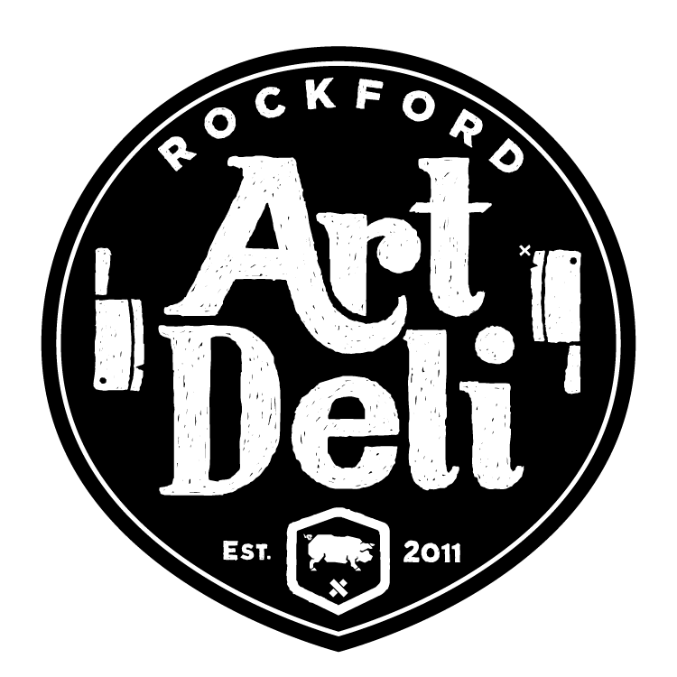 | 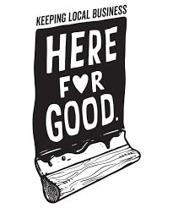

“OUR JOURNEY” MICRO-GRANT PROGRAM

In partnership with Rockford Art Deli’s #HereForGoodRKFD campaign, the Rockford Area Convention & Visitors Bureau and Rockford Area Arts Council are excited to announce the “Our Journey” micro-grant program.

The program is designed to benefit artists and art organizations by awarding microgrants up to $500 for varying amounts for creative endeavors throughout the Rockford region. Applications will be considered using criteria below along with the anticipated overall community impact. We encourage you to be creative, express your love for Winnebago County and celebrate all that our community has to offer as we recover from the economic effects of COVID-19. Our Journey Begins at Home!

Project Selection Criteria:
- Projects must be based in Winnebago County
- All artistic mediums will be considered
- Must have public impact (can be digital or via social media)
- Happy, uplifting, inspiring and colorful work is encouraged
- Absent of any political, social statements or influences
- Encouraged to be representative of our entire community
- Universal or broad-based appeal
- Design and implementation are of high quality and excellence

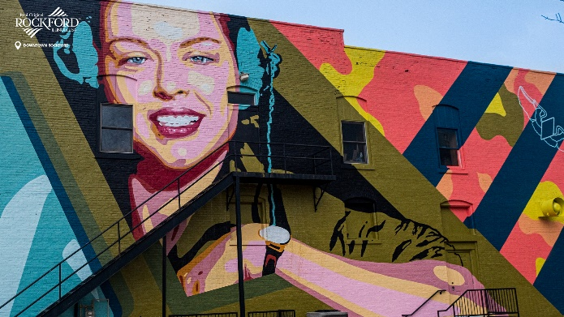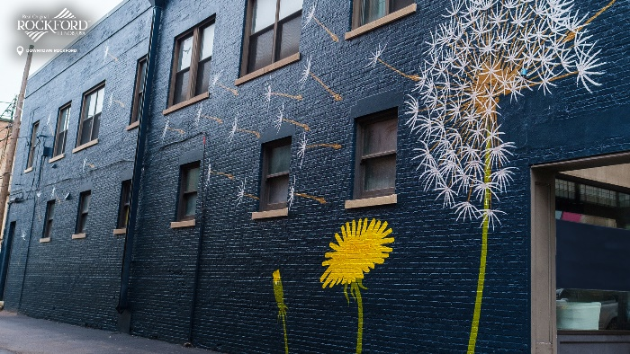

“OUR JOURNEY” MICRO-GRANT APPLICATION

Email completed application to kpaul@gorockford.com.
Decision anticipated within 30 days of submission.

Organization or Individual Name:

Project Goal:

Amount Requested:

Proposed Project Description:

Total Cost of Project:

Proposed Project Time Frame (estimated start, completion):

Contingency Plan (will project be able to go forward if full funding is not received):

Please Attach:
- Examples of past projects or organization mission statement
- Resume or list of Board of Directors

Certification:
I certify that the information contained in this application, including all attachments, and supporting materials, is true and correct to the best of my knowledge.

Signature: _________________________________________________ Date:

Print Name & Title:

Best Way to Contact:

