Performance Application
Join us for Stroll on State and enhance the joy and wonderment of Christmas and the holiday season through your gift of music. Stroll on State is a holiday celebration that kicks off the holiday season every year on the Saturday following Thanksgiving. It is free and open to the public.

Event Timeline
(subject to change)

- 8 a.m. – Stroll on State begins with the Dasher Dash 5K, a certified run, which will start and end at the UW Health Sports Factory
- 2 p.m. – Stroll on State begins! Grounds will be closed to vehicular traffic from 6 a.m. – Midnight. Performances, attractions, food and beverage will be open throughout the Stroll on State footprint in downtown Rockford.
- 2 p.m. – Stroll on State Merry & Bright Parade kicks off
- 6 p.m. – The Official City of Rockford Christmas Tree lighting will begin promptly at 6 p.m. with holiday music from the Heartland Community Church Band, remarks from Mayor McNamara, John Groh (CEO, Rockford Area Convention & Visitors Bureau) and a countdown to light the Christmas tree.
- 6:15 p.m. (approximately) – Fireworks conclude the tree lighting
- 6:30 p.m. – Stroll on State continues with performances and attractions within the Stroll on State footprint throughout downtown Rockford.

As we celebrate our 8th anniversary, we expect to exceed 2018’s attendance of 87,500 guests. Stroll on State is truly an event that is driven by community support through both monetary donations and the efforts and talents of our volunteers. Stroll has remained free to our community. We invite performers of all genres to apply to participate in this event and share their talents. Performances must be holiday music, outdoor, and donated. Thank you for your consideration of performing at Stroll!

Thank you again, from the bottom of our hearts, to all past and future performers who make Stroll on State possible!

Performance Information
We love music! Live music throughout the Stroll on State footprint is always a huge hit with people of all ages. We have a total of 3 stages, each of which feature a variety of live performances throughout the festival.

FACTS TO CONSIDER
Performances are strictly donated. Basic sound equipment is provided. Performances must be 100% Christmas music!

- Do you like Manheim Steamroller? Please apply!
- Do you perform country, jazz, rhythm and blues, and sing or play Christmas music? Please apply!
- If you sound like Pentatonix or Michael Bublé…Please, please apply!
EQUIPMENT SET-UP
You will have a maximum of 30 minutes between sets for set-up/tear-down. Sound and lighting will be provided.

The footprint of Stroll on State will be closed to traffic at 6 a.m. the day of Stroll on State (November 28, 2020). We will do our best to provide a parking location for you; however, we ask that you please reference the Stroll on State parking map for garages/lots hear your performance location. Keep in mind that most public parking decks will cost $5 to park for the day and fill up quickly.

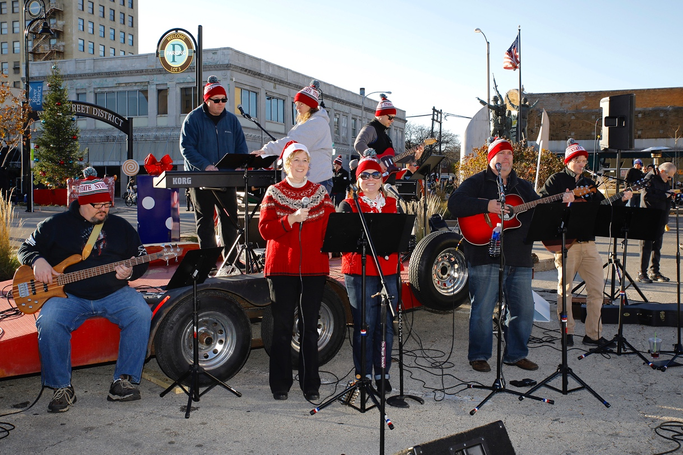

Stroll on State will do its best to allocate performance time slots based on artist preference, but please note that due to the sheer number of performance applications we receive, we may not be able to guarantee performance in your preferred locale/time. Early applications will receive priority consideration.

Stroll on State will do its best to promote all performances. Once confirmed by the Stroll on State performance selection committee that you have been selected, performers are invited to link to the event website at www.strollonstate.com and at www.facebook.com/strollonstate.

Performance Application
Please fill out ALL fields in the form.

Email Address:
Contact Phone Number:
Performer / Group Name:
Number of Members in Band:
Brief description of genre/type of performance:

Links to videos/websites/soundtracks that demonstrate your music:

Stroll on State will provide 2 wired mics, speakers and front wash lighting on the stage. There will be 15 amps available to the performer for additional equipment (provided by performer). All cords need to be provided by the performer. All instruments are provided by performer. There will be tech support at each stage throughout the evening.
Additional equipment/instruments needed for performance (provided by performer):

Time slot(s) preference:
Afternoon Evening No Preference
Outdoor Venues include public parking lot 3 (adjacent to Memorial Hall) and parking lot on the NW corner of 2nd & State Streets (both venues in close proximity to the Fire & Ice attractions).

By checking this box, the artist agrees to donate their performance for Stroll on State:
Yes, I will donate my performance to Stroll on State.
Yes, I agree to abide by all the rules/conditions/intent set forth within this agreement.

Signature: ________________________________________________________ Date: ______________________

Applications must be received on or before October 13, 2020.
Late applicants may not be considered if all slots are filled.
Early applications will be given priority consideration.

Please submit applications to:
Austin Taylor at ataylor@gorockford.com (815.489.1676)
Rockford Area Convention & Visitors Bureau, 102 N. Main St., Rockford, IL 611101

