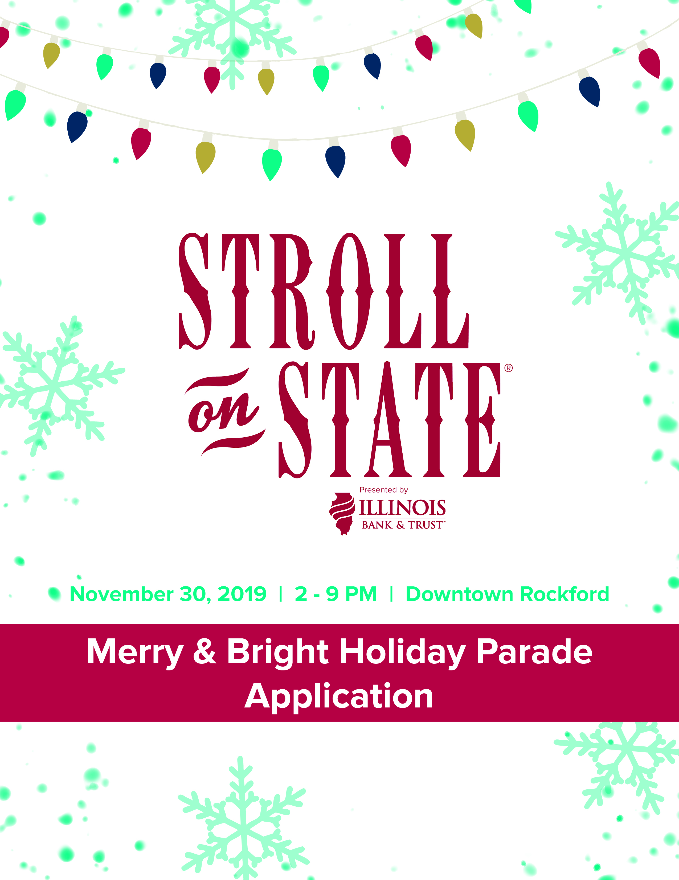
November 27, 2021 I 2 - 9 pm I Downtown Rockford

STROLL ON STATE’S
MERRY & BRIGHT HOLIDAY PARADE

Downtown Rockford will once again be an enchanted wonderland when Stroll on State steps off with its Merry & Bright Holiday Parade! Featuring fabulous floats, festive music, and costumed characters, this special celebration will create cherished memories that last a lifetime! Last year—without the ability to gather with loved ones—we faced unprecedented challenges to keeping the spirit of the season alive. The outpouring of support for our televised Stroll on State in 2020 was truly overwhelming, and we’re excited to bring our community together again—in person—this holiday season. Come join the fun on this colorful, dazzling path of pure holiday delight!

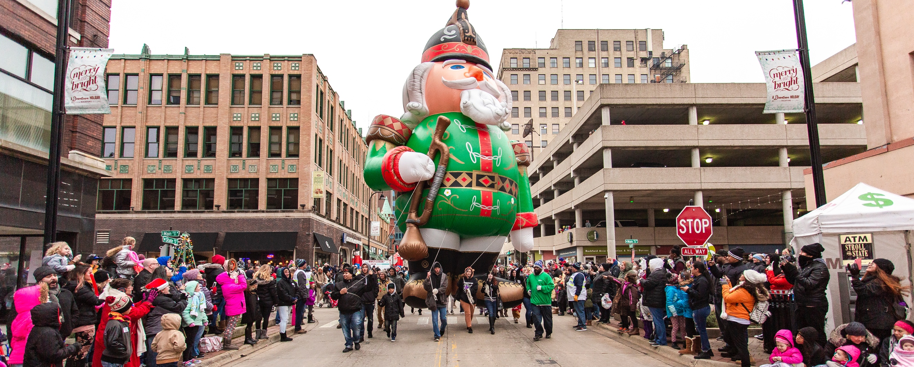

QUICK FACTS
Date/Time
Saturday, November 27, 2021
Line-up begins at 12 p.m. in the municipal parking lot at 401 S. Main Street
Step-off at 3 p.m.
Additional details/times will be provided closer to the parade date.

Theme
All parade floats/participants must be Christmas-themed.
Classic Christmas (examples: North Pole, Santa’s Workshop, Winter Wonderland)

Attendance & Broadcast Features
In recent years, almost 90,000 people have participated in Stroll on State each holiday season. The Merry & Bright Holiday Parade is a family favorite and includes a combination of balloons, bands, princesses, elves, professional quality floats, and antique vehicles. Stroll on State is an established, regionally-renowned and widely-promoted event.

Parade Route (subject to change)
The approximately one-mile route begins at 401 S. Main Street and turns east onto State Street, ending at 3rd Street. At the parade end (E. State & 3rd Streets), parade units go north on 3rd Street to 1st Street and disembark at Trinity Lutheran Church.

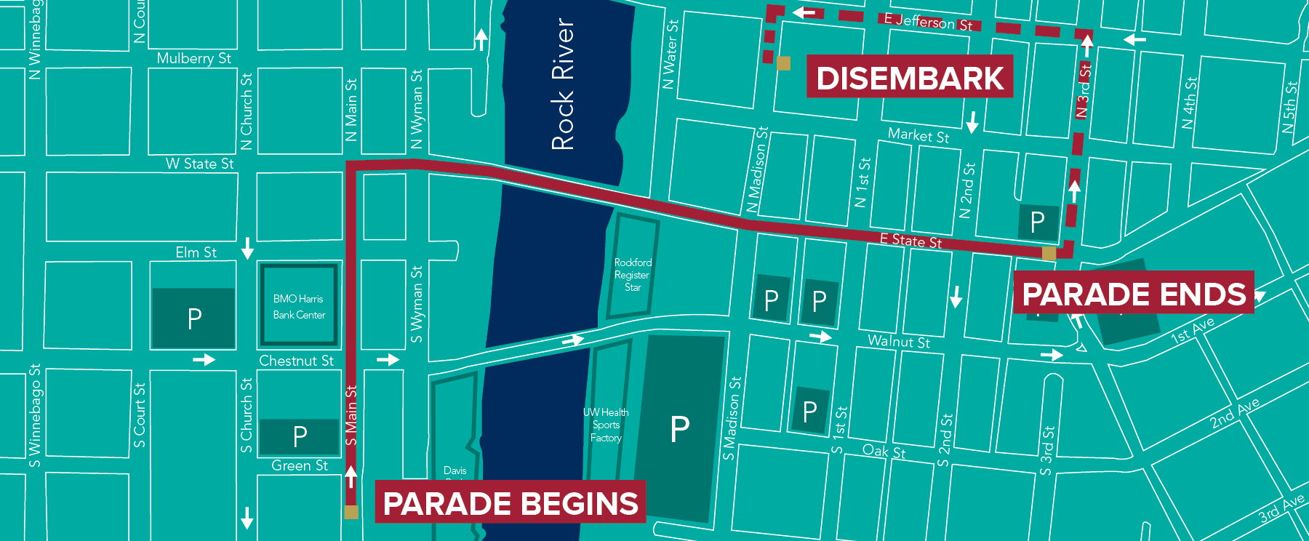

Decorations
- All entries must decorate units with a classic Christmas theme. Your entry will not be allowed in the parade if it is not decorated. Be creative and use your imagination!
- Stroll on State will provide the official Santa and Mrs. Claus for the Merry & Bright Holiday Parade. You will not be allowed to participate if someone in your party is dressed as Santa Claus or Mrs. Claus.
- Everyone in your group – whether on the float, walking, or riding – must wear Christmas apparel. Family friendly holiday wear examples are: elves, wearing a Santa hat, a Rudolph nose, Christmas sweater, etc.
- Everyone loves candy! You are encouraged to be well-stocked with candy to pass out along the route. Please note, for safety, candy cannot be thrown from the float or unit.

Floats
The Stroll on State, Merry & Bright Holiday Parade Committee is pleased to arrange for commercially prepared floats for your use. These floats average 28’ in length and 8’ in width, include your business or organization’s name on both sides, and are ready for you and your group to ascend and ride. Most floats will accommodate 12-15 people. First come, first served. Limited availability.
Please contact StrollOnState@gorockford.com for pricing options and availability. Both stock and custom options are available.

Participation Fee*
Non-Profit Fee  - $25 if turned in by November 1  - $50 if turned in after November 1  High School / Musical Act  - Fees waived before November 1 | For Profit Fee  - $50 if turned in by November 1  - $100 if turned in after November 1
*Participation will not be allowed if fee is not paid in full prior to event.

RULES
For the safety of parade spectators and participants, the following parade rules and regulations are required:

- All members of any marching/walking unit must be able to walk the entire 1-mile route. All children must be supervised by an adult.
- Only vehicles pulling floats will be allowed in the parade. Exceptions will be considered for antique vehicles and other organized specialty car groups with prior approval. Vehicles that are pulling floats should be incorporated as much as possible into the float and decorated accordingly. No vehicle may accompany marching units without written approval of the parade committee.
- Float platforms must be built on a trailer/frame no smaller than 4’ x 8’. Floats must be sturdily constructed, with rider and participant safety paramount, not presenting a health or safety hazard to participants or spectators. A photo of the towing vehicle is required with the entry form submission.
- Fire extinguishers rated 2A-10BC are required on all floats, if electrical devices are used.
- All electrical devices must be properly grounded.
- All floats must have handholds or standup holds for each rider on the float. Any self-propelled float must have a spotter beside the float, who is in two-way communication with float driver.
- No participant may jump on a float to ride and may not interfere with any other unit in any way. Float capacity will not be exceeded. No participant will dismount from a float during the parade route. Participants will not have legs, feet, etc. extending past the sides, front, or rear of float, as this is a safety hazard.
- All banners must be professionally lettered and legible. The word “Christmas” must be spelled out fully – please do not use “X-Mas.”
- It is strongly encouraged to include Christmas music, approved by the SOS Merry & Bright Holiday Parade Committee. Music must be played at a compatible sound level. Parade officials have the complete authority in this matter and reserve the right to withdraw any unit that does not comply with instructions to turn down or turn off sound when instructed to do so. Failure to comply with officials’ instructions will result in immediate removal from the parade and jeopardize future participation.
- Any parade unit that performs exhibitions en route must be a moving demonstration as not to cause gaps in the parade. A space of 50’ between each unit will be enforced. If for any reason a gap of more than 50’ is created, marching units must increase their pace to close the gap. All units are required to close the gap between units when instructed by parade officials. Failure to do so may warrant removal from the parade. All marching units must maintain forward motion. Routines that cause gaps will not be permitted. Stopping or reversing motion will result in removal from the parade.
- All float units are to be in their assigned space in the parade staging area no later than 1:30 p.m. (Late arrivals may not be accommodated.)
- A copy of the rules, signed by the person in charge of the entry, must be in their possession at the time of inspection, and a copy is to be attached to the parade application.
- Place your number on the right-hand side of the lead vehicle with a clear view for the announcers and cameras (provided by Stroll on State).
- Although candy is encouraged, to increase the safety of the children watching the parade, items may not be thrown to spectators during the parade. You may walk alongside the parade unit and place candy in the hands of attendees. If parade units want to hand out anything other than candy (cannot be a paper handout), it must be pre-approved and holiday-themed.
- Political or social cause campaigning is not permitted.
- Paper handouts of any kind are not permitted.
- Only Stroll on State designated animals will be permitted in parade units. Dogs may not ride on floats due to safety concerns for spectators and the animal.

2021 STROLL ON STATE,
MERRY & BRIGHT HOLIDAY PARADE ENTRY FORM
Name of Organization:
Contact Name:
Email Address:
Mailing Address:
City: State: Zip:
Phone Number – Day: Evening: Cell:
Entry Name:

Brief description of entry in 25 words or less: (required)

Sponsor Type (please select a level):
For-profit business
Non-profit/educational organization (must provide certification verifying non-profit status)
Non-profit sponsored by a for-profit company
Number of Participants:
Entry Type:
Float provided by entry organization
Commercial float, rented from the Stroll on State Merry & Bright Holiday Parade Committee
Marching/walking
Costumed character (Except NO Santa Claus or Mrs. Claus)
Classic car
Band / Musical Group / Dance Group

- Please submit this entry form by end of day November 1, 2021 to StrollOnState@gorockford.com.
- All float entries must submit this parade application along with a diagram of the float by November 7, 2021.
- No entry forms will be accepted after November 19, 2021.
- Submission of an entry form does not guarantee acceptance. Acceptance of parade applications will be reviewed and selected by parade committee.
- Entrants will be notified of application status by phone or email.
- Please make checks payable to “RACVB” (Rockford Area Convention & Visitors Bureau)
- All participants approve of video and photos taken of the parade.

If making a float, please provide a sketch with color
or include a photo if available: (required)

Float Dimensions:
Length:
Width:
Height:
I agree that candy will not be thrown from the float. (Walkers are encouraged to pass out candy along the route.)

Contact Info: StrollOnState@gorockford.com | 815.963.8111

FLOAT EXAMPLES
