Interim Guidance for Risk Assessment for COVID-19
SARS-CoV-2 is a novel coronavirus that has emerged and caused Coronavirus Disease (COVID-19). Public health experts continue to learn about SARS-CoV-2, but based on current data and similar coronaviruses, spread from person-to-person happens most frequently among close contacts (those within about six feet for a time period of 10 minutes) via respiratory droplets.

- What are the symptoms of COVID-19?
  - Fever, new or worsening cough, or shortness of breath.
- How does COVID-19 spread?
  - COVID-19 is spread by:
    - Close contact: defined as (a) being within approximately 6 feet (2 meters) of a COVID-19 case for a prolonged period of time; close contact can occur while caring for, living with, visiting, or sharing a healthcare waiting area or room with a COVID-19 case, or (b) having direct contact with infectious secretions of a COVID-19 case (e.g., being coughed on).
    - Touching a surface or object with the virus and then touching mouth, nose or eyes.
- Does wearing a mask prevent someone from being exposed to COVID-19?
  - No. The IDPH has not found a mask to prevent exposure to COVID-19; they should not be used as a preventative measure.
  - Masks should be saved for patients with COVID-19 and medical staff – and used as directed by the manufacturer and medical professionals.
- What should employees do after they receive a diagnosis?
  - If the employee is diagnosed with COVID-19 or potential COVID-19, initially, the employee will continue on approved time off with pay. The employee should alert their supervisor. If the employee has tested positive for COVID-19, the employee should remain under home isolation precautions from seven days after symptoms started and until 72 hours after fever is gone and symptoms have improved, whichever is longer, in accordance with direction from local public health.

- As a supervisor, after learning of my employee’s potential COVID-19 symptoms or diagnosis, what should I do?
  - Remain calm. Local or state public health officials will reach out to you and to any affected co-workers with directions if it will be necessary to take additional measures. Supervisors may always exercise discretion and caution – for instance, working to ensure distance between employees, moving work stations if an employee recently has been sick, sending home employees who feel sick, and promoting compliance with public health guidance.

- As a supervisor, if I learn of a case or potential case of COVID-19, who should I tell? What about employees’ private medical information?
  - Supervisors do not need to inform IDPH of COVID-19 cases; IDPH will be informed of such laboratory-confirmed cases by private laboratories or IDPH Laboratories.
  - When dealing with employee medical information, employers, including supervisors, have a general duty of confidentiality. As such, supervisors should not discuss an employee’s medical information with anyone other than the supervisor’s chain-of-command, HR, or Labor Relations. An employee’s medical information should be kept in the utmost confidence and only discussed as needed for legitimate business reasons.
  - It is public health officials – not supervisors – who should alert co-workers about exposure.
- If an employee fears they have been exposed to COVID-19, what should they do?
  - If an employee has had close contact with a confirmed case of COVID-19, the employee will receive instructions from the local health department about what work, movement restrictions, and monitoring are required.
  - If an employee asks you about a potential close contact, you can refer them to the definition in Question 2 and advise them to call their medical provider or local health department for further instruction.

- What is social distancing?
  - Social distancing means remaining out of community settings, avoiding public transportation (such as buses, subways, taxis, ride sharing, trains), and maintaining at least 6 feet in distance from others. Public health guidance suggests that people who can stay home do stay home as much as possible.
- What is the contact information for the Illinois Department of Public Health?
  - Call the IDPH Hotline at 1-800-889-3931 or email dph.sick@illinois.gov.
- Where can an employee or supervisor access more information about COVID-19?
  - IDPH’s COVID-19 FAQ.
  - CDC Interim Guidance for Risk Assessment of COVID-19.
  - Monitor for illness using the HCW Employee Monitoring Tool.
  - Evaluate for COVID-19 against the COVID-19 Testing Decision Matrix.

Exhibit 1 – Risk Categories
Note – these are interim and subject to change.
Table 1: Risk Categories for Exposure to Laboratory-Confirmed Cases of COVID-19
Risk Level | Geographic (Travel-associated) Exposures | Exposures identified through Contact Investigation
High | Travel from Hubei Province, China | Living in same household as, being an intimate partner of, or providing care in a nonhealthcare setting (such as a home) for a person with symptomatic laboratory-confirmed COVID-19 infection without using recommended precautions for home care and home isolation
Medium | Travel from mainland China outside Hubei Province or Iran  Travel from a country with widespread sustained transmission  Travel from a country with sustained community transmission  Country-level risk classifications | Close contact with a person with symptomatic laboratory-confirmed COVID-19  On an aircraft, being seated within 6 feet of a traveler with symptomatic laboratory-confirmed COVID-19 infection (distance equals approximately 2 seats in each direction)  Living in same household as, an intimate partner of, or caring for a person in a nonhealthcare setting (such as a homme) to a person with symptomatic laboratory-confirmed COVId-19 infection while consistently using recommended precautions for home care and home isolation
Low | Travel from any other country | Being the same indoor environment (e.g., a classroom, a hospital waiting room) as a person with symptomatic laboratory-confirmed COVID-19 for a prolonged period of time but not meeting the definition of close contact
No identifiable risk | Not applicable | Interactions with a person with symptomatic laboratory-confirmed COVID-19 infection that do not met any of the high-, medium-, low-risk conditions above, such as walking by the person or being briefly in the same room

Table 2: Summary of Contacts of Asymptomatic Exposed to COVID-19
Risk Level | Geographic (Travel-associated) Exposures | Exposures identified through Contact Investigation
High | - Quarantine (voluntary or under public health orders) in a location determined by public health  - No public activities  - Daily active monitoring  - Controlled travel | - Immediate quarantine (or isolate if symptomatic)  - Assessment to determine need for medical evaluation  - Controlled travel
Medium | Close contacts:  - Recommendation to remain at home or in a comparable setting  - Practice social distancing  - Active monitoring  - Postpone long-distance travel on commercial conveyances  Travels from Countries with widespread transmission:  - Recommendation to remain at home or in a comparable setting  - Practice social distancing  - Active monitoring  - Postpone long-distance travel on commercial conveyances  Travel from Countries with community transmission  - Practice social distancing  - Self-observation | - Self-quarantine (unless symptomatic then self-isolate)  - Seek health advice to determine if medical evaluation is necessary (which should be guided by clinical presentation and diagnostic testing by PUI definition)  - Controlled travel while symptomatic person wearing face mask
Low | - No restriction on movement  - Self-observation | - Self-quarantine, social distancing  - Seek health advice to determine if medical evaluation is necessary (which should be guided by clinical presentation and diagnostic testing by PUI definition)  - Post-pone commercial conveyances until no longer symptomatic
No identifiable risk | None | - Self-quarantine, social distancing  - Seek health advice to determine if medical evaluation is necessary (which should be guided by clinical presentation and diagnostic testing by PUI definition)  - Post-pone commercial conveyances until no longer symptomatic
Note: The public health management recommendations made above are primarily intended for jurisdictions not experiencing sustained community transmission. In jurisdictions not experiencing sustained community transmission, CDC recommends that post-exposure public health management for asymptomatic exposed individuals continue until 14 days after the last potential exposure; however, these decisions should be made based on the local situation, available resources, and competing priorities. These factors should also guide decisions about managing symptomatic exposed individuals.

Exhibit 2: Releasing Cases and Contacts

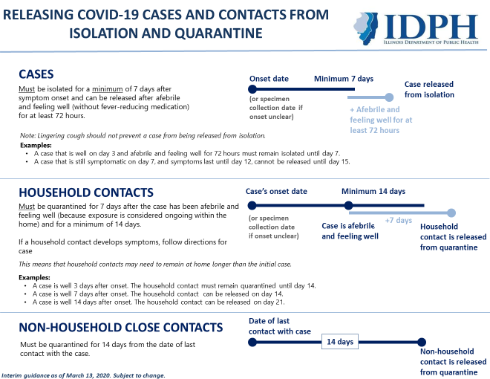

Exhibit 3: Who Should I Call About COVID-19?

