**Rockford Area Convention & Visitors Bureau**

**VICE PRESIDENT OF MARKETING**

Rockford, IL

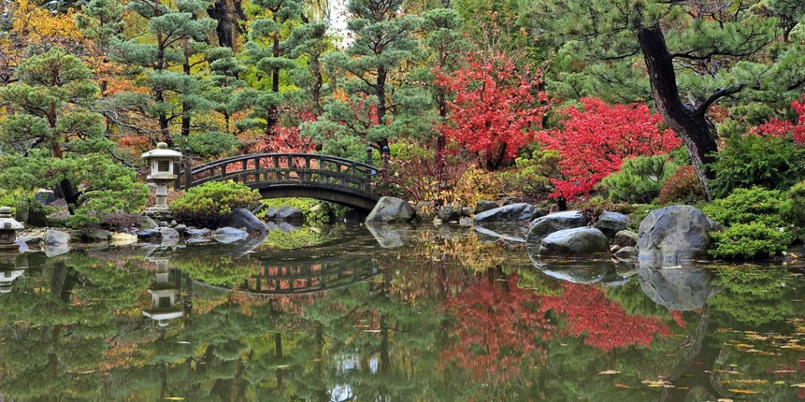

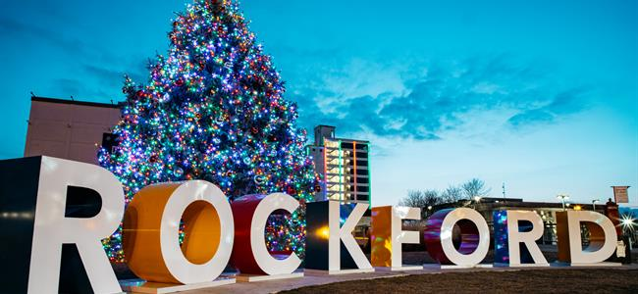**EXPLORE ROCKFORD**

***You Were Made For Rockford If…***

If you'd like to trade cramped quarters for open spaces, build equity rather than paying the landlord, experience less traffic and enjoy remarkable outdoor spaces, and live in a diverse community with a walkable downtown that loves and supports its small businesses; welcome home - you were Made for Rockford.

***Live (Large) And Prosper in The Rockford Region***

Recently, we took the opportunity to talk to folks who have moved back to Rockford (we call them “Boomerangers”) and folks who have moved here for the first time (we call them “new friends”). From young adults who chose to move back to be near their parents as they’re raising their own families to retirees looking to enjoy Rockford’s low-hassle, high-value lifestyle, we heard one common theme: “we can afford to do so much more here - we’re living bigger lives.” If you want to live a bigger life while spending less money, you were Made for Rockford.

***1.5 Hours Max to Other Vibrant Destinations/Transit Hubs***

Thanks to our central location smack dab in the middle of America, Rockford residents enjoy easy access to the best the Midwest has to offer. We love being able to visit Chicago, Milwaukee, Madison and many other locations on a whim. They’re literally a hop, skip and a jump away. When we really get the travel bug, we can take advantage of our proximity to the world through O’Hare International Airport, Milwaukee’s Mitchell International Airport and our own Chicago/Rockford International Airport. And that also means our visitors have many options to get to Rockford!

The Rockford region is an incredibly diverse enclave of interesting people doing amazing things. Take a moment to meet a few folks who have made a life in Rockford. [Hear their stories.](https://www.gorockford.com/about/our-city-our-story/) Feel their passion. More than likely, you’ll be able to imagine yourself creating your own story in Rockford, too.

***When You Want to Own Your Life, Not Rent It***

With the Rockford region’s comparatively low cost of housing, the dream of homeownership can become yours. Or, perhaps you want to pay the same - but live in a LOT more house than in your current high-cost-of-living community. If it’s three (affordable) bedrooms with a view you’re after, you were Made for Rockford.

***Welcome to (Your Kind of) Downtown***

Like a lot of downtowns in the middle of America, downtown Rockford went through some hard times. But *unlike* a lot of downtowns in recent years, Rockford’s downtown is once again an energetic hub of commerce, livability and entertainment. Our beautiful downtown straddles the rolling Rock River and has been the beneficiary of $800 + million in recent public-private investment - along with buckets full of passion, ingenuity and hard work. Downtown Rockford is now recognized as a flourishing live, work, learn, play destination for people of all ages. If that sounds like *your*kind of downtown, you were Made for Rockford.

***For Those Who Were Born to Make a Difference***

If you long to be an essential part of a real community, consider moving to the Rockford region. All people are welcome here in our diverse community. And, alongside others on a mission, those who want to make a difference in the lives of others can do so in our myriad of inspiring not-for-profit community organizations. From coaching sports to teaching music to mentoring children to helping those in need if you like to help, you were Made for Rockford.

***Our Region Builds Champions***

Rockford has been a pioneering sports town since the mid-1980s, when it opened its first of many multi-purpose sports complexes. Decade after decade, we’ve set the standard for hosting sports tournaments with our unparalleled venues, accessibility and drive market, and the tourism and hospitality professionals that proudly call the region home. Thanks to its marketing and sales results and industry leadership, **the Rockford Area CVB has garnered five national awards for its industry work since 2016**, created a growing variety of locally produced events and driven millions in economic impact to the region from hosted sports tourism events.

Our facilities portfolio includes the state-of-the-art [**UW Health Sports Factory (UWHSF**](https://www.gorockford.com/sports/sports-factory/)**)** designed for championship caliber basketball, volleyball and much more with its 105,000 square feet of competition space. The Sports Factory, as it’s known by residents and visitors, is located just across the Rock River--a national events venue in its own right--from the 160-room [Embassy Suites by Hilton Rockford Riverfront](https://www.gorockford.com/listings/embassy-suites-by-hilton-rockford-riverfront-%26-rockford-conference-center/1433/) that opened in 2020 and the 7,500-seat [BMO Harris Bank Center](https://www.gorockford.com/listings/bmo-harris-bank-center/429/).

Head across town to Loves Park where you'll find [**Mercyhealth Sportscore Two**](https://www.gorockford.com/sports/mercy-sportscore-two/), which features 26 outdoor fields--including six with turf and lights for night games. The venue also comes equipped with the 2,500-seat Wedgbury Stadium and the 200,000+ square foot Indoor Sports Center. The complex remains a regular site of national soccer, baseball, softball, Ultimate, rugby, football, lacrosse and wrestling events. Need more fields of play? [**Mercyhealth Sportscore One**](https://www.gorockford.com/sports/mercy-sportscore-one/), the facility that opened in the mid-1980s to jumpstart the region's entry in sports tourism, offers 17 natural grass soccer fields and eight baseball/softball diamonds in northwest Rockford.

Need more world-class sports venues? Check out the one-of-a-kind [**West Rock Wake Park**](https://westrockwakepark.com/)and take a ride around the cables at historic Levings Park. Additional unique venues in the Rockford region include the wide-body Rock River for rowing, skiing and other water sports and region-wide high school field houses, including the Auburn High School's field house that features full indoor track and field capabilities that allows it to host national meets.

***Move Forward on Arrival with a Bigger Quality of Life***

The Rockford region is a real, original “City of Gardens” and rivers, and a wonderful place to spend a life, or a weekend. Explore one of our museums, visit some unique shops, grab a bite to eat at one of our many restaurants, take in some arts and culture, or relax at one of our hotels. You’ll be in good company in real, original, Rockford.

* [Arts & Culture](https://www.gorockford.com/things-to-do/arts-culture/) – Rockford’s arts and culture scene is one of its many facets. Whether it’s a trip to Frank Lloyd Wright’s Laurent House, an afternoon spent at the Rockford Art Museum, or a night at the theatre or symphony, Rockford has something for every taste.
* [Gardens](https://www.gorockford.com/things-to-do/gardens/) – There’s such a variety of abundant gardens to explore right here in the Forest City. With the reputation as the “City of Gardens,” there is beauty to explore all year long at the region’s local museum campuses, forest preserves, arboretums, paths and along the beautiful Rock River.
* [Museums](https://www.gorockford.com/things-to-do/museums/) – Our Riverfront Museum Campus features three museums in one convenient location featuring Rockford’s newest and oldest dinosaur named Jane at Burpee Museum of Natural History, the more than 250 hands-on children exhibits at the Discovery Center Museum, and the “most significant collection of Chicago art, inside or outside the city,” at the Rockford Art Museum.
* [Nightlife](https://www.gorockford.com/things-to-do/nightlife/) – Creative craft cocktails have become a trendy staple at bars and clubs across the country, and in the Rockford region that sentiment holds true.
* [Outdoor Activities](https://www.gorockford.com/things-to-do/outdoor-activities/) – The Forest Preserves of Winnebago County is one of the best systems in Illinois with more that 10,000 acres of natural areas, recreational areas, lakes, rivers, and forests to explore.

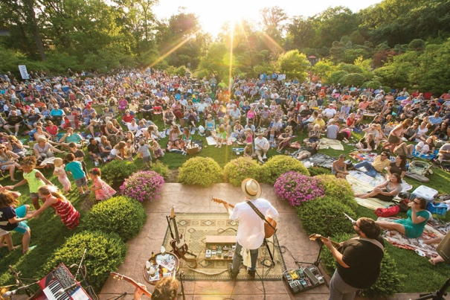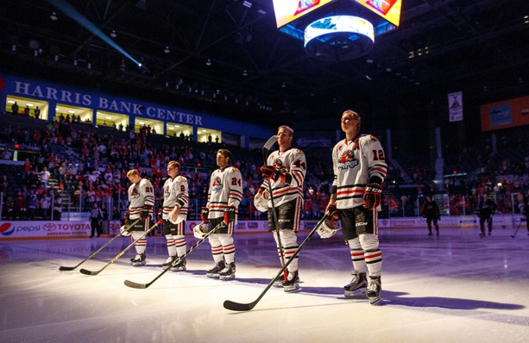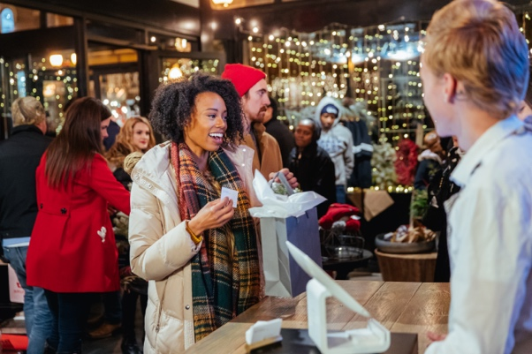

* [Runs, Walks and Rides](https://www.gorockford.com/things-to-do/races/) – Lace up your running or walking shoes. There are many local races to participate in throughout the year.
* [Sports](https://www.gorockford.com/things-to-do/sports/) – Cheer on the Chicago Blackhawks affiliated Rockford IceHogs professional hockey team or the Rockford Rivets collegiate baseball team.

**ABOUT THE ROCKFORD AREA CONVENTION & VISITORS BUREAU**

Rockford Area Convention & Visitors Bureau is a private, non-profit organization established in 1984 to promote and champion efforts to make the Rockford Region an overnight visitor destination. The mission of RACVB is to drive quality of life and economic growth for our citizens through tourism marketing and destination development.

Community leadership has long been a hallmark of RACVB. We eagerly seek out opportunities to partner with other leaders throughout the region to work in lockstep toward making our community its Real. Original. best.

From supporting small businesses with pandemic survival and economic recovery; to chartering our Welcoming Diversity commitment (and encouraging others to do the same); to seeking innovative, new revenue streams; and beautifying public spaces with art, RACVB has continued to play a lead role in community collaborations.

RACVB is dedicated to doing our part to ensure the Rockford region is welcoming to all. We are committed to showcasing love, acceptance, equitable inclusion, and respect for our diverse residents, visitors and a culture that helps to make our region vibrant.

## **Organizational Priority Results:**

**1. CREATE ECONOMIC WEALTH:** The Rockford Region experiences growth in tourism's leading indicators.

**2. ENHANCE TOURISM PRODUCT:** The Rockford Region offers unique and marketable experiences and venues that meet or exceed visitor expectations and enhance quality of life for citizens.

**3. ENGAGE CONSTITUENTS ON BEHALF OF TOURISM:** RACVB tourism marketing and destination development efforts have broad support among key stakeholders.

## **External Role Statement:** The RACVB adds wealth to the region's economy by growing tourism.

Click [here](http://www.gorockford.com/) and [here](http://www.madeforrockford.com/) for more information.

**POSITION SUMMARY**

The Vice President of Marketing will effectively oversee the development and implementation of all RACVB marketing, public affairs, and advocacy programs. This position serves as a member of the RACVB’s senior leadership team.

**TEAM SUMMARY**

The Marketing and Communications team is responsible for planning, executing and measuring RACVB’s MarCom brand management, group sales, leisure marketing and community and stakeholder relation activities.

**ESSENTIAL JOB FUNCTIONS**

* Identifies, develops, and evaluates overall marketing strategy based on knowledge of established objectives, market characteristics, and cost and margin factors.
* Develops, implements, and evaluates all internal and external marketing, communication, and public affairs programs.
* Develops, implements, and evaluates regular and strategic communication to/with stakeholders to ensure awareness, engagement, and support for RACVB and the destination.
* Creates strategies to use electronic/digital and social media to promote RACVB and the destination; establishes metrics to measure the effectiveness of marketing messages.

**STAKEHOLDER AND COMMUNITY RELATIONS**

* Ensures regular communications (news releases, newsletters, e-updates, etc.) to/with stakeholders to ensure awareness and engagement.
* Develops, implements, and evaluates all internal and external advocacy, public affairs, and community relations programs.
* Works with the CEO to manage political action involvement and government affairs.
* Manages close working relationships with local media to ensure RACVB is properly positioned.
* Actively participates in trade shows, community events, and organizations to promote RACVB.

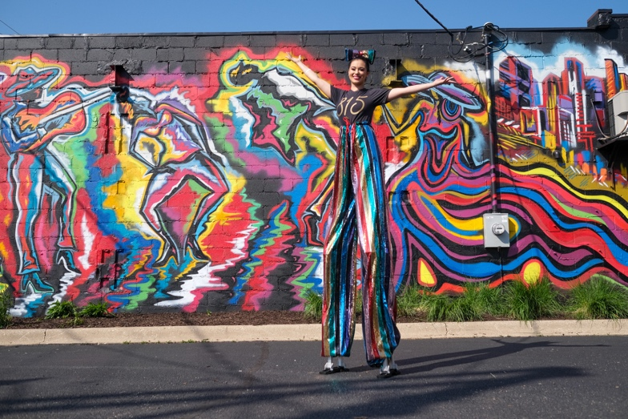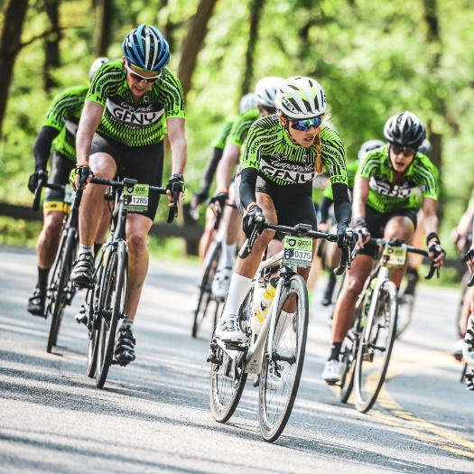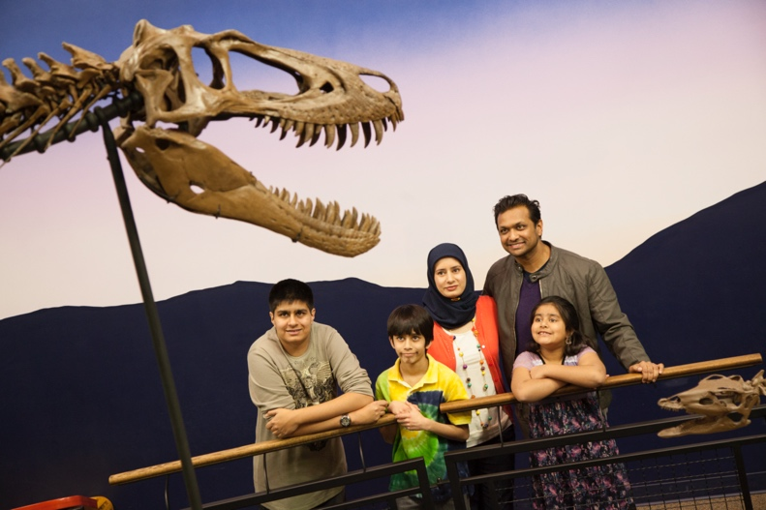

**PROJECT MANAGEMENT**

* Leads the overall direction, coordination, completion, and control of MarCom projects, ensuring consistency with RACVB strategy, commitments, and goals.
* Monitors project timelines to ensure milestones are achieved.
* Presents regular progress reports to the CEO, Executive Team, and other stakeholders.
* Evaluates and assesses results of completed projects to ensure ongoing success and sustainability.

**PRODUCT DEVELOPMENT**

* Collaborates with the CEO to perform market research and analyzes results to develop new visitor projects and programs that enhance the region as a destination.
* Identifies and monitors macro tourism trends to recommend new ideas and approaches of attracting tourism to the Rockford region.
* Works with the group sales staff to forecast, plan and promote services with a results-oriented objective of profitability of services through effective marketing strategies.
* Monitors and evaluates competitor approaches to marketing and trends in tourism to continually bring new product development and marketing ideas to RACVB.

**PLANNING LEADERSHIP**

* Functions as part of the senior leadership team.
* Assists in the development and implementation of short- and long-term corporate strategy that is aligned with Board directives and Ends Policies.
* Effectively manages a budget that supports RACVB’s overall strategy.
* Serves as an organizational spokesperson, including with media, community groups, and stakeholders.

**PERFORMANCE AND ACCOUNTABILITY REPORTING, RESEARCH**

* Working with the CEO and staff, serves as the internal advisor on Board Governance and company policies, and manages the preparation and submittal of Board monitoring reports. Ensures systems include a feedback loop to receive information from stakeholders and the community.
* Directs and reports research conducted among leisure travelers, meeting/event planners, and local stakeholders.
* Collects and disseminates primary and other research information pertaining to current and future trends of group market segments.
* A picture containing text, building, floor, people

  Description automatically generatedManages the collection, analysis, and reporting of data that indicates accountability performance, including hotel data, City and County tax receipts, and other key industry and organizational indicators.

**TEAM MANAGEMENT**

* Directs the hiring, training, and performance management of marketing staff of 3 full-time employees, advertising/marketing agency, and communications contractors, to meet overall results.

**CRITICAL KNOWLEDGE, SKILLS, AND ABILITIES**

* Represents and performs a leadership role inside and outside the organization with a global mindset.
* Possesses excellent communications capabilities in both written and oral forms and comfort with public speaking as a representative of RACVB.
* Encourages and builds mutual trust, respect, and cooperation among team members.
* Possesses a thorough understanding of planning and performance management principles and can lead others in transforming vision into action that can be measured and evaluated.
* Performs assignments in support of the high ethical standards set for RACVB staff.
* Performs critical analysis, draws conclusions, and makes recommendations about tourism trends.
* Identifies needs and evaluates services to ensure customer satisfaction.
* Directs the creation and implementation of innovative concepts, messages, images, and delivery systems.
* Is detail-oriented and an effective process/project manager.
* Has strong interpersonal skills that allow for success internally and externally and works in a team environment.
* Works comfortably with Board members and elected officials and facilitates their engagement.
* Works effectively with local, state, and federal government staff/elected officials.
* Is actively involved in the community and its public/private organizations.
* Is flexible and willing to effectively recommend ideas to the CEO.
* Communicates with and effectively directs staff activities.
* Has knowledge of marketing principles and methods for promoting and selling services.
* Collaborates with sales staff in developing media to promote and sell services.

**KEY CONTACTS**

* RACVB Staff
* RACVB Board Members
* Leisure/Group Customers
* Vendors/Consultants
* Destination Partners
* City and State Tourism Industry Leaders
* Community/Government Leaders
* Local/Regional/National Media

**EDUCATION/EXPERIENCE REQUIREMENTS**

* Minimum of a bachelor’s degree in Business, Marketing, Management, or Communications, plus 5 to 7 years related destination and tourism experience; or equivalent combination of education and experience.
* Prior management and destination marketing experience is preferred.
* Should demonstrate experience in innovative use of various promotional tactics in marketing media, including print and digital as well as effectively managing the process of creating and producing a variety of marketing promotions, materials, and programs.
* Experience in research, strategy, creativity, collaboration, and project management skills to produce meaningful results.

**If interested in learning more about this great opportunity, please send your resume to the SearchWide Global Executive listed below.**

**Donna Thornton,** Executive Recruiter | SearchWide Global

[www.searchwideglobal.com](http://www.searchwideglobal.com) | [info@searchwideglobal.com](mailto:info@searchwideglobal.com)

202-951-0406 (mobile)

**About SearchWide Global**

SearchWide Global is a full-service executive search firm primarily for companies in the travel, tourism and convention, and hotel and lodging industries. We specialize in C-Level, Director, and Management level executive searches for companies ranging in size from Fortune 500 corporations to mid-sized public and private companies.