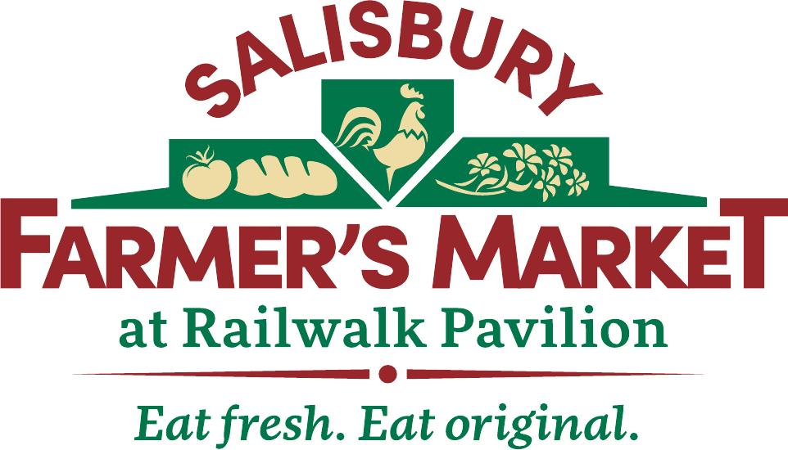
2024
Monthly Craft Market Rules and
Application

The Salisbury Farmers Market is excited to announce plans for a monthly craft market. Craft Vendors will be set-up in the gravel parking lot, between the Market Pavilion, and the Salisbury Emporium.
The Craft Market will be open the 1st Saturday of each month, beginning May 4, 2024. Market will operate 8-12.
Vendors must submit an application to the Salisbury Farmers Market, and receive approval, prior to setting up at market. Applications must be received prior to April 1, to be considered for opening day.
Fee will be $15/booth/day.
Each booth is limited to 10’x10’.
Crafts sold at the Salisbury Farmers Market must be preapproved by the Market Board. All crafts must be hand made by the vendor.
The North Carolina Department of Revenue requires vendors to obtain a certificate of registration. You must collect the appropriate tax and register with NCDOR, and provide a copy of your certificate to the market manager. ​
Spaces will be assigned by the Market Manager
No vehicles will be allowed in lot between 7:15am and 12:10pm.
All complaints must be submitted in writing to the market manager.

2024 Monthly Craft Market
Application
Opening Day
May 4, 2024

Name: ____________________________________________________
Business Name: _____________________________________________
Address: ___________________________________________________
__________________________________________________________
Phone number: _______________________
Website: ___________________________________________________
Social Media: _______________________________________________
E-mail: ______________________________
Emergency Contact: _______________________________
County in which the product is produced: _______________
NCDOR Tax Number: ________________________

Please make a detailed list of the product(s) you wish to sell.
__________________________________________________________ __________________________________________________________________________________________________________________________________________________________________________________________________________________________________________________________________________________________________

Months you wish to participate in market________________________
Website you would like linked to your Name/Business in the Newsletter: ___________________________________________________________.
Market Board may use their discretion in which spaces will be available for selection in order to meet the needs of the vendors and maintain market balance.

Applications will be reviewed by the Salisbury Farmers Market Board of Directors.

All applications are due April 1, 2024

If applications are received after the deadline, they will be reviewed by the Board of Directors within 30 days. The vendor will be notified of acceptance or denial once board has voted.

I have read and agree to abide by the 2024 Rules and Policies of the Salisbury Farmer’s Market.

Signature: ______________________________________
Date: ________________

Email completed applications to: Leigh Anne Powlas, Manager
manager.salisburyfarmersmarket@gmail.com
The Salisbury Farmer’s Market provides equal opportunity regardless of race, color, creed, national origin, religion, sex or age.

Rates for 2024- $15/day

If you have further questions, please email- manager.salisburyfarmersmarket@gmail.com

