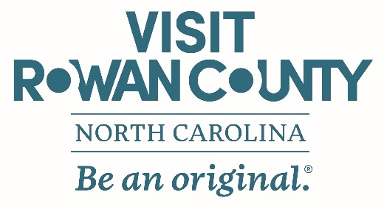
REQUEST FOR TOURISM, VISITOR, OVERNIGHT & HOSPITALITY RELATED SPONSORSHIP

Organization Name: Click or tap here to enter text. Federal Tax ID: Click or tap here to enter text.
Address: Click or tap here to enter text.
Project Director: Click or tap here to enter text. Phone: Click or tap here to enter text.
Project Director Email: Click or tap here to enter text.
Project Name: Click or tap here to enter text. ☐ New Event ☐Existing Event:
Date of last event: Click or tap here to enter text.
Project Start Date: Click or tap here to enter text. Project End Date: Click or tap here to enter text.
Organization’s Annual Budget: Click or tap here to enter text.
Total Project/Event Budget: Click or tap here to enter text.
(*Provide a detailed budget and funds provided by applicant, including marketing and advertisement efforts)

Narrative Description of Event/Project: (*Include: organizations purpose/goals for the event, what activities will occur, timeline of activities, partners involved in project/event, targeted audience of the event/project) Click or tap here to enter text.

Event/Project Justification & Benefit to Tourism in Rowan County: Click or tap here to enter text.

How will this attract new visitors? Click or tap here to enter text.

Anticipated Reach: Click or tap here to enter text.
Projected Number of Generated Hotel Room Nights: Click or tap here to enter text.

Describe marketing efforts that will be facilitated to promote event: Click or tap here to enter text.

Has your organization received previous Tourism funds? ☐Yes, Amount: Click or tap here to enter text. ☐No
Does your organization receive tax funding? ☐Yes, Amount: Click or tap here to enter text. ☐No
Tax Funding Source: ☐Local ☐State ☐Federal
Does your organization receive funding from a foundation(s): ☐Yes ☐ No
Foundation Name: Click or tap here to enter text. ☐ For profit ☐ Non-Profit
REQUIREMENT | ANY TOURISM RELATED EVENT | NON-TICKETED EVENT | TICKETED EVENT
Tourism Related Event Annual Economic Impact: | Minimum Impact of $5,000 | Minimum Impact of $10,000 | Minimum Impact of $10,000
Eligible for: (and/or) | Up to $500 in hospitality support (food, beverage & venue) | Up to $1,000 in hospitality support (food, beverage & venue) | Up to $1,000 in hospitality support (food, beverage & venue)
 | Up to $500 lodging support | Up to $1,000 lodging support | Up to $1,000 lodging support
 | Overnight incentive package support established by Tourism staff | Overnight incentive package support established by Tourism staff | Overnight incentive package support established by Tourism staff
Type of Support Funds Requested: (check all that apply)
☐ Loding Expenses ☐ Hospitality ☐ Overnight Stay Package/Collaborative Tourism Partnership
Provide Exact Detail of the Support Requested: Click or tap here to enter text.

If requesting lodging, please provide the number of hotel rooms, check-in/check-out date for each room and room type (queen-queen or king) for each room: Click or tap here to enter text.

If requesting hospitality, please provide detailed information, including type of hospitality, costs, and who will be providing the hospitality: Click or tap here to enter text.

(*Additional sheets may be attached to provide added detail on any application questions. Complete all information as applicable.)
*Partnership Conditions: If requested sponsorship is approved and granted by Rowan County Tourism, the requesting partner must agree to fulfill the following conditions:
▪Rowan County Tourism is recognized as a sponsor and logo is presented on event materials
▪Rowan County Tourism local hotel booking engine is placed or linked on the requesting partners website
▪Partner must provide Rowan County Tourism with event follow-up information, including event attendance and room nights associated with the event no later than 2 weeks after the event
(Rowan County Tourism staff will assist the partner with fulfilling the necessary conditions.) ☐ AGREE

Click or tap here to enter text. Click or tap here to enter text.
Project Director Signature Date

