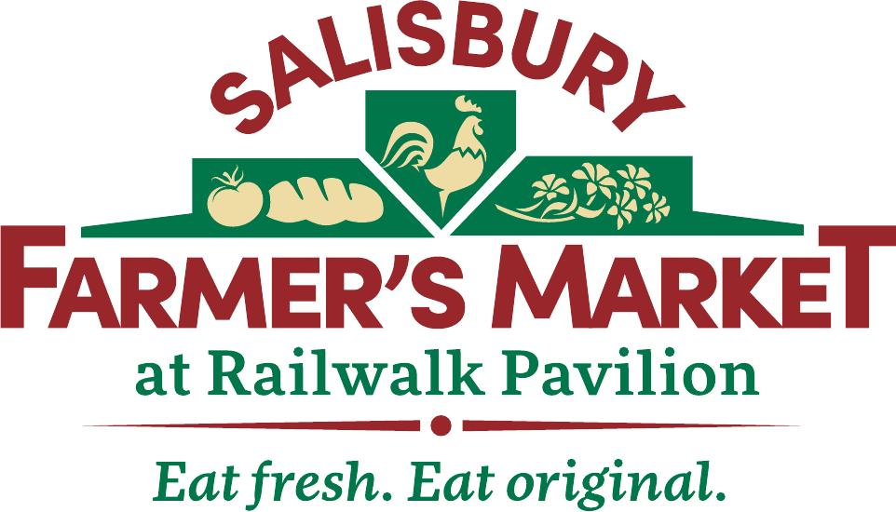
2024 Vendor Application Salisbury Farmer’s Market

Opening Day - April 20, 2024

Name: ____________________________________________________
Farm/Business Name: ________________________________________
Address: ___________________________________________________
__________________________________________________________
Phone number: ____________________________
E-mail: ___________________________________
Website: __________________________________
Social Media: _________________________________________
Emergency Contact: ___________________________________
County in which the product is produced: __________________ NCDOR Tax Number (if applicable): _______________________

Please make a detailed list of the product(s) you wish to sell.
__________________________________________________________ __________________________________________________________________________________________________________________________________________________________________________________________________________________________________________________________________________________________________
Months you wish to participate in market:________________________
Website you would like linked to your business name in the newsletter:
__________________________________________________________
Market Board may use their discretion in which spaces will be available for selection in order to meet the needs of the vendors and maintain market balance.

Applications will be reviewed by the Salisbury Farmers Market Board of Directors.

Salisbury Farmers Market reserves the right to select vendors based on their product offerings, in order to maintain a balanced market.

All applications are due April 1, 2024 to receive priority for the Market Grand Opening.

If applications are received after the deadline, they will be reviewed by the Board of Directors within 30 days. The vendor will be notified of acceptance or denial once board has voted.

I have read and agree to abide by the 2024 Rules and Policies of the Salisbury Farmer’s Market.

Signature: ____________________________________________
Date: _____________________

Email completed application to:
manager.salisburyfarmersmarket@gmail.com

Rates for 2024
There is annual membership fee of $100.00. The daily space rental is $15.00 for members and $25.00 for non-members. A limited number of ½ spaces may be available for $10. The annual membership fee covers expenses for maintaining the website, a weekly newsletter, promotional activities and advertising.

If you have further questions, please email- manager.salisburyfarmersmarket@gmail.com

