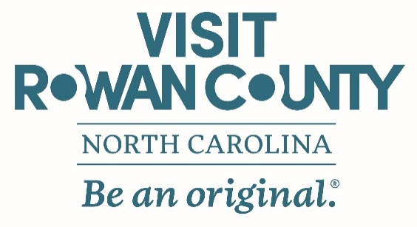

FOR IMMEDIATE RELEASE
Contact:
Rowan County Tourism
704-638-3100
Date: March 30, 2026

Spring into Adventure: April Events Bloom Across Rowan County
Rowan County, N.C. — April is an exciting time to visit Rowan County, as spring brings a vibrant lineup of family-friendly festivals, outdoor adventures, and seasonal farm experiences. From Easter celebrations and baby barnyard animals to live music and hands-on historical events, there is something happening nearly every weekend.
Whether planning a day trip or a weekend getaway, visitors will find plenty of opportunities to explore and enjoy the best of the season throughout Rowan County.
- Egg-Cellent Adventure at Patterson Farm — April 2–4, 2026. Celebrate spring on the farm with a Chaos-Free Egg Hunt, baby animal visits, wagon rides, and access to Pawpaw Carl’s Playground featuring more than 40 activities. Special experiences include Donuts with the Bunny, complete with decorating, story time, and photos.
- Kannapolis Cannon Ballers Home Games — April 2, 3, 4, 7, 8, 9, 10, 12, 21, 22, 23, 24, 25 & 26, 2026. Enjoy an exciting evening at Atrium Health Ballpark with family-friendly entertainment, energetic gameplay, and classic ballpark fare.
- Easter Bunny Express at the N.C. Transportation Museum — April 3 & 4, 2026. Families can explore trains, automobiles, and aviation exhibits while enjoying crafts, games, and egg hunts. Upgrade the experience with a ride on the Easter-themed train featuring a visit from the Easter Bunny.
- Lazy 5 Ranch’s Easter Eggstravaganza — April 4, 2026. Experience a unique Easter celebration with a safari drive-through, animal encounters, a helicopter egg drop, scavenger hunts, and family-friendly activities.
- Town of Granite Quarry: 125 Years in the Making – Spring into 125 — April 11, 2026. Celebrate Granite Quarry’s 125th anniversary at Granite Civic Park with historic tours, food trucks, a beer garden, and live music.
- Barnyard Baby Days at Patterson Farm — April 11–26, 2026. Meet adorable baby animals, enjoy wagon and cow train rides, and experience hands-on farm fun perfect for all ages.
- Hurley Park Spring Celebration — April 12, 2026. Celebrate the season with live music from the Salisbury Swing Band, carriage rides, a magician, outdoor activities, and more.
- Sensory Friendly Day at the N.C. Transportation Museum — April 12, 2026. Designed for individuals with sensory sensitivities, this event offers a supportive environment with interactive exhibits, quiet spaces, and visual guides.
- “Logistics of Liberty” A250 Presentation — April 16, 2026. Discover how transportation shaped the American Revolution through this engaging and educational program.
- Tractors & Trains at the N.C. Transportation Museum — April 17 & 18, 2026. Explore antique tractors, modern farm equipment, demonstrations, music, and kid-friendly activities.
- Earth Day Jam in Downtown Salisbury — April 18, 2026. This free music and arts festival celebrates sustainability with farm-to-festival experiences and educational programming, benefiting local nonprofit Happy Roots.
- 20th Annual Touch a Truck — April 25, 2026. Hosted by Salisbury Parks & Recreation, this interactive event allows visitors to explore a wide variety of vehicles and learn about the essential roles they play in the community.
Visitors can make the most of their April trip by turning their visit into an overnight stay with the Spring in Rowan County Stay & Play Package. Guests who book at participating hotels receive a VISA e-Gift Card valued at 50% of their stay—creating even more opportunities to dine, shop, and explore.
From Easter celebrations and festivals to outdoor adventures and cultural experiences, Rowan County offers something for everyone this spring.
For more information on events and special offers, visit www.VisitRowanCountyNC.com.
# # #
The Rowan County Tourism Development Authority (Rowan County Tourism) is a North Carolina Public Authority established through enabling legislation from the North Carolina General Assembly. Rowan County Tourism is county-wide in scope, and its efforts are directed at the promotion and development of Rowan County’s existing and potential tourism assets and visitor travel. For more information, contact Rowan County Tourism at 704-638-3100 or welcome@visitrowancountync.com.

