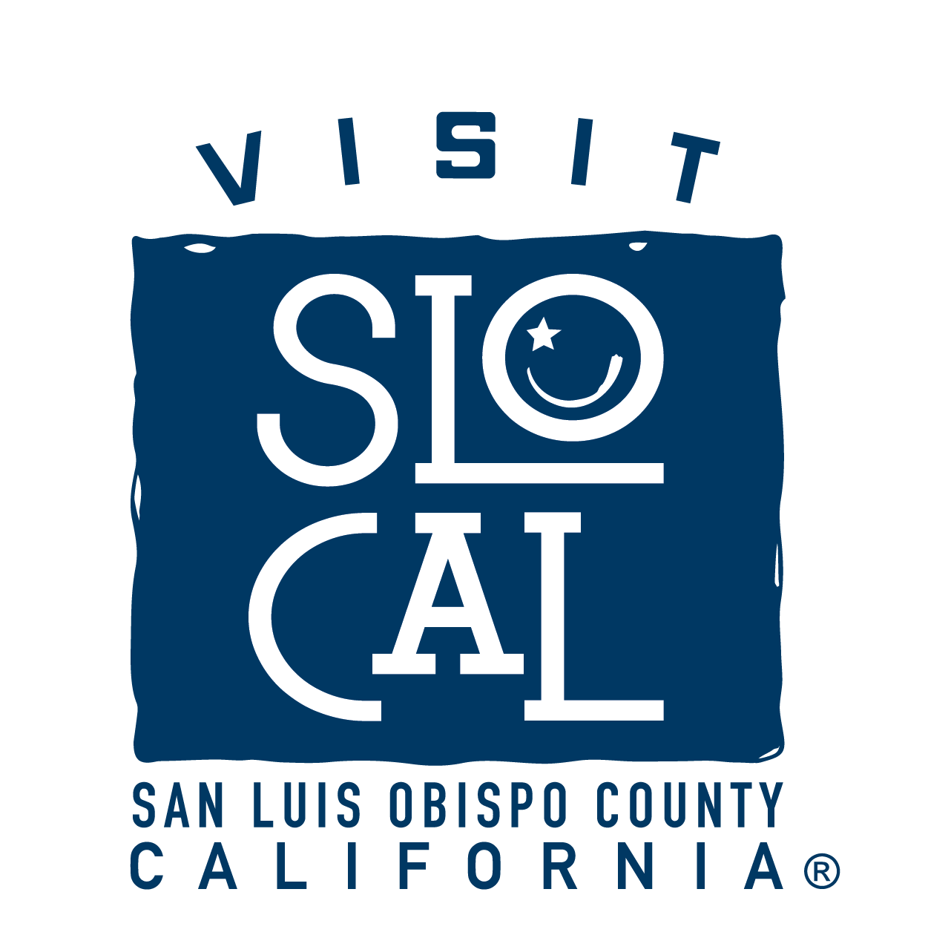
MINUTES
Visit SLO CAL Marketing Committee

Visit SLO CAL Marketing Committee Minutes
Tuesday, February 18, 2020
8:30 am – 10:30 am
Courtyard by Marriott
1605 Calle Joaquin Road, San Luis Obispo, CA 93405

1. CALL TO ORDER: Lisa Verbeck
PRESENT: Terrie Banish, Molly Cano, Gordon Jackson, John Sorgenfrei, Danna Stroud, Jill Tweedie, Lindsey Roberts, Lori Keller, Jocelyn Brennan, Ashlee Akers, Joel Peterson, Cheryl Cuming
ABSENT: Jim Allen, Audrey Arellano, Jennifer Little, Anne Steinhauer

STAFF PRESENT: Chuck Davison, Lisa Verbeck, Michael Wambolt, Haley Cahill, Kim Cadwell, Kelly Brickey

Call to Order at 8:35 am.

2. PUBLIC COMMENT (On Non-Agenda Items)
None.
ANNOUNCEMENTS
Visit SLO CAL provided a packet with an update on the coronavirus impact on travel. Verbeck noted that printed copies of the Ad & Marketing Update Slides deck were provided to the Committee.
Tweedie noted that it’s Breakaway Tours 25th Anniversary and they will be creating short video clips with valuable partners to be posted on social and in e-blasts.
Verbeck introduced herself, Brickey introduced herself, Verbeck also introduced Nieporte & Mastako to the team. The Marketing Retreat will happen March 4-5, 2020 with dinner at Milestone Tavern on March 4 and an all day meeting at Avila Beach Golf Resort on March 5. Visit SLO CAL is hiring for PR & Communications Manager and Marketing & Brand Manager positions.
CONSENT AGENDA
- Approval of November 12, 2019 Marketing Committee Meeting Minutes

This item was removed from the agenda. Approval of the November 12, 2019 Marketing Committee Meeting Minutes will occur at the March 5, 2020 Marketing Committee Meeting.

- Marketing Discussions
a. Advertising & Marketing Update – Verbeck referenced the Ad & Marketing Update and provided an update on theSLOIFF and Film Scout Familiarization Tour. Restaurant Month was very successful and received great media coverage. She provided an update on the SLO CAL Open at Pismo Beach, and noted the upcoming SLO CAL Open at Morro Bay and Spartan Race. She provided an update on owned and paid media results. Wambolt provided an update on recent and upcoming Travel Trade programs. Verbeck noted that she will be accompanying Wambolt on UK Mission. Davison also added that Visit SLO CAL met with international destinations at Outlook as a way to help vet potential new international markets. Visit SLO CAL is currently working with Brand USA on roadtrip specials, but is looking to deepen its partnership in the UK, and looking heavily on China & Korea.
Public Comment – None.
Committee Discussion – Stroud noted that there was a lot conversation about being ‘China Ready’ at the Visit SLO CAL Advisory Committee meeting on Friday, February 14, 2020. She said that the impact from Chinese visitors is very large and it would be helpful for the Marketing Committee to better understand how it can prepare for Chinese visitors. Davison noted that it would be impactful to even look beyond Chinese visitors. Visit SLO CAL wants to make sure it is ready and creates a system for SLO CAL communities to be prepared and welcoming. Cano said she would like to know how the Spartan race is coming along. Davison noted that Visit SLO CAL has a call with Spartan scheduled for more details. Visit SLO CAL will have a better idea of the tracking of the event by Friday. Jackson asked how Visit SLO CAL’s agency partnerships have been going. Verbeck noted that Turner has been very supportive in Visit SLO CAL’s recent and upcoming FAMs, and Miles comes into market on Thursday to have a discussion about Visit SLO CAL’s campaigns in preparation for the Marketing Committee Retreat on March 5, 2020. Visit SLO CAL is working with BCF on new banner ads, videos and creative, and switching imagery out for our latest brand shoot. Stroud asked when the Portland campaign will begin. Verbeck responded that the campaign will be beginning in March, with the flight launching in June. Keller noted it would be nice to see year-over-year statistics on bookings so that the Committee can evaluate the success of the campaign. Davison said that campaign results will give us YOY information, so when the campaign is complete, Visit SLO CAL will share with Marketing Committee and other stakeholders. Discussion will follow regarding our personas. Visit SLO CAL is also working closely with Simpleview on SEO & SEM.Cuming noted she would like to better understand additional support around Google Co-op. Verbeck responded that Visit SLO CAL received an initial report. Cuming then asked about providing the CBID’s Google words to Visit SLO CAL to collaborate. Verbeck agreed this would be a good idea. Sorgenfrei asked if there is an opportunity to integrate with the destinations currently using Simpleview. Verbeck noted that Visit SLO CAL is analyzing what Simpleview currently offers and will share with the Marketing Committee what it finds valuable.Cuming noted that there’s strong interest from Highway 1 partners in continuing to use Crowdriff. Verbeck noted that Visit SLO CAL will continue to dive in to the platforms capabilities and see how we can best utilize its features. Sorgenfrei agreed that Crowdriff has been very helpful and useful for his clients as well. Cuming noted that they have their own contract with Crowdriff but ladder up to Visit SLO CAL for assets and take advantage of utilizing the media hub through Visit SLO CAL.
b. Marketing Discussions
1. Google DMO – Verbeck noted Visit SLO CAL receives 4.6 million views on uploaded images and a 115% increase January 2, 2020 to February 4, 2020. Visit SLO CAL will include training videos on SLO CAL Connection to help partners learn how to keep their content fresh.
Public Comment – None.
Committee Discussion – Sorgenfrei noted that the Google Destination co-op is a great example of what works for co-op because it touches all destinations as well as lodging partners. Cano noted that the business verification process has changed and they would like to better understand what that process now looks like. Davison noted Visit SLO CAL will ensure the verification webinar is up-to-date and will share it with The Marketing Committee.

2. Arrivalist Update – Verbeck noted that Visit SLO CAL is working with Arrivalist to deliver a report to each destination for 2019’s data.
Public Comment – None.
Stroud noted that her SLO CAL Connection access is not populating the reports. Kirk said that Visit SLO CAL will deliver SOP’s so the Marketing Committee understands how to find the resources and reports they need. Kirk also noted that Visit SLO CAL hopes to utilize SLO CAL Connection further.
3. Brand USA – Verbeck note the landing page and media campaign begins in March and will run internationally. Davison noted that Visit SLO CAL was not able to provide a lot of feedback in the content of the Brand USA SoCal video.
Public Comment – None.
Keller asked if VSC will be redistributing the Brand USA SoCal video. Davison noted we will redistribute as soon as it’s final.
4. PR Duplication – Verbeck proposed the idea of a PR-focused sub-committee to be more collaborative. Davison noted that the sub-committee will need to be Brown Act compliant and agencies can call in as public comment.
Public Comment – None.
Sorgenfrei noted that Visit SLO CAL should focus on providing valuable information in the PR-focused sub committee. Verbeck noted that when agencies pitch every month, there’s new information, so frequent check-ins can be helpful. Stroud noted that being timely with the information is extremely important. Jackson noted that if Visit SLO CAL shares what it’s looking for, it can be discussed in the monthly Marketing Committee meetings as well. Verbeck agreed and said she will take this input into consideration.
- California Welcome Center
Kirk noted that he is pleased the Board made the decision to continue the Welcome Center with the help of the South County Chambers. Kirk noted that the desire is not to inundate visitors with paper products. Kirk noted that within the next 90 days, Visit SLO CAL will be reaching out to destination partners to ensure their brand identities are reflected.
Public Comment – None.
Committee Discussion – Jackson noted that the California Welcome Center is not Pismo Beach’s Welcome Center; it is SLO CAL’s Welcome Center. Kirk also emphasized that the California Welcome Center is for each SLO CAL community.
Brennan noted that the Visitor Centers in Nipomo & Arroyo Grande are frequently visited. There is still a need for a California Welcome Center in SLO CAL. Visit California is working to modernize these Welcome Centers with digital kiosks and video walls. Brennan noted they are aiming for March 2020 or April 1, 2020 at the latest for opening.
ADJOURNMENT
Meeting adjourned at 10:08 am.

