**Museum Scavenger Hunt**

All items on this list can be found at both museums!

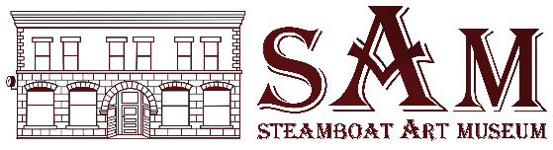

807 Lincoln Avenue 800 Oak Street

CAN YOU FIND THESE?

* Tee Pee *(Tipi Indio)* _______________________________
* Headdress *(Tocado Indio)* _______________________________
* Saddle *(Sillín/Silla de montar)* _______________________________
* Horse  *(Caballo)*  _______________________________
* Cowboy Hat *(Sombrero de vaquero)* _______________________________
* Snake  *(Víbora)* _______________________________
* Rabbit *(Conego)*  _______________________________
* Cattle  *(Ganado)* _______________________________
* Lariat  *(Riata)* _______________________________
* Chaps *(Chaparreras)* _______________________________
* Cowboy Boots *(Botas be vaquero)* ____________________________
* Feathers *(Plumas)* _______________________________
* Mountain Lion *(Leon de montaña)* ______________________________
* Bow and Arrow *(Arco y flecha)* _____________________________
* Bridle *(Brida)* _______________________________
* Spear *(Lanza)* _______________________________
* Fox *(Zorro)* _______________________________
* Bear *(Oso)* _______________________________
* Saddle Blanket *(Manta de silla de montar)* _______________________________
* Flowers *(Flores)* _______________________________

Name: ______________­­­­­­­­­­­­­­­­­­____________________ Phone: _____________________________ e-mail: ________________________________­­­­_______________________________