Culinary Events in Temecula Valley Southern California Wine Country
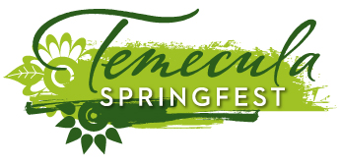
Taste of Temecula Valley in Old Town Temecula: fourth Saturday in April
Temecula Wine and Music Festival: last Saturday in September

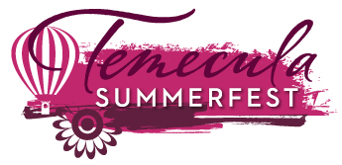
Temecula Valley Balloon & Wine Festival: First weekend in June
Pechanga Microbrew Festival & Chili Cook-off: second weekend in June

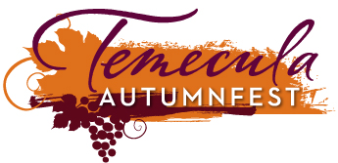
Temecula Valley Wine Month: September 1-30
Temecula Valley Crush Wine & Culinary Showcase: second Saturday in September
People’s Choice Blind-Tasting & Awards: November

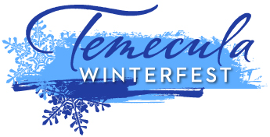
Temecula Chilled: Restaurants in Wine Country, Old Town Temecula and Pechanga Resort & Casino offer special “chilled” menu items during the month of December
California Restaurant Month: January 1-31
Annual Barrel Tasting: last weekend in January
Chocolate Decadence and the Pechanga Wine Festival: third weekend in February
Please refer to the Calendar of Events at VisitTemeculaValley.com for additional events occurring in the area and for the most up-to-date information.

