Union County Convention & Visitors Bureau

Partner Portal Quick Start Guide

Welcome to the Union County Convention & Visitors Bureau Partner Portal Guide. The Partner Portal is an online marketing and communication hub that includes various tools to help your business, receive real time promotional opportunities from the CVB team and allow you to share ideas and connect with fellow partners. Throughout this guide you will learn about the various tools available to you and how to navigate the system. As always, the CVB team is here for you, should you need assistance.

An email communication will be sent to all partners with a link to the Partner Portal, username, and password for logging in. Please be sure to check your SPAM folder. Access to the Partner Portal can be found at https://unioncountyoh.extranet.simpleviewcrm.com/login.

  - Login – page 2
Check List:
  - Login and save your password
  - Update your business account information
  - Update your contacts information
  - Select your Amenities
  - Submit your Calendar of Events
  - Create and review your Listings
  - Select your Amenities
  - Upload photos & videos
  - Check and respond to Service Requests

  - Accounts & editing details – page 5
  - Contacts – page 7
  - New! Amenities – page 8
  - Collateral Management – page 9
  - Calendar of Events – page 10
  - Listings – creating effective copy – page 12
  - Media – uploading photos – page 15
  - Opportunities Overview – page 17
  - Service Requests – page 18
  - Occupancy for hoteliers – page 22
Getting Started
- Once you have your username and password, follow the Portal link to the main login page. Here you can enter your credentials to login.
- If you hold multiple accounts (businesses) you will be prompted to create a single password for logging in.

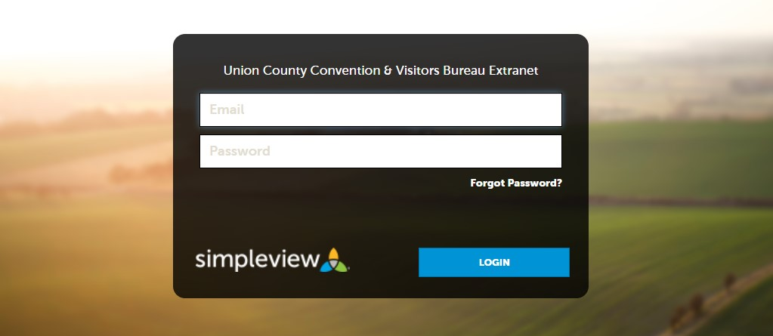

Partner Portal Home Page
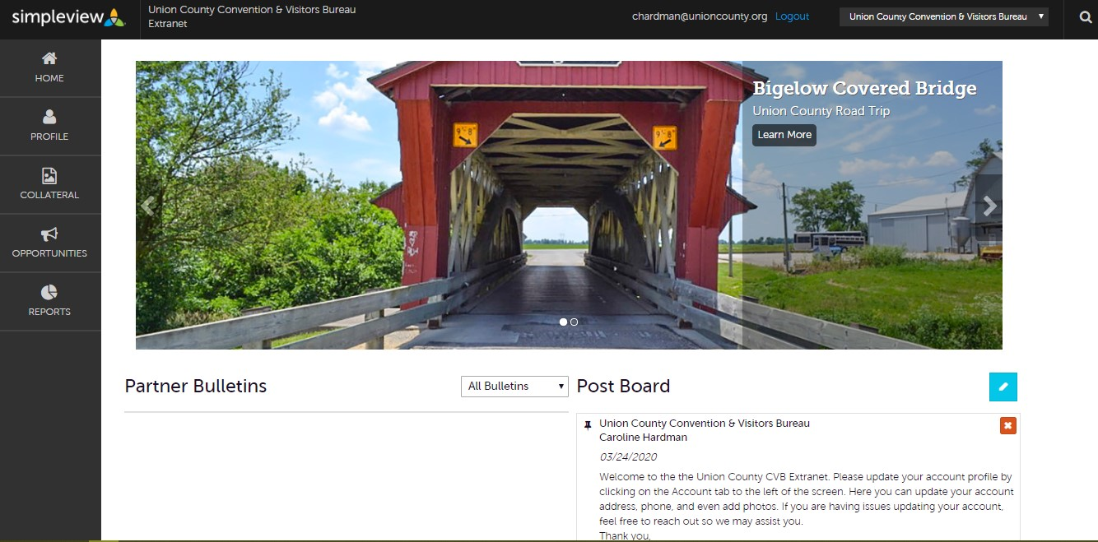

- This is the Partner Portal home page where the latest information from the CVB and fellow partners can be viewed.
  - Partner Bulletin – This is where you will see notices posted by the CVB Team.
  - Board Post – This is where you can communicate with the CVB team or share ideas and connect with fellow partners
- The tabs in the black column to the left contain pages with certain tools:
  - Profile Page – where you can update your business information such as address, phone, email and upload photos to your gallery
  - Collateral – where you can input or update your listings, event information, or any special promotions your business is offering. The CVB team will review the information and post it to the CVB website pending approval, on visitunioncountyohio.org.
  - Opportunities – this is where you can view more information on special business opportunities presented by the CVB

Partner Portal Home Page continued…
  - Reports – this page is dedicated to collecting data via the CVB website (i.e. number of clicks, social media shares, mentions, etc.)
- You can always return to the Home page at the top of the column to view the latest posts from the CVB or other partners

Continue to Page 5 for the Profile Page…

Profile Page
- By clicking on the “Profile” tab, you have access to your Accounts, Contacts, and Benefits pages
- To view your accounts, click on the “Accounts” tab
- On the Accounts page you can filter through your active or inactive businesses, the names will show under the green bar.
- Click your respective account to view information
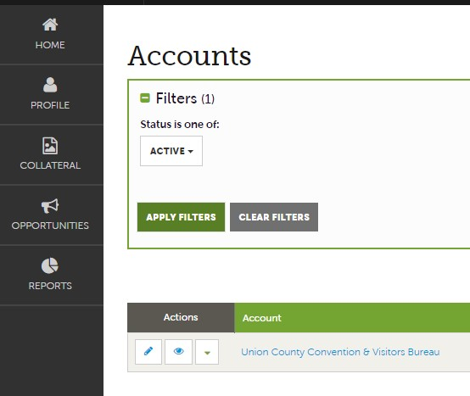
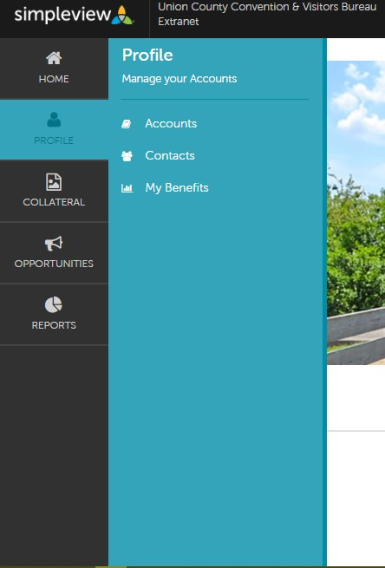

Account Details, Editing, and Adding Information
- To edit or add information, click in the white boxes or click the blue pencil icon
- *Required indicates a field that must be filled with information before continuing
- Be sure to click the Save button at the top to keep the changes you have made
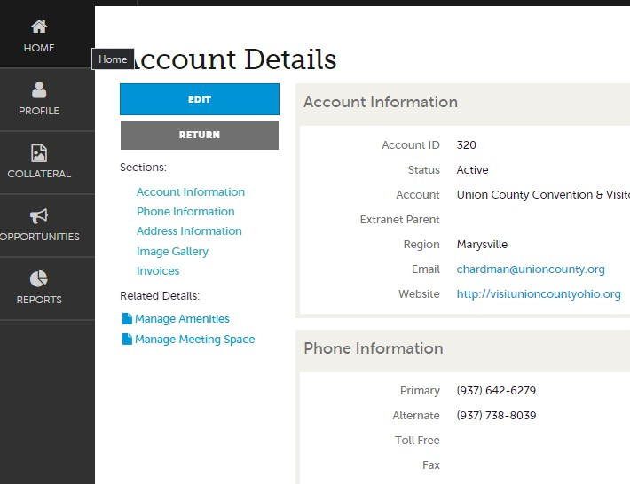

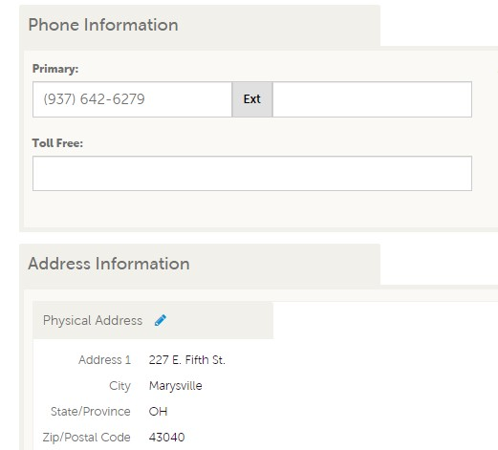

Contact Information
- The Contacts tab is in Profile underneath Accounts. Here you can add or modify contacts to your accounts
- To add a contact, click on the blue ADD CONTACT button
- To modify a contact or information, click the blue pencil icon to the left of the contact name. Be sure to click the save button to keep your changes
- If you have multiple accounts, you can choose what you view from the filter dropdown
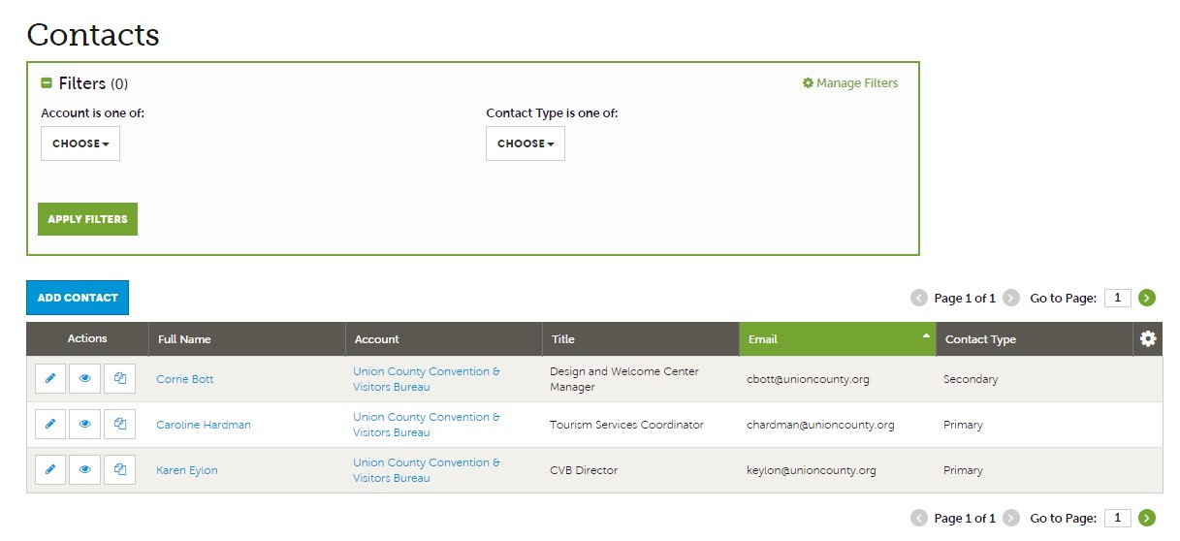

New* Amenities

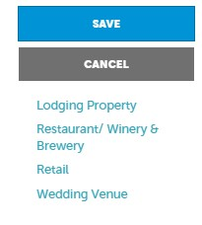
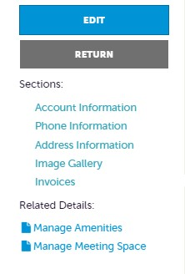
- New for the Partner Portal, businesses can now list their Amenities to be displayed on the CVB Website
- On the Profile tab Click on your account details and then click on Manage Amenities
- Select the amenities available at your business and click the Save button

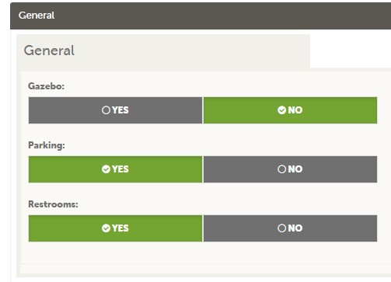

Collateral Management

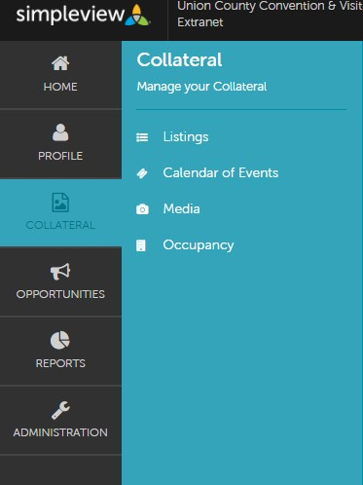
- The Collateral tab contains pages where you can create listings, add your events, and update media.
- The Listings Page lets you create a listing for each of your business components such as dining, meeting space, tour, etc. Add your copy, photos, and other important information about your business here.
- In the Calendar of Events page, you can upload events to the collective Calendar of Events displayed on the CVB website.
- The Media page allows you to upload photos or videos to be posted on the CVB website in conjunction with your business listing.
- The Occupancy page allows Hoteliers, Airbnb (and other short-term rental properties), and Meeting Space venues to display how much occupancy is available throughout the year.
Calendar of Events
- The Calendar of Events page allows Partners to upload events happening at your businesses to be posted on the CVB website Calendar of Events section
- Once the necessary information is filled out and submitted, the CVB team will review the event submission for approval
- Once any corrections are made and approved, a notification will be sent to you that your event will be posted to the Calendar of Events on the CVB website
- If an approved event needs to be altered or updated after being posted, please notify the CVB staff
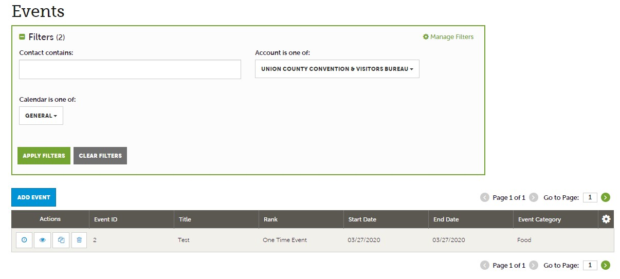

Calendar of events continued…
- When creating a new event, fill out the blank fields. Fields with *Required indicates that text boxes much have information
- Be sure to fill out as much detail about your event including, dates, hours of operation, address, detailed description, etc.
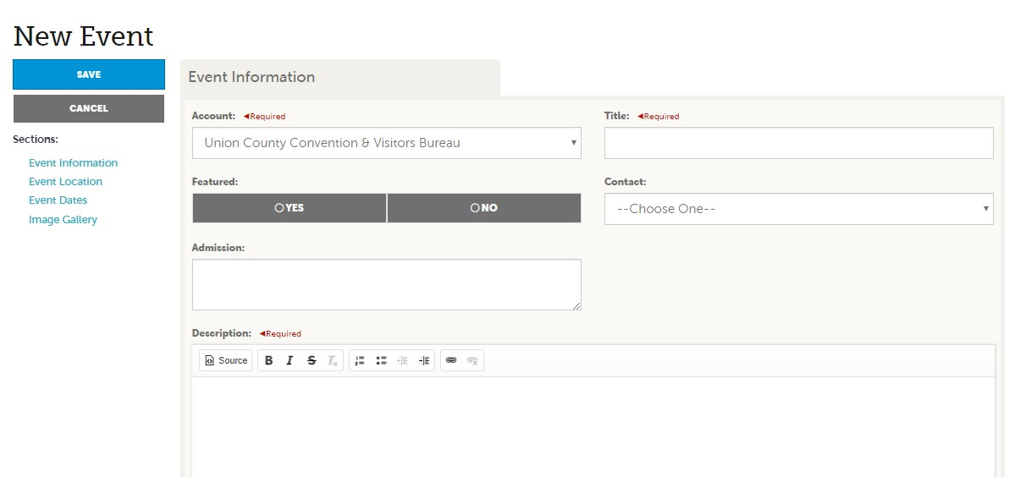
- Please note that an image is required for your event and can be uploaded to the image gallery at the bottom of the page
- Be sure to click the SAVE button at the top of the page to submit your event
Listings and creating web copy
- The Collateral tab is where you will find the various tools to create content for the web. In this section we will discuss how to update and add to your business Listings. Your Listing will be displayed on the CVB website under specified categories where visitors can view your business details and plan their next trip.
- Begin with the Collateral tab then click “Listings”
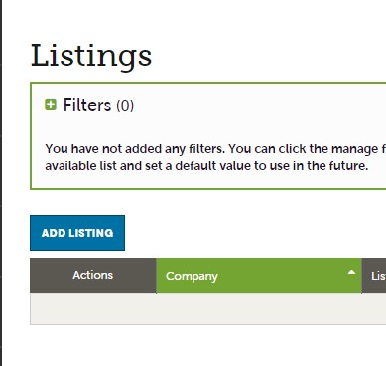

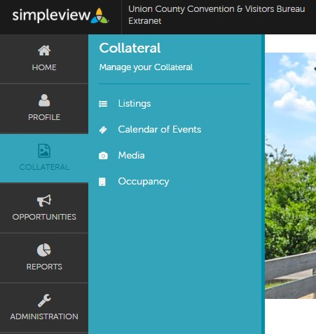
- Your listings will be displayed in the main grid. If you have multiple listings you can navigate via the filter or select from the main grid.
- To add a listing lick on the “ADD Listing” button

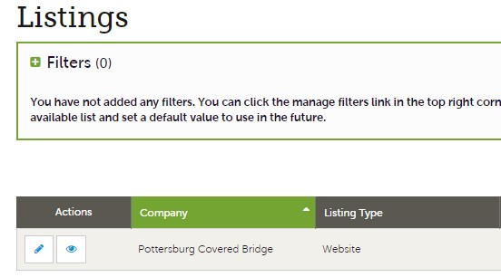

- To edit a Listing, click on the pencil icon next to the desired Listing to be changed
- Fill in the blank and *Required fields with your information to continue

- Web Copy: This is the detailed description of your business to be featured on the CVB website. Below are some helpful tips to creating an effective web copy readers will understand and enjoy:
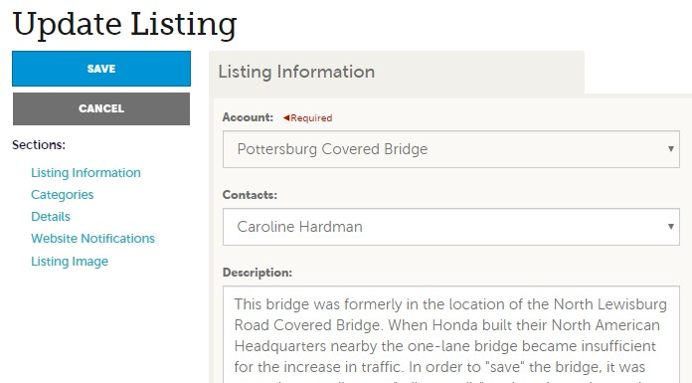

- Keep the Copy under 100 words
- Identify who you are trying to reach and why
- What do you want your audience to do?
- What makes your business unique?
- Vary your sentence length and use paragraphs for easier reading
- Use clear and concise language with a diverse vocabulary
- Have fun with writing! Be sure to proofread and check spelling and grammar
- Be sure to click the Save button at the top to keep your changes
- The Details section includes information you wish to be displayed on the CVB website
- Click on the title boxes in grey to turn green; this indicates information you have selected to be displayed on the website.
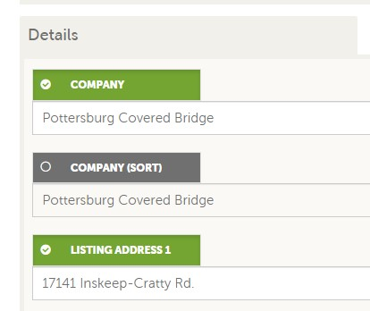

Continue to Page 11 for Media…

Media
- To add photos to your account or Listing click the Collateral tab and select Media
- Click the Add Media Button
  - Use original photos instead of stock photos
  - Choose clear images with good lighting
  - Vivid colors with attention to detail
  - Feature your logo, smiling customers & employees, or shop display
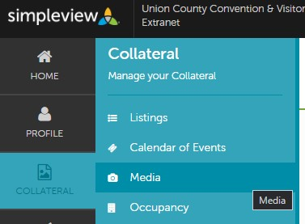

- Fill in the *Required information and give a brief description of your photo such as date and time of use
- You can choose if you would like to add the photo to a Listing by clicking on the dropdown menu under the “Listings” field.
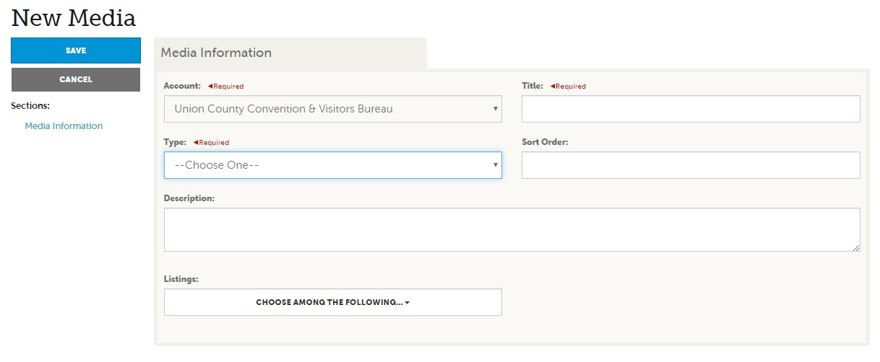

- To upload a photo, select from the “Type” dropdown, this will prompt the Drag and Drop feature, or you can select the Browse button to choose a file
- Be sure your photos are of high-quality pixel count
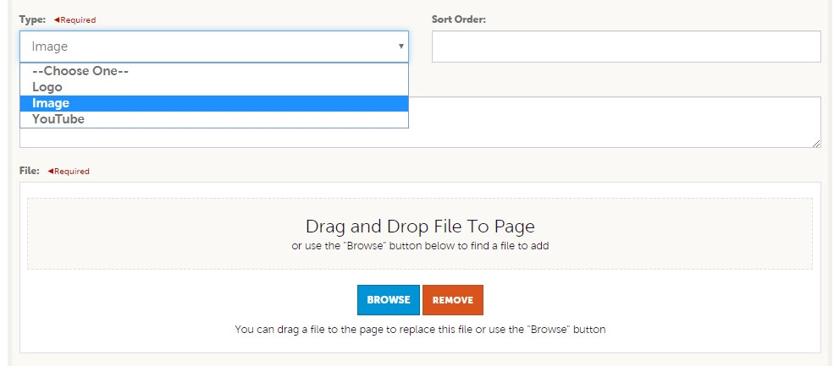
- Give time for the photos to upload to the system
- Click the Save button at the top once your photos are done uploading

Opportunities Overview
- The Opportunities Tab includes the RFP’s and Service Requests provided by the Union County CVB
- The RFP’s (Request for Proposal) will allow you to send proposals to events and groups looking for venues, services, etc. (covered in Phase 3)
- The Service Requests will include requests from Tour/Travel Groups for specific services such as tours or catering where you can respond directly with the CVB as a one-point contact
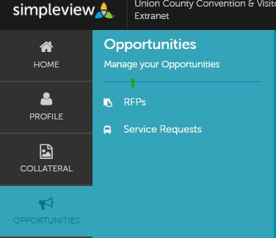

Service Requests
- The Service Requests page shows tourism requests made by a tour operator or company relayed through the CVB
- All Service Requests can be seen on this page. Filters can be applied to find request for specific accounts, date range, etc.
- To Review a service request, click the “eye” icon to the left of the Request title

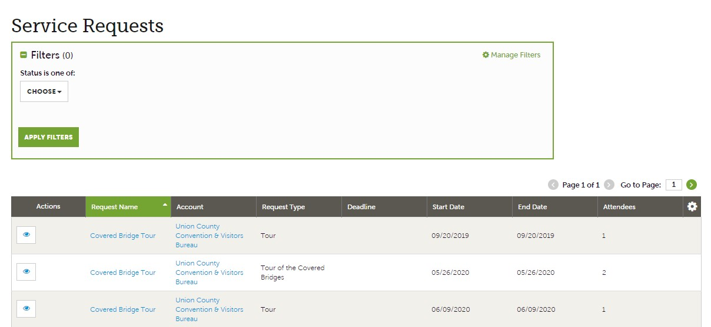

Service Requests continued…
- Carefully review the Request information
- If you require more information, please contact CVB staff
- Once you have decided if you can fulfill the Service Request click on the Blue Plus Sign at the bottom
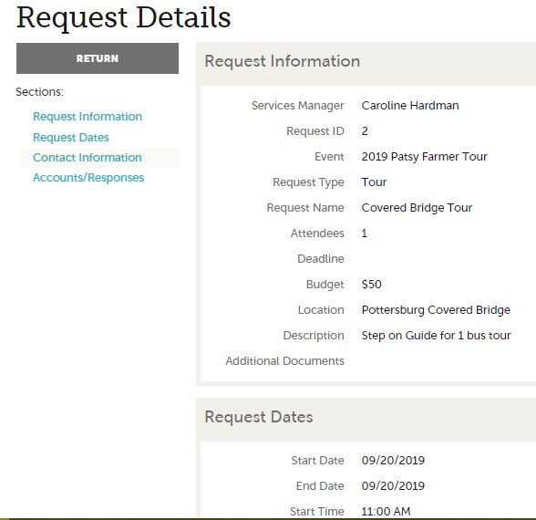

- Once you have decided if you can fulfill the Service Request click on the Blue Plus Sign at the bottom
- A Pursuing ribbon will appear at the right of the screen. If you wish to pursue this request, click YES. You can leave comments in the box below for the CVB team. Be sure to click UPDATE once complete
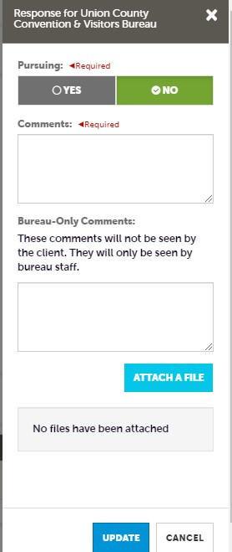

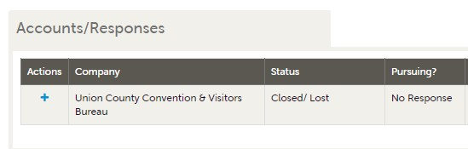

Rental Properties: Occupancy
- Hoteliers, Airbnb (and other short-term rental properties), and campgrounds can update their Occupancy based on the year and season to be posted on the CVB website
- This allows visitors to check occupancy in one place making it easy for them to identify which lodging best suits their needs
- Partners can list by Occupancy Percent or Rooms Occupied and include rates if you choose

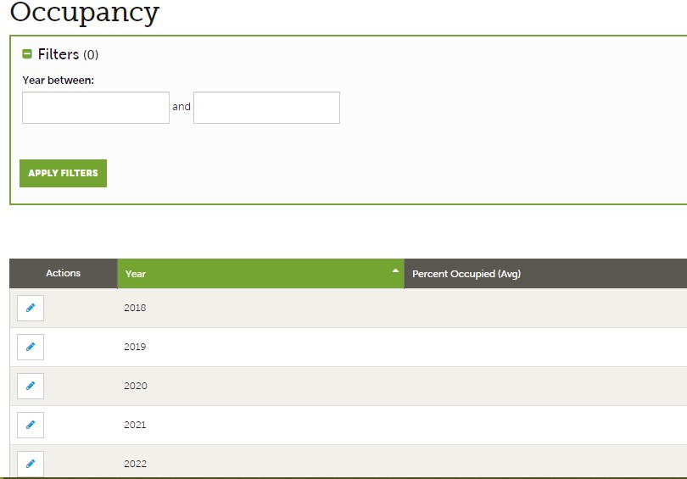

Rental Properties continued…
- Select the date you wish to enter information by clicking on the blue pencil icon on the left
- Select the Entry Mode “By Percent” or “ By Occupancy” to be able to fill the text boxes
- This can be done for each month of the year selected making it easy for visitors to plan their next trip
- Be sure to click the SAVE button at the top right corner to save the updated information

