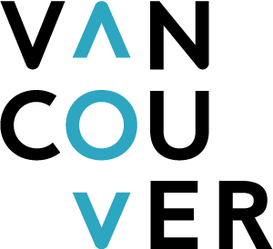

Destination Vancouver

Media Information Form

Thank you for your interest in Vancouver! Please provide us with the following information about your outlet, intended story and needs while in Vancouver.

Click below to read our Media Visit Guidelines.
https://www.destinationvancouver.com/media/travel-media/media-visit-guidelines/

WHO ARE YOU?

Your name:
Your job title:
Your personal website:
Your social media handles and number of followers:

YOUR CONTACT INFORMATION:

Email:
Phone:
Address:

YOUR ASSIGNMENT / EDITORIAL DETAILS:

Name of the publication(s) or outlet(s) you will be producing Vancouver content for:
Web address of that outlet:
Description of outlet::
Circulation / audience / views per month:
Advertising value:
Audience demographics:
Feature title:
Content:
Will your coverage include details about your hosting hotel(s)? (Please be specific).
Will your coverage include details about hosting restaurant(s)? (Please be specific).
Article/Content Length:
Airdate/Publication Date:
Are you on assignment? Y/N. *If no, please explain purpose of trip
Social media coverage (Twitter, Facebook, blog):

PERSONAL INFORMATION:
Answers to these questions help us determine what Vancouver experiences you may be interested in.
Your hobbies/ interests:

Level of fitness:
Do you smoke? Y/N.
Food allergies or intolerances?

TRIP DETAILS:
Vancouver arrival date/time:
Vancouver departure date/time:
Number in your party:
Names in party: (Include job titles if applicable. Also note any guests travelling with you).

What assistance are you looking for from Destination Vancouver (please be specific):
Specific accommodation / dining requests:

Are you interested in pre/post trips to other regions of BC? (Explain).

LET’S STAY IN TOUCH:

Would you like to be subscribed to any of Destination Vancouver’s monthly media newsletters?  You can unsubscribe yourself at any time. | Check all that apply
I would like to start receiving Fresh – Destination Vancouver’s Monthly Travel and Trade Media Newsletter.
I would like to start receiving Out in Vancouver – Destination Vancouver’s LGBTQ2+ newsletter.

Please return this form to Destination Vancouver:

Sabrina Tey
Manager, Communications
stey@destinationVancouver.com

Thank you for completing this form. We will be in touch shortly.

