Board of Directors Nomination 2015-2016

Industry Category: Director At Large (Vancouver Convention Hotel Category)
Term: Effective June, 2015; Two Years

Nominee: Philip Barnes
Regional Vice President, Pacific Northwest
& General Manager Fairmont Pacific Rim

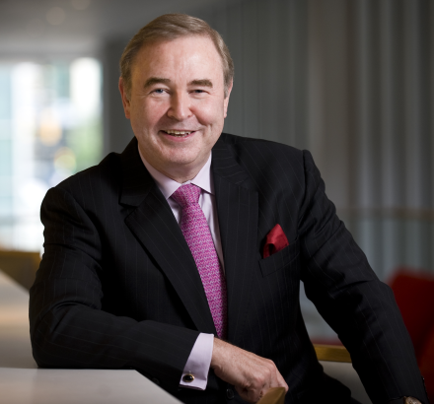

Philip Barnes is Regional Vice President of the Pacific Northwest & General Manager of the Fairmont Pacific Rim in Vancouver. He joined FRHI in September 1998 as RVP for British Columbia for Delta Hotels, and three years later became RVP for Western Canada for Delta. He moved to the Fairmont brand in May 2004 as RVP for the Pacific Northwest & General Manager of the Fairmont Hotel Vancouver until May 2007 when he moved to Dubai as RVP of the Middle East overseeing the regional office and assisting in the developments and openings in the UAE, Egypt, Saudi Arabia, Oman, and South Africa. In May 2009 he moved to the Fairmont Dubai as General Manager and RVP of the UAE where he remained until July 2011 when he transferred back to Vancouver.

Prior to joining FRHI Barnes was COO of Stamford Hotels in Australia having been recruited by the parent company during their acquisition of the Regent of Auckland where he was General Manager in 1996.Prior to this he had held a number of positions over a ten year period with Four Seasons/Regent Hotels including opening FS Singapore as HM,GM FS Inn on the Park Houston, DOP’s FS Inn on the Park Toronto, and DOR at The Pierre New York. He left Four Seasons for a two year period after the sale of the property in Houston in 1991 to become initially Resident Manager of the Shangri-la Singapore, and subsequently General Manager.

He was born and educated in the UK and began his hospitality career there working at Hotels in and around London before transferring to Chicago in 1979.He is married to Heidi, and they have three children, Nicholas (21),Austin (20),and Catherine (18).

.

