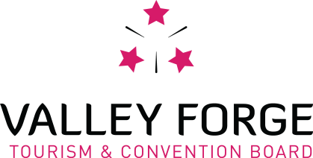

DIGITAL MARKETING & WEB INTERN

SUMMARY:
The Valley Forge Tourism & Convention Board seeks an energetic digital marketing intern who is interested in supporting the Marketing and Communications Department efforts in marketing and promotion of the Valley Forge area and Montgomery County as a convention site and leisure visitor destination.

Daily responsibilities will vary. They include, but are not limited to:
- Working within CMS (content management system) to manage, update and create web pages.
- Writing and editing content for website & publications.
- Analyzing campaign results and provide post-campaign reports that will directly impact future marketing decisions.
- Assist Visitor Services at Valley Forge National Historical Park, Membership, Sports, Domestic/International Tourism & Convention Sales/Services with special projects, FAM tours, and on-site activations as needed, including possible weekend events.
- Other projects can be tailored to the individual’s interests and experience within the marketing department.

QUALIFICATIONS:
- Available 10-15 hours a week.
- Strong writing and computer skills required.
- Self-starter. Able to work independently, but also contribute as a collaborative team player.
- Excellent written and oral communication and research skills.
- Proficient in Microsoft Excel and PowerPoint, Google Analytics experience is ideal.
- Must be efficient, organized and professional.
- Able to troubleshoot problems and find creative solutions.
- CMS and CRM (customer relationship management) database training will be provided.

WHO WE ARE:
The Valley Forge Tourism & Convention Board is a private, non-profit membership sales and marketing organization which actively promotes the Valley Forge area and Montgomery County as a convention site and leisure visitor destination by promoting patronage of its member hotels, restaurants, attractions and services.

1000 First Avenue, Suite 101 • King of Prussia, Pa. 19406 610.834.1550 • Fax 610.834.0202 • 800.441.3549 • www.valleyforge.org

