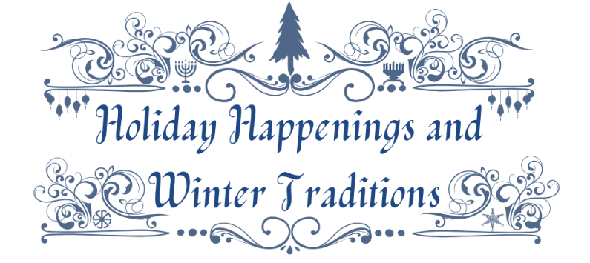
The Watkins Glen Area Chamber of Commerce in collaboration with
Watkins Glen Promotions is pleased to announce “Holiday Lights - Schuyler Style!”
A NEW Holiday Happenings & Winter Traditions Activity
Generously sponsored by
Visions Federal Credit Union
Tuesday, December 15, 2020 through Sunday, January 17, 2021
This Festive Lights Competition invited …
Businesses, Residence (Owners or Renters), Farmers/Barns and Organizations of all kinds throughout Watkins Glen/Schuyler County, NY to a challenge! Decorate their exterior grounds, yards, fields, buildings and/or windows for the community and public to enjoy from December 15, 2020 through January 17, 2021 (or longer they like) for a fun, festive and enjoyable competition.
The Theme: Use the Holiday Happenings & Winter Traditions Logo (above) and the symbols in it to inspire how they and you, families, peers, work associates and/or clients, customers and/or visitors celebrate throughout the winter season. Look at all the symbols in the logo; Christmas and a tree are prominent but also see the menorah, kinara and symbols for winter solstice, Chinese New Year and Los Ponchos. Hopefully they focused on one, or include a combination of all and/or others in their displays with holiday or winter “must do’s” they did not see in the logo but want to incorporate to share their and your holiday happenings and winter traditions!
Our melting pot of citizens, guests and visitors enjoy many rich traditions using food, faith, lighting, decorations both from nature and man-made items so displays should as well! Displays can be layers of items or may be kept simple but have fun in sharing customs, make people feel joy, happiness and maybe even educate everyone a bit on how diverse we all celebrate the holidays and winter (or not).
Visit www.ExploreWatkinsGlen.com for updates contest rules, registration, deadlines, hints for decorating and voting. Locations of participant will also be posted there along with other details on this and other events and other activities for Holiday Happenings & Winter Traditions on or after Dec. 2, 2020 and throughout December through Jan for this contest and through March for other activities.
Only one vote per e-mail address will be allowed for awards. The most votes in each category being awarded will win cash prizes. 2nd, 3rd and likely some Honorable Mentions will also be awarded with ribbons and bragging rights. Zip Codes will be required/needed as well to decipher between Schuyler County Local Residents and our Guests and Visitors. Should voters choose to share e-mails and/or addresses they will be entered to win some fun prizes offered by the partners and local businesses.
E-mails and addresses collected by the contest will only be used by the WGACC to award prizes and send promotions of other activities should voters opt in, and will not and cannot be used for any other purpose or sold or used by others organizations.
Results and prizes will be announced on Friday, January 22, 2021 at The Watkins Glen Area Chamber of Commerce at 214 N. Franklin Street, Watkins Glen, NY 14891 at 4:00p.m. as well as in media that evening and in The Chamber News and Other Happenings Monday, January 25, 2021.
Awards
Over $2000 in Cash Prizes (and some nifty trophies and ribbons as well)!!
These 4 categories will be voted on-line by the public and *a panel of judges as needed;
- 1st, 2nd, and 3rd Places for Residential Display (owned or rented) - $200 Top Prize (1st)
- 1st, 2nd, and 3rd Places for Business Display - $300 Top Prize (1st)
- 1st, 2nd, and 3rd Places for Organization (non or not-for-profit) Display - $350 Top Prize (1st)
- 1st, 2nd, and 3rd Places for Farm/Barn Display - $250 Top Prize (1st)
Best of Contest Local Vote (In-County Zip Codes) - $500 – most votes on-line with zip codes
and Best of Contest Visitor Vote (Out-of-County Zip Codes) - $500 – most votes on-line with zip codes
*In case of ties a committee of judges will break the ties by majority of vote.

RULES For Displays and consideration for voting;
1) All Federal, State and Local Laws are to be adhered to with regards to lights, sounds, zoning and curfews, etc. WGACC, WGP and Visions cannot and will not be held liable for any infractions.
2) Safety and courteousness of, and to, participants, spectators and neighboring homes, properties and businesses must be a top priority. Viewing must be complimentary (no fee).
3) All registrations for participants were turned in to The Watkins Glen Area Chamber of Commerce (WGACC) at 214 N. Franklin Street, Watkins Glen, NY 14891 on by Friday, December 11 by 4:00p.m. Registrations may also be e-mailed to Katherine@WatkinsGlenChamber.com or faxed to 607-535-6243 by the same date and time. All participants must have a fully completed (printed or typed) registration with only one category chosen to be judged in. E-mail Katherine for Registration Form or call 607-535-4300 for one and/or to see when you can pick one up at The Chamber.
4) All venues are encouraged not to have any social gatherings! Ideally, all viewing can and should happen by vehicle drive-by and/or a stroll that allows safe physical/social distancing on a public sidewalk. Displays need to be lit from 5:00p.m. to 11:00p.m. each evening and should look nice by day as well if at all possible and not have any dangerous elements to creators or spectators.
5) Displays must last up to the last day of the contest: Voting ends on Jan. 17, 2021 at 11:00p.m. You can vote ( once) throughout the 32-day competition and entrants were encouraged to see that their displays lasted that long or longer, so refreshening and maintenance should be happening/be observed.
Most importantly, no matter how big or small the decorating/display are, keep the spirit of the season in mind as you vote and know this is to be a fun, friendly and safe competition! Participants were to try to embrace theirs, and others’ traditions. How did they do? Thank you for participating.
*In case of ties a committee of judges will break the ties by a majority of vote.

**On-line voting is best and goes to 11:00p.m. Sunday, 1/17/2021!
Click Here to Go Online!
Link needed OR NO HAND VOTING TBD as of 12/2/2020 mjh

Voting Rules and Ballots
PLEASE TYPE OR PRINT/**On-line voting is best and goes to 11p.m. Sunday, 1/17/2021!
4 Categories to be judged in – Use the number and category given each location/entry on the on-line map;
__1___ Residence (Home Owner or Renter); 1st#________, 2nd #_______3rd #_________
__2___ Business 1st#________, 2nd #_______3rd #_________
__3___ Farm/Barn 1st#________, 2nd #_______3rd #_________
__4___ Not for Profit/Nonprofit 1st#________, 2nd #_______3rd #_________
* Name(s): ________________________________________________________________________________________
* Phone: ________________________________________________________________________________________
* Address: _______________________________________________________________________________________
* E-Mail: __________________________________________________ Zip Code: ______________ MANDATORY
- *Your Name, Phone, E-mail and/or address are OPTONAL. Fill out only information you would like us to have for contacting you for other contests and any prizes we will draw from provided by partners and members Jan. 22nd.
Details about Display (i.e. materials used, theme, etc.) you/your family liked; __________________________________

The Chamber has permission to use images and/or photographs of display and those attending for promotions, marketing (including social and traditional media; print, on-line and/or in displays indefinitely). We will not use any information for any other purpose or sell or provide the information to any other source. With your signature you acknowledge this; Signature: _________________________________________________ Date:_________________
**Hand voting due by; e-mail: katherine@watkinsglenchamber.com, fax: 607-535-6243 or in-person on Friday, January, 15, 2020 by 4:30p.m. at The Watkins Glen Area Chamber of Commerce (WGACC), 214 N. Franklin St., Watkins Glen, NY 14891. For questions call 607-535-4300. GOOD LUCK! Have fun! Be Safe and HAPPY HOLIDAYS!
**On-line voting is best and goes to 11p.m. Sunday, 1/17/2021!
FYI - The map and ballots will go out to the media and the public at 4:00p.m. on Tuesday, December 15th, 2020!
Keep a copy of this document for your records! Received WGACC Date:______________ Time: ______________

