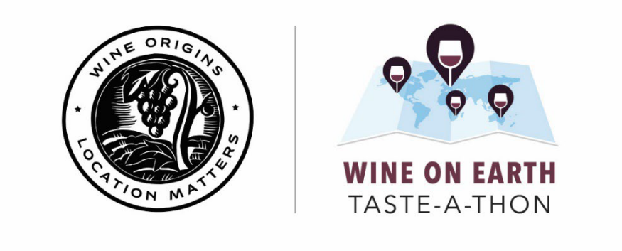

FOR IMMEDIATE RELEASE: June 8, 2021
CONTACT: Natalie Pavlatos, +1 218-428-1402, info@wineorigins.com

GLOBAL WINE REGIONS TO HOST SECOND ANNUAL “WINE ON EARTH TASTE-A-THON,” JUNE 17
Wine enthusiasts from around the world are invited to join a series of virtual tastings hosted by 11 wine regions from Australia, France, Portugal, South Africa, Spain and the United States

WASHINGTON – The Wine Origins Alliance today announced the second annual Wine On Earth Taste-A-Thon, a day of virtual wine tastings and events hosted by some of world’s most renowned wine regions. The Taste-A-Thon, which will take place on Thursday, June 17, will feature online events organized by wine producers and trade associations from 11 wine regions spanning six countries: Australia, France, Portugal, South Africa, Spain and the United States.

“This past year has taught us just how special the simple act of coming together over a bottle of wine can be,” said Jennifer Hall, Director of the Wine Origins Alliance. “Now, whether we are still social distancing or celebrating welcome reunions with family and friends, wine still brings us together. After all, it’s always 5 o’clock somewhere!”

Virtual tastings will happen throughout the day on various platforms including Zoom, Facebook Live and Instagram Live. Wine enthusiasts can join in at any time, from any time zone, and from the comfort of their own home. Participating countries and wine regions include:

- Barossa, Australia
- Bordeaux, France
- Champagne, France
- Jerez-Xérès-Sherry, Spain
- Napa Valley, USA
- Paso Robles, USA
- Porto/Douro Valley, Portugal
- Rioja, Spain
- South Africa
- Texas, USA
- Willamette Valley, USA

The Wine On Earth Taste-A-Thon is an initiative of the Wine Origins Alliance, a global coalition which represents nearly 90,000 wineries and grape growers that have generated nearly one million jobs and more than $8 billion in global wine exports. Go to www.WineOnEarth.org to learn more and find out details on how to attend specific virtual tastings, and join the online celebration with #WineOnEarth.

###

About Wine Origins Alliance
The Wine Origins Alliance, previously known as the Joint Declaration to Protect Wine Place & Origin, works to eliminate barriers to trade in wine. Members represent the regions of Barossa, Bordeaux, Bourgogne/Chablis, Champagne, Chianti Classico, Côtes de Provence, Finger Lakes, Jerez-Xérès-Sherry, Livermore Valley, Long Island, McLaren Vale, Missouri, Monterey County, Napa Valley, Oregon, Paso Robles, Porto, Rhône Valley, Rioja, Santa Barbara County, Seneca Lake, Sonoma County, South Africa, Texas, Tokaj, Victoria, Walla Walla Valley, Washington state, Western Australia, Willamette Valley and Yamanashi. For more information, visit origins.wine or follow the Alliance on Twitter, Facebook and Instagram.

