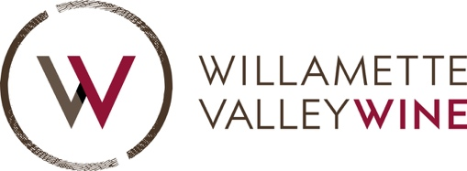

Contact:

Sarah Murdoch
Oregon Wine Board
sarah@oregonwine.com

Emily Petterson
Willamette Valley Wineries Association
emily@epkmedia.com

FOR IMMEDIATE RELEASE

Oregon Welcomes its 22nd American Viticultural Area (AVA)
Lower Long Tom becomes tenth nested AVA in the Willamette Valley
and the first AVA in the southern Willamette Valley

Portland, Ore. (December 13, 2021) – Lower Long Tom, the newest appellation in Oregon and the southernmost in the Willamette Valley, has received federal recognition as an American Viticultural Area (AVA). Drawn to reflect distinct soil, topography, and climate attributes, Lower Long Tom becomes the 22nd federally recognized winegrowing region in Oregon, the tenth nested AVA within the Willamette Valley, and the first in the Southern Willamette Valley. The new AVA was granted approval by the Alcohol and Tobacco Tax and Trade Bureau (TTB) on November 10 and took effect on December 10, 2021.

Located in Lane and Benton counties, Lower Long Tom is characterized by a chain of rolling hills separated by east-to-west valleys, cut by the tributaries of the region’s namesake, the Long Tom River. The Long Tom River is a tributary of the Willamette River, and its watershed marks the eastern edge of the new AVA.

Vineyards in the appellation are located on stream-cut ridge lines, with Bellpine as the predominate soil type. These shallow, clay-loam soils are formed from up-lifted ancient marine sediments, primarily sandstone. To the west, the region is flanked by a stretch of significant peaks within the Coast Range, which serve as a weather shield. The rain shadow contributes to consistent grape maturity in the region.

Long Tom is a regional name associated with the Kalapuyan people who have lived in the area for more than 10,000 years. The name is used in recognition of the ongoing contributions of the Kalapuyan people in the local community and across Oregon.

Four years ago, Dieter Boehm of High Pass Winery petitioned the TTB for the addition of the AVA to the wine country map. 12 wineries and 24 vineyards join the new Lower Long Tom AVA. A full list of wineries and vineyards can be found below.

“This neighborhood is warm, genuine, authentic, and down-to-earth, with passionate owners and farmers connected to the land,” said Matt Shown, second-generation winemaker at Brigadoon Wine Co. “That love for this place goes beyond wine and permeates our daily lives.”

“Oregon’s newest viticultural area acknowledges the increasing appreciation our grape growers and winemakers are developing for site-specific growing conditions and flavor complexity,” said Oregon Wine Board Executive Director Tom Danowski. “In the shadow of Prairie Mountain and the Coast Range, Lower Long Tom will add a unique dimension to the Willamette Valley’s esteemed reputation for extraordinarily elegant and expressive fruit.”

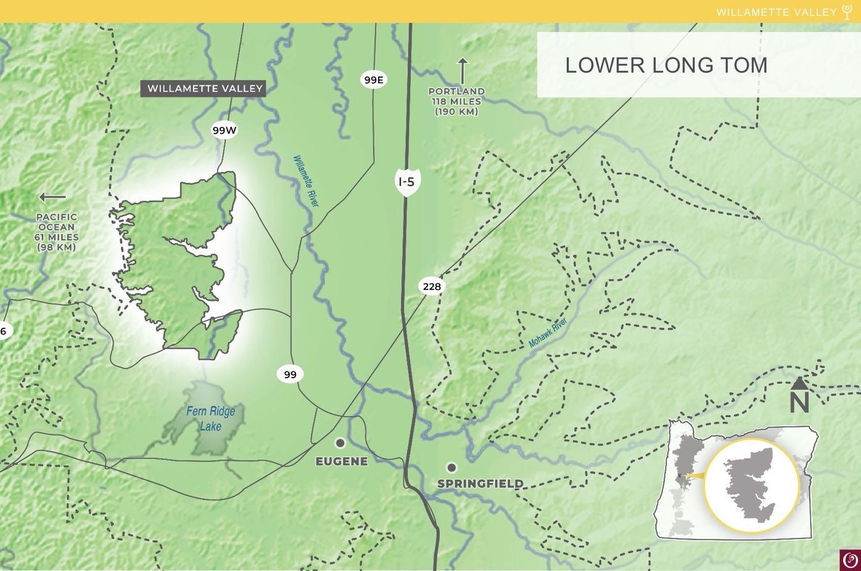

Both the industry and consumers who look to Oregon for its one-of-a-kind appellations and the sense of place in Oregon’s wines can celebrate the addition of Lower Long Tom as a nested AVA of the Willamette Valley. Pinot noir is the predominant grape of the region, with wines leaning toward blue and black fruits and plush tannins for graceful aging. Around a dozen white grape varieties are grown as well, most notably Chardonnay, Riesling, Pinot gris, and Sauvignon blanc.

“Pinot noir is still the kingpin variety in the Willamette Valley,” said Morgen McLaughlin, executive director of the Willamette Valley Wineries Association. “Winemakers love Pinot noir because it’s such an expressive grape: it insists on telling you where it’s from. We’re so excited to see Pinot noir and other wines from Lower Long Tom AVA recognized in the larger story of the Willamette Valley.”

Images of the new AVA can be found in the folder here.

Lower Long Tom AVA:

Details
Official date of recognition: December 10, 2021
Total acreage: 25,000
Planted acreage: 575
Number of wineries: 12
Number of vineyards: 24
Varieties: Pinot noir, Chardonnay, Riesling, Pinot gris, and Sauvignon blanc
Soil: Bellpine

Wineries
Antiquum Farm
Bennett Vineyards and Wine Company
Bradshaw Vineyard
Brigadoon Wine Co.
Benton Lane Winery
Five Fourteen Vineyard
High Pass Winery
Pfeiffer Vineyards and Winery
Poco Collina
Rainsong Winery
Territorial Vineyards and Wine Company
Walnut Ridge Vineyard

Vineyards*
Bellpine Vineyard
Chardonnay Way
Davis Reid Vineyard
Evans Vineyard
Fitzpatrick Vineyard
Gelardi Vineyard
Grace Hill Vineyard
Hildebrand Ranch
Kliewers Weinberg
Kokkeler Vineyard
Moriah Vineyard
Priddy Vineyard
Stroda Vineyard
Sunny Mountain
Union School
*Many of the wineries above are located on an estate vineyard.

###

About the Oregon Wine Board
Oregon is home to 995 wineries and 1,370 vineyards planted, generating annual economic impact of $7.2 billion for the state. The Oregon Wine Board is a semi-independent Oregon state agency managing marketing, research, communications, and education initiatives that support and advance the Oregon wine and wine grape industry. The Board works on behalf of all Oregon wineries and independent growers throughout the state’s diverse winegrowing regions. Visit oregonwine.org

About the Willamette Valley Wineries Association
The WVWA is a nonprofit industry association dedicated to achieving recognition for Oregon’s acclaimed Willamette Valley as a premium Pinot noir-producing region. The WVWA has more than 230 members representing wineries, tasting rooms and vineyards throughout the Willamette Valley. The organization also hosts Willamette: The Pinot Noir Auction, Oregon Pinot Camp, Pinot in the City, May in Wine Country, The Giving Season and the Cellar Season. Visit www.willamettewines.com for more info.

