Contact:
Oregon Wine Board
Sally Murdoch
sally@oregonwine.org
503.228.8336
503.735.5943 cell

FOR IMMEDIATE RELEASE

Strong Demand for Oregon Wine Confirmed by Newest Industry Reports

New studies show Oregon statewide increases in grape acreage, wine production and sales, including a 12% boost in Oregon wine sold across the U.S.
PORTLAND, September 12, 2019 – The Oregon Wine Board released its annual Oregon Vineyard and Winery Report today, showing continued momentum throughout the state’s wine industry in 2018. While the North Willamette Valley leads in quantity of vineyards and wineries—651 and 503, respectively—there are now 793 wineries across the state with 24 added last year. Wineries in the South Willamette Valley swelled by 16, the biggest regional growth in 2018, now totaling 89 in the region.
PLANTED ACREAGE
Total planted acreage of wine grapes increased by almost 6%, nearly 2,000 acres, increasing from 33,996 to 35,972, showing a healthy optimism in vineyard plantings. The highest growth rate in planted acreage last year was seen in the Umpqua and Rogue valleys with 10% more acres of grapes planted this year over last.
SALES
Data for the annual Vineyard and Winery Report was gathered by the Institute for Policy Research and Engagement (IPRE) at the University of Oregon. The reported sales growth trend echoes that of recent Nielsen data, which shows sales of Oregon wine at U.S. retail rose 12% in 2018 compared to the total table wine category’s performance of -0.6% versus the previous year.
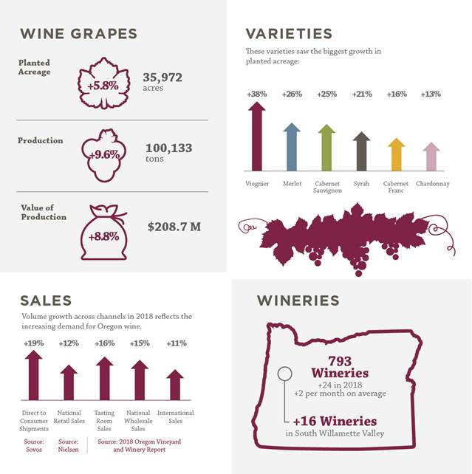

For the first time, the estimated value of Oregon’s wine grape crop topped the $200 million mark in 2018 at $208 million, up from $192 million the year prior, an increase of 8.8%. IPRE researchers also found that Oregon wine sales expanded from $550 million in 2017 to $607 million last year, buoyed by a 19% increase in direct-to-consumer shipments, according to the Sovos/Wines Vines Analytics 2019 Direct to Consumer Wine Shipping Report.

Tom Danowski, Oregon Wine Board president, noted that industry momentum is due to the increasing recognition of Oregon’s reputation for quality and consumers’ willingness to seek out and pay for exceptional wines. “Visit any winery or vineyard now in the midst of harvest, and it’s easy to see the skills, experience and extra effort from winemakers, vineyard managers, growers, tasting room staff and everyone involved in the process of crafting Oregon wines,” he said.

VARIETIES
Pinot noir continues to reign supreme among varieties, with more than 20,000 acres planted representing a modest 5% jump. The leading variety accounts for 56% of all planted acreage and 58% of 2018 wine grape production. Oregon’s second-most planted variety, Pinot gris, grew by 4% this year, now with 5,078 planted acres. Merlot grew by 26% in planted acreage, Cabernet Sauvignon grew by 25% in planted acreage, Syrah also made a large leap at 21%, and Cabernet Franc and Chardonnay continued their healthy ascents at 16% and 13% growth in planted acres, respectively.
New varieties that made their way to the chart for the first time include Albariño and Gamay. Viognier added almost 100 more planted acres, an increase of 38%.

WINE EXPORTS
Exports play a special role in Oregon wines being recognized on the international stage, with Canada being the leading the export market, accounting for 45% of export sales, and with Canadians consuming 47,338 cases of Oregon wine. Notable growth was seen in Scandinavian markets, with a 59% increase in wines exported to Denmark, and Asia, with 15,258 cases of Oregon wine exported supported by increases in exports to Japan, China, Hong Kong, South Korea and other Asian countries.

The complete report is available on the OWB website, with past years’ reports dating back to 2005: industry.oregonwine.org.

Image caption Source: 2017 and 2018 Oregon Vineyard and Winery report, University of Oregon’s Institute for Policy Research and Engagement.

###
About the Oregon Wine Board
The Oregon Wine Board is a semi-independent Oregon state agency managing marketing, research and education initiatives that support and advance the Oregon wine and wine grape industry. The Board works on behalf of all Oregon wineries and independent growers throughout the state’s diverse winegrowing regions. Visit oregonwine.org.

