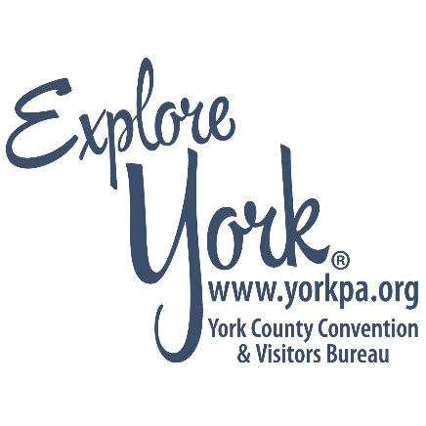

**April 18, 2018**

**FOR IMMEDIATE RELEASE**

Eric Menzer

Chair, York County Tourism Grant Committee

717-801-4481 or [emenzer@yorkrevolution.com](mailto:emenzer@yorkrevolution.com)

Louise Heine

Destination Marketing Director, York County Convention & Visitors Bureau

717-852-9675 or [louise@yorkpa.org](mailto:louise@yorkpa.org)

**York County Tourism Grant Committee Received 39 Grant Applications for Round 1 in 2018**

YORK, PA – Highlighting the ongoing demand to grow the local tourism industry, the York County Tourism Grant Committee received 39 applications for funding during the first round of 2018. There were no funding limitations for grant applications in Round One.

Applicants requested almost $4 million in total funds during Round One which were due on February 14, 2018. Grants needed to request a minimum of $2,500, with state law requiring a 25 percent cash or in-kind match. The York County Tourism Grant Committee will announce funding determinations by early June 2018.

In its first year, the York County Tourism Grant Committee approved over $1 million for projects that have the potential to boost visitation to York County.

“The funding of these projects represent a broad range of ideas that will grow tourism, overnight stays and enhance the visitor experience in York County, creating a greater economic impact for the county and residents,” said Eric Menzer, President of the York Revolution and Chair of the York County Tourism Grant Committee.

The next round of grant applications will open in mid-June 2018, with awards announced by October 11, 2018. There is a $10,000-dollar limit on applications in Round Two. Details will be available at [yorkpa.org/aboutus.](https://www.yorkpa.org/about-us/york-county-tourism-grant-program/)

In addition to Menzer, the York County Tourism Grant Committee is comprised of State Representative Kate Klunk, York County Commissioner Susan Byrnes, York County Economic Alliance President and CEO Kevin Schreiber, RKL Partner and YCCVB Board Member Rob Berkebile, Springwood Hospitality CEO Dave Hogg and Hanover Area Chamber of Commerce Marketing and Public Relations Coordinator Emily Freiert.

The York County Convention & Visitors Bureau's Mission is to maximize tourism expenditures and their economic impact in York County, PA, through comprehensive tourism sales and marketing programs. The York County CVB's Vision is for a York County where tourism is recognized for the value of its economic impact and its role in raising the profile of York County as a sought-after destination. For more information on the York County Convention & Visitors Bureau, call 1-888-858-9675 or visit yorkpa.org.