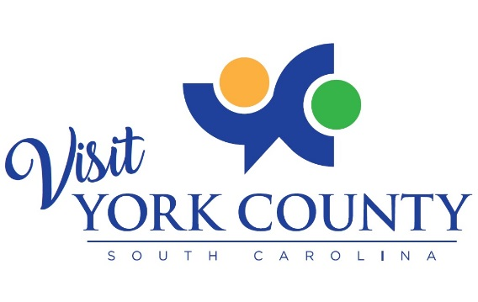
ROCK HILL/YORK COUNTY CONVENTION AND VISITORS BUREAU
BOARD OF COMMISSIONERS’ MEETING

Cambria Hotel – Fort Mill | Wednesday, September 23, 2020 | 8:00 a.m.

- CALL TO ORDER David Roberts

- INTRODUCTION OF NEW STAFF MEMBER Billy Dunlap

- APPROVAL OF MINUTES Board

- TREASURER’S REPORT Denise Cubbedge

- CEO REPORT Billy Dunlap

- PREFERRED HOTEL UPDATE Allison Cleveland

- OTHER / NEW BUSINESS

  - Nomination of 2021 board officers David Roberts

- COMMISSIONER COMMENTS

- ADJOURNMENT David Roberts

NOTES:________________________________________________________________________________________________________________________________________________________________________________________________________________________________________________________________________________________________
__________________________________________________________________________________________________

NEXT VISIT YORK COUNTY BOARD OF COMMISSIONERS’ MEETING
Wednesday, October 28 | 8:00am

